

April 2016

This document was produced for review by the United States Agency for International Development. It was prepared by Cloudburst Consulting Group, Inc. for the Evaluation, Research, and Communication (ERC) Task Order under the Strengthening Tenure and Resource Rights (STARR) IQC.

Mobile Application to Social Tenure Pilot Project (MAST)

User Manual for the Web Application: Data Management Infrastructure

Prepared for the United States Agency for International Development, USAID Contract Number AID-OAA-TO-13-00019, Evaluation, Research and Communication (ERC) Task Order under Strengthening Tenure and Resource Rights (STARR) IQC No. AID-OAA-I-12-00030.

Implemented by:

Cloudburst Consulting Group, Inc.

8400 Corporate Drive, Suite 550

Landover, MD 20785-2238

Mobile Application to Social Tenure Pilot Project (MAST)

User Manual for the Web Application: Data Management Infrastructure

April 2016

**DISCLAIMER**

The authors' views expressed in this publication do not necessarily reflect the views of the United States Agency for International Development or the United States Government.

taBLE OF CONTENTS

[1. DOCUMENT OVERVIEW 5](#_Toc447799840)

[2. About the MAST web Application 5](#_Toc447799841)

[4. Administration Tool 9](#_Toc447799842)

[5. User Management 10](#_Toc447799843)

[5.1 Add User 10](#_Toc447799844)

[5.2 Edit User 12](#_Toc447799845)

[5.3 Delete User 14](#_Toc447799846)

[6. Data Layers 16](#_Toc447799847)

[6.1 Add New Layer 16](#_Toc447799848)

[6.2 Edit Layer 20](#_Toc447799849)

[6.3 Delete Layer 22](#_Toc447799850)

[7. Layer Groups 23](#_Toc447799851)

[7.1 Add New Layer Group 23](#_Toc447799852)

[7.2 Edit Layer Group 25](#_Toc447799853)

[7.3 Delete Layer Group 28](#_Toc447799854)

[8. Survey Projects 29](#_Toc447799855)

[8.1 Add Survey Project 29](#_Toc447799856)

[8.2 Edit Survey Project 36](#_Toc447799857)

[8.3 Delete Survey Project 40](#_Toc447799858)

[9. Master Attribute 42](#_Toc447799859)

[9.1 View attributes category wise 43](#_Toc447799860)

[9.2 Add Attributes 43](#_Toc447799861)

[9.3 Edit Attributes 45](#_Toc447799862)

[9.4 Delete Attributes 47](#_Toc447799863)

[10. Configure Attribute 50](#_Toc447799864)

[10.1 Add/remove Attributes 51](#_Toc447799865)

[11. Configure Data 55](#_Toc447799866)

[11.1 Upload MBTiles 55](#_Toc447799867)

[12. Map viewer 59](#_Toc447799868)

[12.1 Layer Manager 59](#_Toc447799869)

[12.2 Mapping Tools 60](#_Toc447799870)

[12.2.1 Spatial Validations 61](#_Toc447799871)

[12.2.2 Open Project 66](#_Toc447799872)

[12.2.3 Zoom in 67](#_Toc447799873)

[12.2.4 Zoom out 67](#_Toc447799874)

[12.2.5 Pan 67](#_Toc447799875)

[12.2.6 Zoom to layer 68](#_Toc447799876)

[12.2.7 Fixed Zoom in 68](#_Toc447799877)

[12.2.8 Fixed Zoom out 68](#_Toc447799878)

[12.2.9 Zoom Previous 69](#_Toc447799879)

[12.2.10 Zoom Next 69](#_Toc447799880)

[12.2.11 Full Zoom 69](#_Toc447799881)

[12.2.12 Map Info 70](#_Toc447799882)

[12.2.13 Measure 71](#_Toc447799883)

[12.2.14 Select 72](#_Toc447799884)

[12.2.15 Select By Rectangle 72](#_Toc447799885)

[12.2.16 Select By Polygon 73](#_Toc447799886)

[12.2.17 Clear 73](#_Toc447799887)

[12.2.18 Search 74](#_Toc447799888)

[12.2.19 Zoom to XY 75](#_Toc447799889)

[12.2.20 Print 77](#_Toc447799890)

[12.2.21 Query Builder 78](#_Toc447799891)

[Run Query 80](#_Toc447799892)

[Save Query 82](#_Toc447799893)

[Load Query 83](#_Toc447799894)

[12.2.22 Bookmark 85](#_Toc447799895)

[Create Bookmark 86](#_Toc447799896)

[Zoom to Bookmark 86](#_Toc447799897)

[Remove Bookmark 87](#_Toc447799898)

[12.2.23 Export Data 87](#_Toc447799899)

[12.2.24 Markup 88](#_Toc447799900)

[Point Markup 89](#_Toc447799901)

[Line Markup 89](#_Toc447799902)

[Polygon Markup 89](#_Toc447799903)

[Circle Markup 90](#_Toc447799904)

[Rectangle Markup 90](#_Toc447799905)

[Text Markup 90](#_Toc447799906)

[Save Markup 91](#_Toc447799907)

[Delete Markup 91](#_Toc447799908)

[Delete All 91](#_Toc447799909)

[New 91](#_Toc447799910)

[12.2.25 Editing 91](#_Toc447799911)

[12.2.26 General Tools 92](#_Toc447799912)

[12.2.27 Edit 93](#_Toc447799913)

[12.2.28 Edit Attributes 94](#_Toc447799914)

[12.2.29 Snap Settings 95](#_Toc447799915)

[13. Land Records Dashboard 96](#_Toc447799916)

[13.1 Search Land Record 97](#_Toc447799917)

[13.2 Actions on Land Records 98](#_Toc447799918)

[13.2.1 Generate UKA 99](#_Toc447799919)

[13.2.2 Update hamlet 100](#_Toc447799920)

[100](#_Toc447799921)

[13.2.3 Edit Attributes 101](#_Toc447799922)

[Update General Info 102](#_Toc447799923)

[Update Natural Person Detail 104](#_Toc447799924)

[Update Non-Natural Person 111](#_Toc447799925)

[Update Person of Interest 113](#_Toc447799926)

[Update Deceased Person 116](#_Toc447799927)

[Update Tenure Info 118](#_Toc447799928)

[Update Multimedia 121](#_Toc447799929)

[13.2.4 Approve Status 122](#_Toc447799930)

[13.2.5 Reject Status 124](#_Toc447799931)

[13.2.6 Adjudicate Spatial Attribute 125](#_Toc447799932)

[13.2.7 Show on map 126](#_Toc447799933)

[13.2.8 Finalize Data 126](#_Toc447799934)

[13.2.9 Upload Document 127](#_Toc447799935)

[13.2.10 Generate Adjudication FORM 129](#_Toc447799936)

[13.2.11 Generate CCRO Certification 131](#_Toc447799937)

[14. Phase –II Implementations 133](#_Toc447799938)

[15. Incorporation of Hamlet Details and Land Adjudication Committee Members 133](#_Toc447799939)

[15.1 System Function 133](#_Toc447799940)

[15.1.1 Incorporation of Hamlet details 133](#_Toc447799941)

[15.1.2 Adding of Committee Members (Project Adjudicators) 137](#_Toc447799942)

[Data Model changes 139](#_Toc447799943)

[16. MAST and Generate UKA Number 139](#_Toc447799944)

[16.1 Generation of UKA on Web Application 139](#_Toc447799945)

[17. MAST Attributes and Reports Update 142](#_Toc447799946)

[17.1 Final Listing of MAST Attributes 142](#_Toc447799947)

[17.2 Adjudication Forms 143](#_Toc447799948)

[17.2.1 Adjudication Data and Report for Single Occupant 144](#_Toc447799949)

[Data for Tenure Type: Single Occupant Data 144](#_Toc447799950)

[Report for Tenure Type: Single Occupant 145](#_Toc447799951)

[17.2.2 Adjudication Data and Report for Multiple Occupancy (Joint Tenancy) & Multiple Occupancy (Tenancy in Common) 146](#_Toc447799952)

[Data for Tenure Type: Multiple Occupancy (Joint Tenancy) & Multiple Occupancy (Tenancy in Common) 146](#_Toc447799953)

[Report for Tenure Type: Multiple Occupancy (Joint Tenancy) & Multiple Occupancy (Tenancy in Common) 147](#_Toc447799954)

[17.2.3 Adjudication Data and Report for Tenancy in Probate (administrator) 148](#_Toc447799955)

[Data for Tenancy in probate (Administrator) 148](#_Toc447799956)

[Report for Tenancy in probate (Administrator) 149](#_Toc447799957)

[17.2.4 Adjudication Data and Report for Tenancy in Common (Guardian)/Data for Tenancy in Common (Guardian) – minor 150](#_Toc447799958)

[17.2.5 Report for Tenancy in Common (Guardian) – minor 152](#_Toc447799959)

[17.3 CCRO 154](#_Toc447799960)

[17.3.1 CCRO for Single Owner 154](#_Toc447799961)

[17.3.2 CCRO for MULTIPLE OWNER 156](#_Toc447799962)

[18. Adding/Editing Persons of interest (Next of kin) & Natural Persons 158](#_Toc447799963)

[18.1 Web Application Flow 158](#_Toc447799964)

[A form will open where user can add the details related to Person of Interest and click on “Save” button to update the records as shown below: 162](#_Toc447799965)

[19. Mobile Data Capture Application Map Layout 164](#_Toc447799966)

[19.1 System Function 164](#_Toc447799967)

[19.1.1 Sample Map Layout 167](#_Toc447799968)

[19.1.2 Map Layout sample 169](#_Toc447799969)

[20. MAST Spatial Data Validation 170](#_Toc447799970)

[20.1 System Function 170](#_Toc447799971)

[20.1.1 Spatial Validation Methodology 173](#_Toc447799972)

[20.1.2 Spatial Validation Results 174](#_Toc447799973)

[20.1.3 Spatial Validation Error Correction 177](#_Toc447799974)

# DOCUMENT OVERVIEW

This document intends to give the guidelines to MAST Web application users (Administrator and Project Manager).

# About the MAST web Application

The key objective of MAST is to provide a framework for Capturing Land rights information using a participatory approach. This framework provides a suite of applications to support collection and management of land rights information with following key components:

**Mobile Data Capture Application –** Mobile data capture application is an Android based Mobile application to capture land rights information (spatial, alphanumeric and multimedia) on mobile devices in field.

Mobile application will be provided to conduct data collection work without being connected to a central cloud based server in offline mode. Data will be collected and stored on users’ handheld device and once the user is within the influence region of the internet, where data could be synced, the information will be packaged and sent back to the server.

**Land Rights Data management Infrastructure application** – Data collected on mobile devices will be transferred to a cloud based land Rights Data Management Infrastructure application which will provide tools to ingest, manage and store data of land rights information. It will also provide reporting components so that required Land Rights reports can be generated.

This document provides detail of Mobile component of MAST application.

1. Getting Started

To initiate the MAST web application, user opens a browser and enters application URL. As the user clicks on Enter button, the login screen of application appears in the browser window.

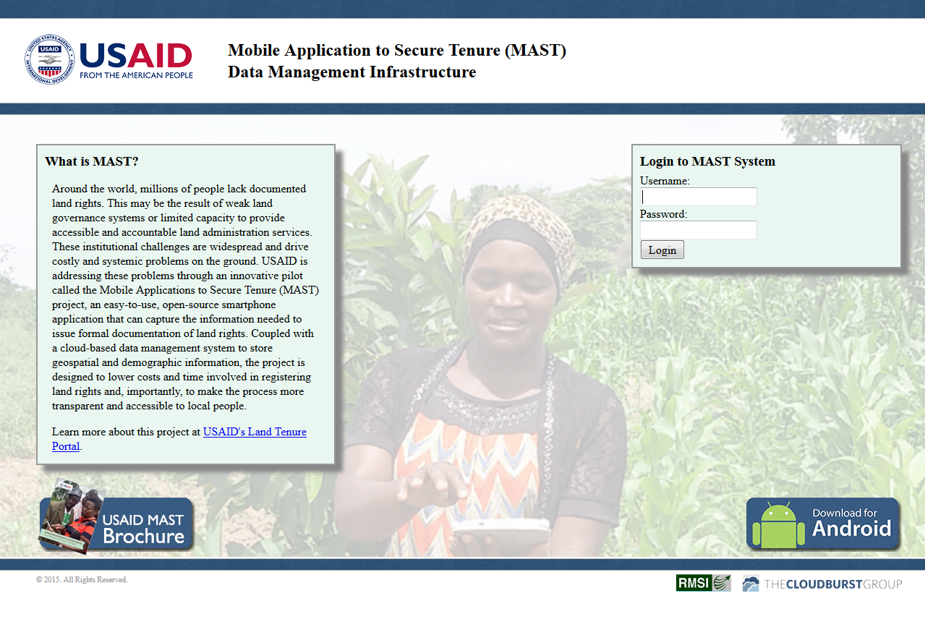

Login window has two fields ‘User Name’ and ‘Password’ with ‘Login’ button. If user is an existing user, one can enter his/her ‘User Name’ and ‘Password’ and clicks on ‘Login’ button. User will be logged in into the application and can view the application according to his/her rights.

|  |  |
| --- | --- |
| **Role** | **Rights** |
| Administrator | Administration Tool, Mobile Configuration Tool, Data Management |
| Project Manager | Administration Tool, Mobile Configuration Tool, Data Management |
| Trusted Intermediary | No access |
| Adjudicator | No access |
| Public User | Data Management |
| Land Administration Officials | Data Management |
| User | Data Management |

Login Page facilitates user to login into the application, Other than this, Login page also provides following facilitates.

1. Login

This functionality will allow authorized users to Login into the application. Depending upon the role, application will provide access to the application. Following are the available functionalities depending upon the Role.

**Steps:**

1. User provides valid User Name and Password

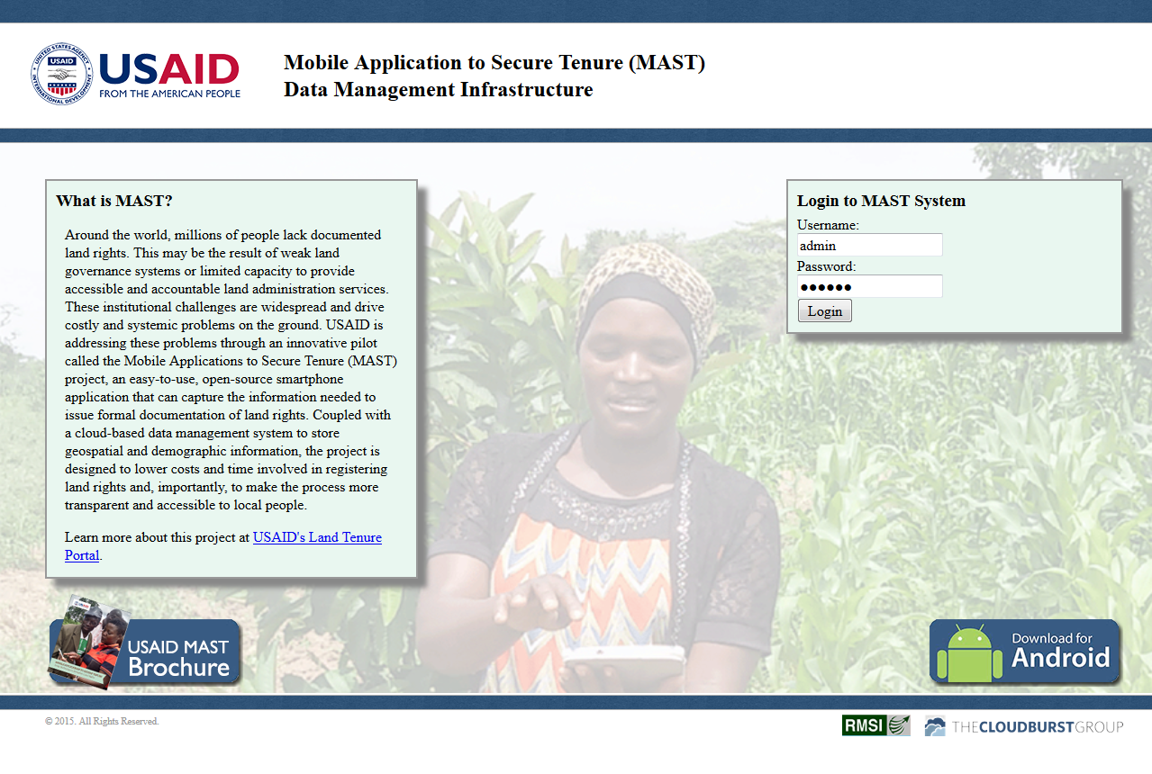

1. Click on ‘Login’ button
2. 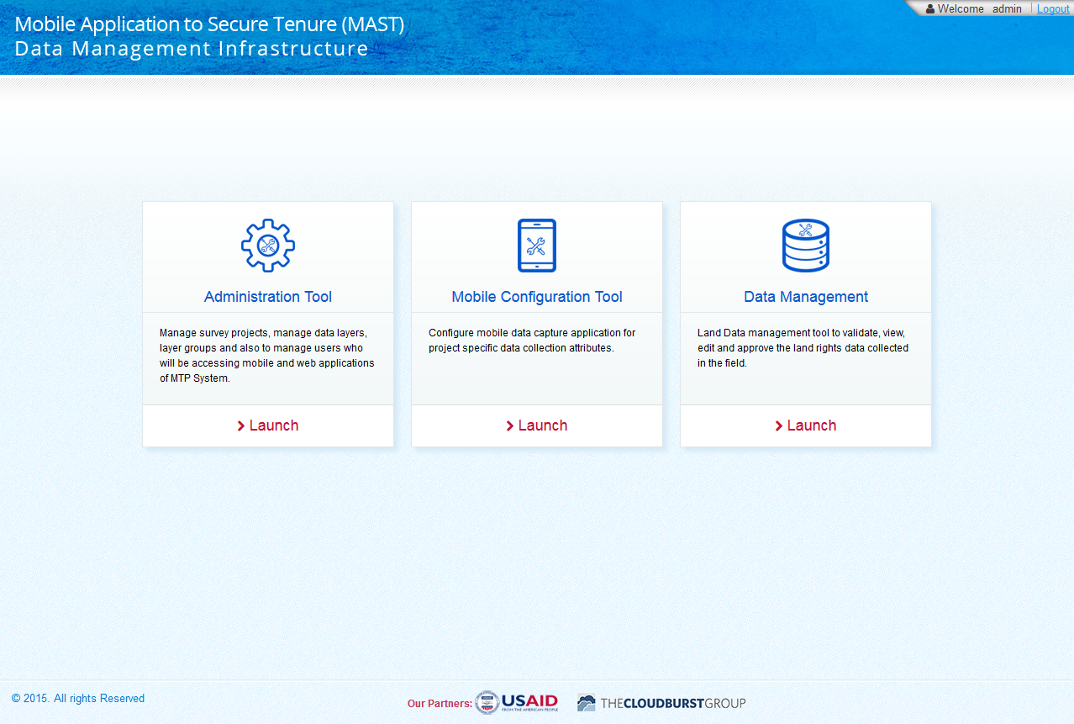Application will open up homepage of application.
3. Following Links are available :

* **Administration Tool** - ‘’Admin Tool’ is to manage Master data of Land Rights System. It will be accessed by the System Administrator to manage survey projects, manage data layers, layer groups and also to manage users who will be accessing mobile and web applications of MTP System.
* **Mobile Configuration Tool** - This module will provide the functionality to configure the project attributes that will be collected using the mobile data capture application in the field. Whenever a new survey project is created in the system, Project manager/Admin user will configure the attributes which will be utilized in the mobile data capture application to collect land rights information in the field for that specific project.
* **Data Management Tool** - This functionality will allow the user to select the working Project for which land data management work is to be done. This is the first step in the land records management tool and thereafter all the data accessible in the land data management tool will be for the selected and authorized project.

# Administration Tool

This tool facilitates user to create and manage users who will be accessing the system. It will also provide facility to add/configure spatial data layers in the application which will be loaded into the Geoserver and then further creation of layer groups.

**Steps:**

1. Login into the system with role as ‘Administrator’.
2. Click on ‘Launch’ link available in ‘Administration Tool’ section.

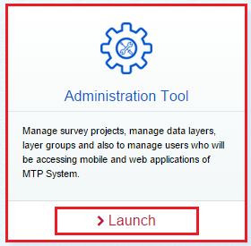

1. User will be navigated to ‘Administration Tools’ page. Following functionalities are provided by Administration Tool

|  |  |
| --- | --- |
| * User | * Layer Groups |
| * Data Layers | * Survey Projects |
| * Master Attribute |  |

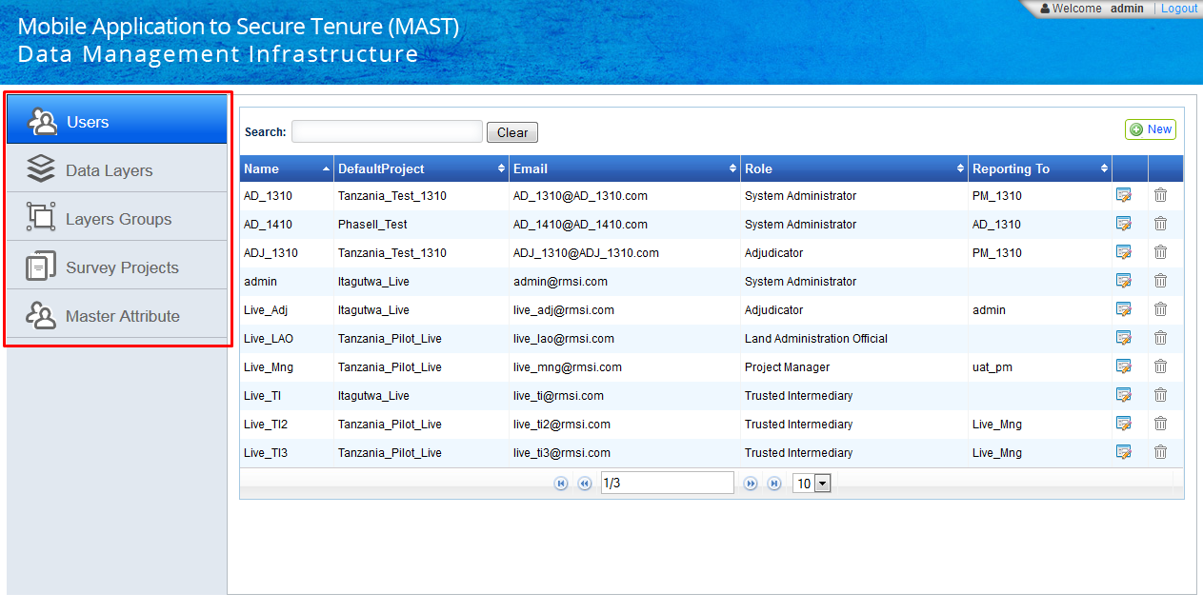

# User Management

MTP Administration tool provides ‘User management’ functionality to manage users who will be accessing web and mobile applications of MTP System.

It provides following set of functionalities for creation and management of users of the System.

* + - Add User
    - Edit User
    - Delete User

## Add User

This functionality facilitate administrator user to Create New User of the system.

**Steps:**

1. Login into the system with role as ‘Administrator’.
2. Click on ‘Launch’ link available in ‘Administration Tool’ section.
3. By default, ‘Users’ option will be selected and Details of existing users will be displayed in grid along with associated ‘Edit’ and ‘Delete’ options.
4. 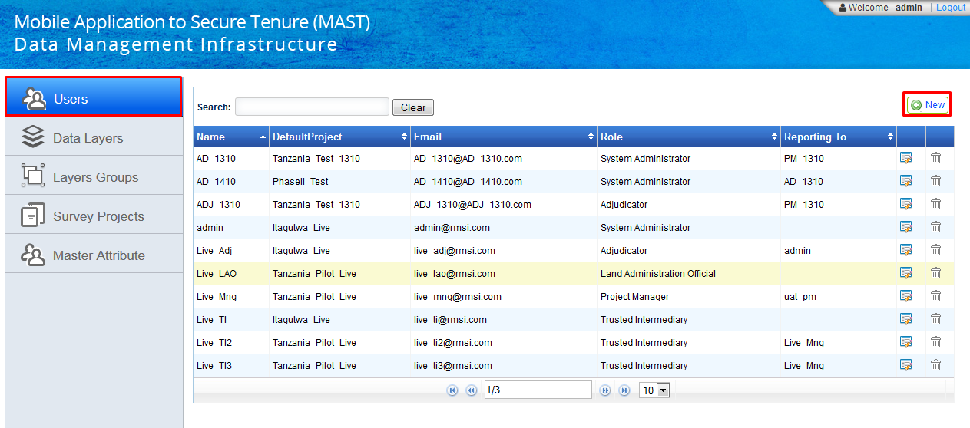On right top, ‘New’ button  will be available.
5. Click on New button. ‘General’ section will be displayed with following options

|  |  |
| --- | --- |
| * Name | * Email |
| * Password | * Confirm Password |
| * Default Project | * Active |
| * Password Expires | * Reporting to |
| * Role |  |

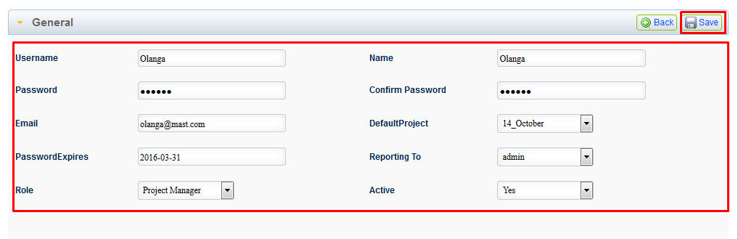

1. Provide valid details and click on ‘Save’ button.
2. 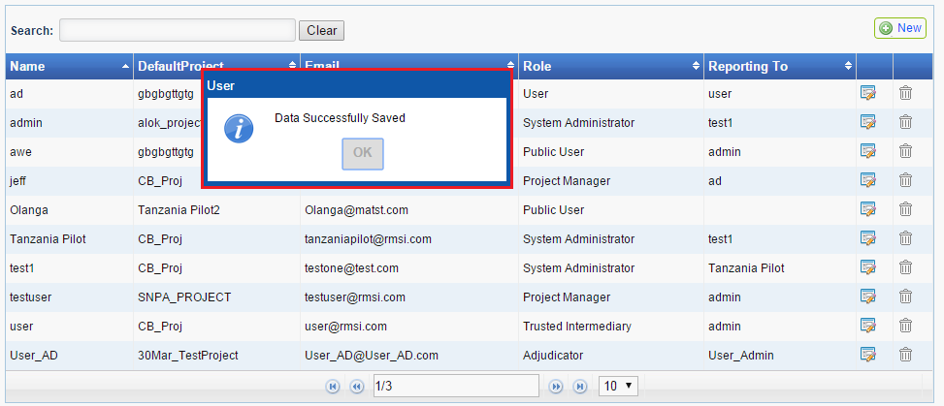On successful creation of new user, Application will display a confirmation message and user will navigate to User list.
3. Enter user name in Search input box. Recently created user’s details will be available in user grid.

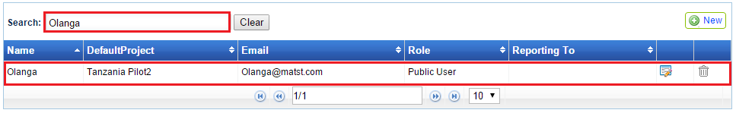New user will be able to access MAST web or Mobile application depending upon rights.

## Edit User

This functionality facilitate administrator user to edit existing user’s details.

**Steps:**

1. Login into the system with role as ‘Administrator’ and click on ‘Launch’ link available in ‘Administration Tool’ section.
2. 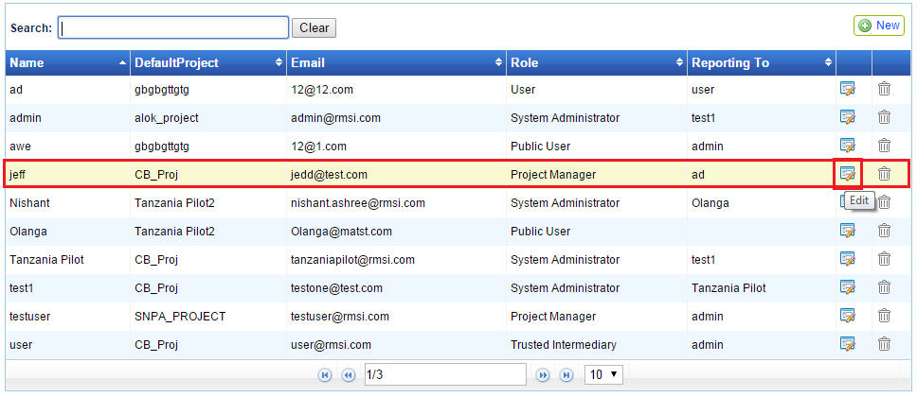By default, ‘Users’ option will be selected and Details of existing users will be displayed in grid along with associated ‘Edit’ and ‘Delete’ options.
3. Click on ‘Edit’ option available with record, which is to be edited. ‘General’ section will be displayed along with details of corresponding user in edit mode.
4. 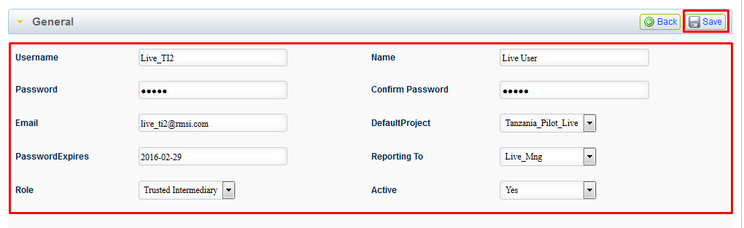Edit required details of user like – ‘Email’, ‘Password’, ‘Default Project’, ‘Active’, ‘Password Expires’, ‘Reporting To’ and ‘Role’.
5. 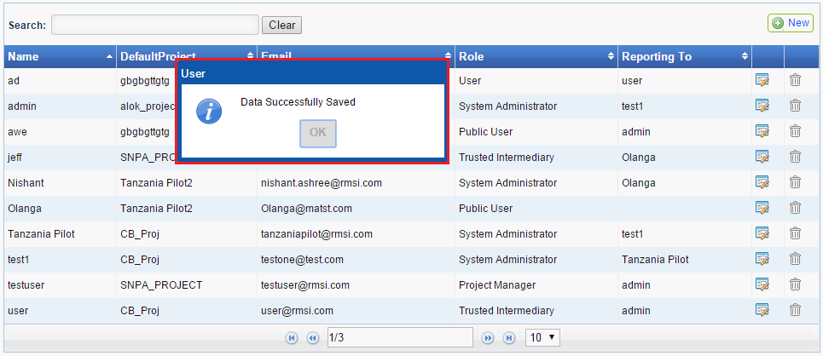Click on ‘Save’ button. Application will save edited details and will display an acknowledgement message.
6. 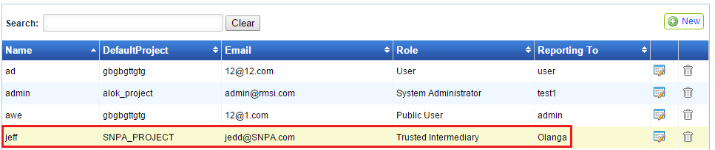Search for the same user, Updated details will be available.

## Delete User

‘Delete User’ functionality facilitates administrator user to Delete User from the system.

**Steps:**

1. Login into the system with role as ‘Administrator’ and click on ‘Launch’ link available in ‘Administration Tool’ section.
2. 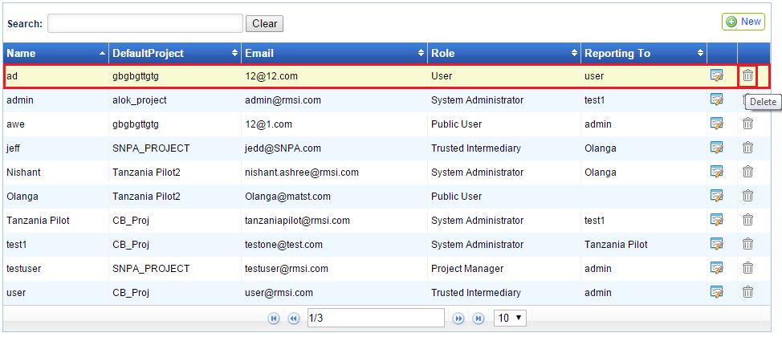By default, ‘Users’ option will be selected and Details of existing users will be displayed in grid along with associated ‘Edit’ and ‘Delete’ options.
3. 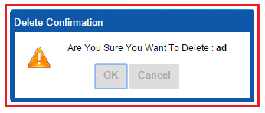Click on ‘Delete’ option available with record, which is to be edited. Application will display a confirmation message.
4. 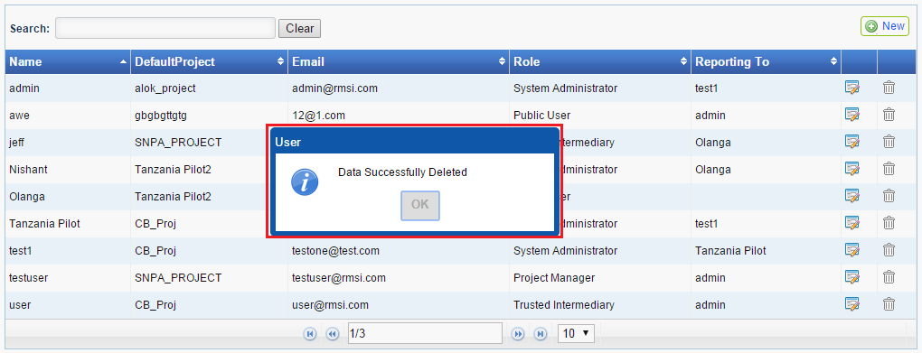Click on ‘OK’ button, Corresponding user will be deleted and application will display an acknowledgement message.

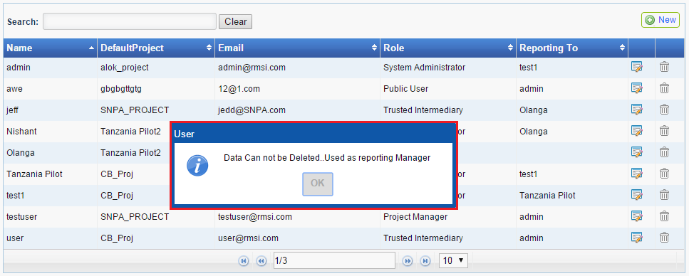**Note: If user which is to be deleted is reporting manager of some user, Application will not delete that user and an appropriate message will be displayed.**

# Data Layers

This functionality facilitates administrator user to Add New Layer in the application or edit details of existing layers of the System.

It provides following set of functionalities for creation and management of layer

* + - Add New Layer
    - Edit Layer
    - Delete Layer

## Add New Layer

This functionality facilitates administrator user to add new layer in the application.

**Steps:**

1. Login into the system with role as ‘Administrator’ and click on ‘Launch’ link available in ‘Administration Tool’ section.
2. Click on ‘Data Layer’ section available in left. Details of available layers will be displayed in grid along with associated ‘Edit’ and ‘Delete’ options.
3. 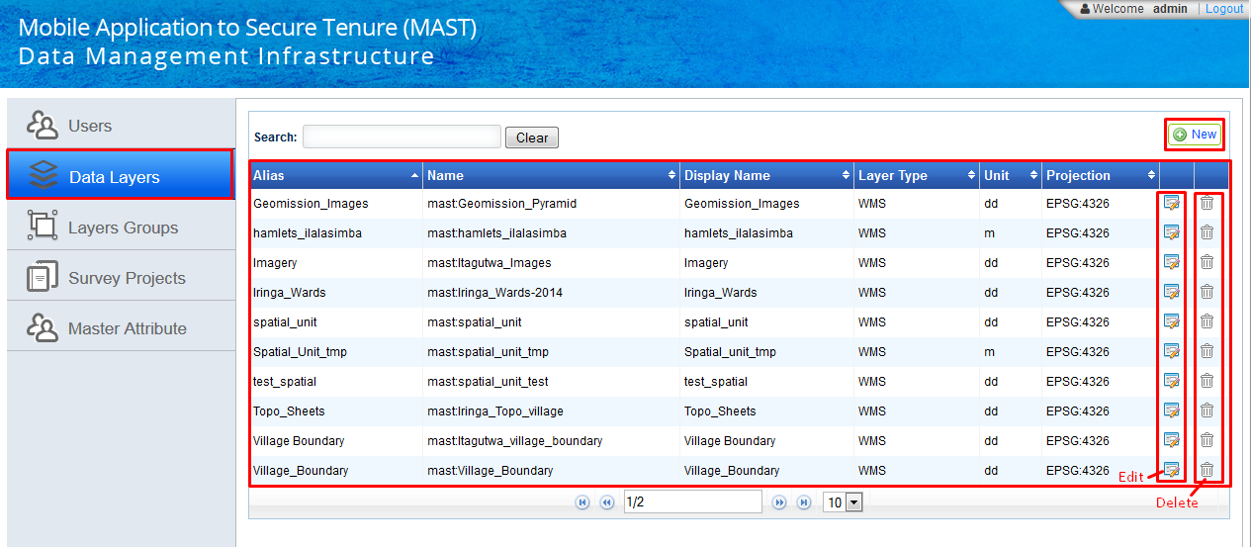On right top, ‘New’ button  will be available.
4. Click on New button. ‘Type’ dropdown will be displayed with following options -
   * + WMS
     + 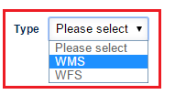WFS
5. Select required type in corresponding dropdown.
6. 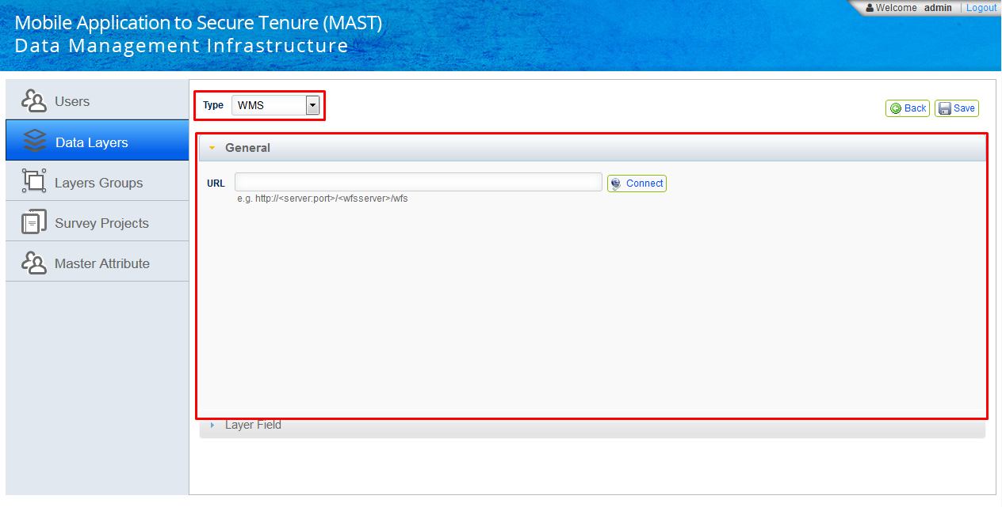‘General’ and ‘Layer Fields’ accordion will become available.
7. Enter server URL in ‘URL’ input box, click on Connect button.
8. Once connection with the specified URL is established, following input options for new layer details will be displayed in ‘General’ accordion.

|  |  |
| --- | --- |
| * Layer Name | * Display Name |
| * Alias | * Max Extent |
| * Format | * Projection |
| * Queryable | * Editable |
| * Selectable | * Exportable |
| * Unit | * Min Extent |
| * Min Scale | * Max Scale |
| * Num Zoom Levels | * Buffer |
| * Layer Visibility | * Display In Layer manager |
| * Is Base Layer | * Display Outside Max Extent |
| * Geom Type | * Tiled |

1. ‘Layer Name’ dropdown will be populated with data available on specified server.
2. Select required layer in ‘Layer Name’ Dropdown.
3. Max Extent, Min Extent and Projection will be populated in corresponding input options.
4. 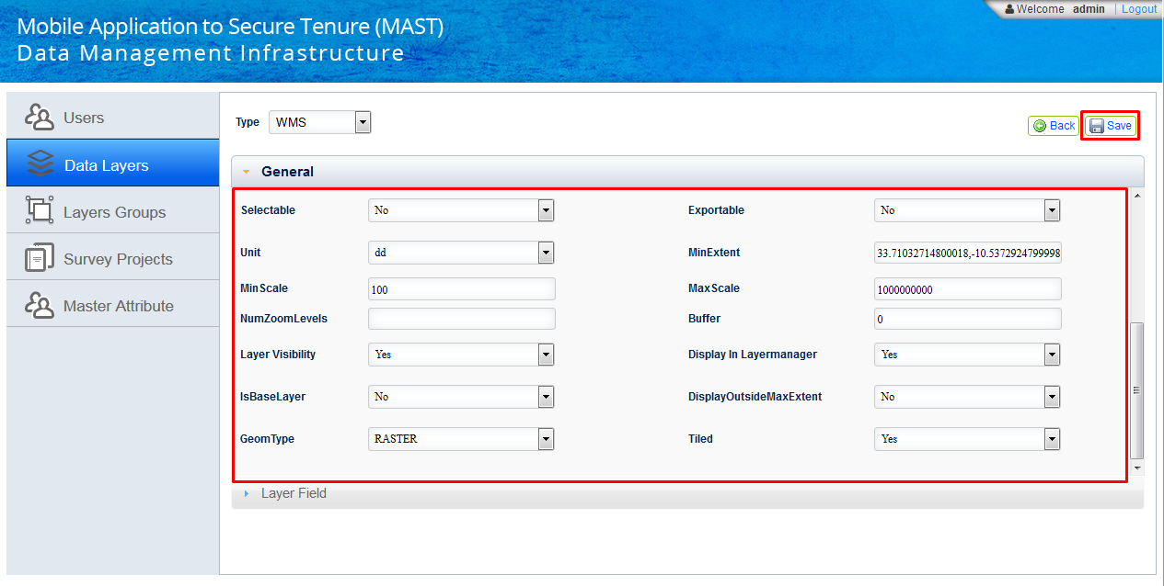 Provide all other required inputs.
5. Click on ‘Save’ button.
6. Application will save new layer and an acknowledgement message will be displayed.
7. 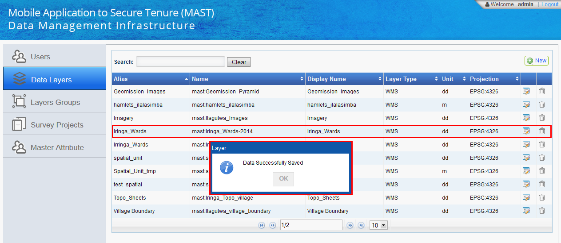Newly created layer will become available in Layer list.

## Edit Layer

‘Edit Layer’ functionality facilitates administrator user to edit the details of any existing layer.

**Steps:**

1. Login into the system with role as ‘Administrator’ and click on ‘Launch’ link available in ‘Administration Tool’ section.
2. 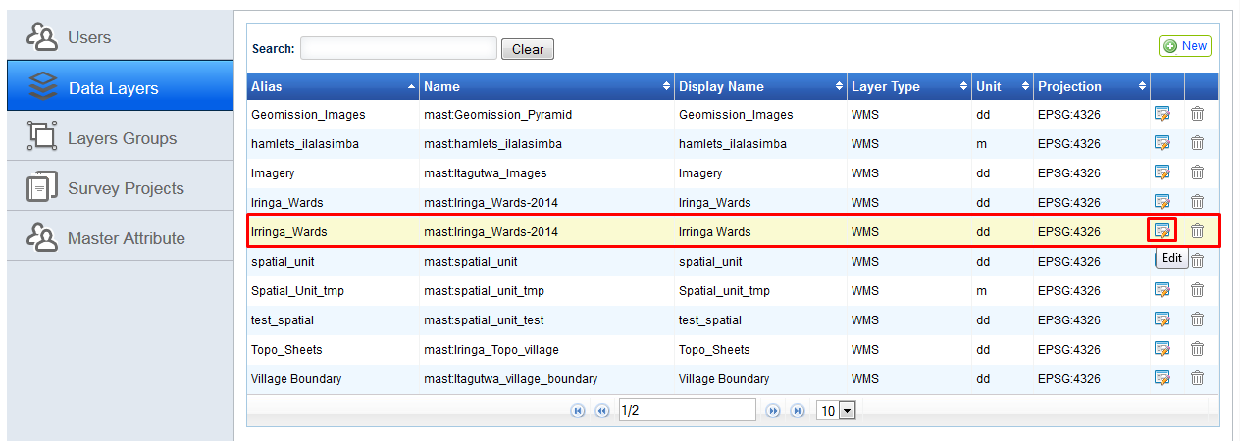Click on ‘Data Layer’ section available in left. Details of available layers will be displayed in grid along with associated ‘Edit’ and ‘Delete’ options.
3. Click on ‘Edit’ option associated with layer record, which is to be edited. ‘General’ section will be displayed along with details of corresponding layer in edit mode.
4. 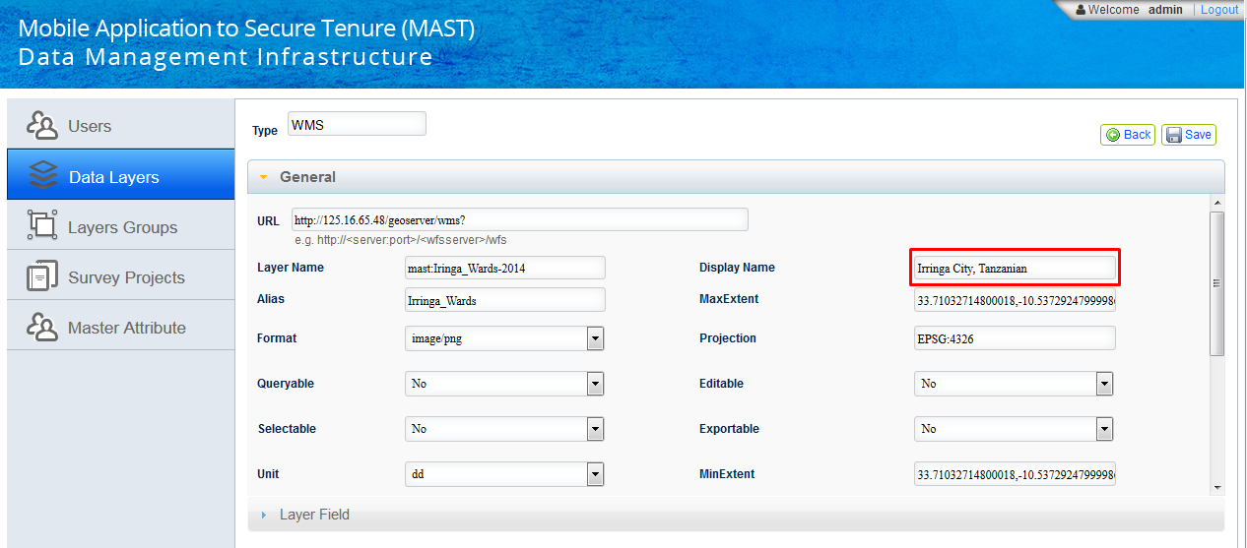Edit required details. 'URL', 'Layer Name' and 'Alias' will be non-editable.
5. 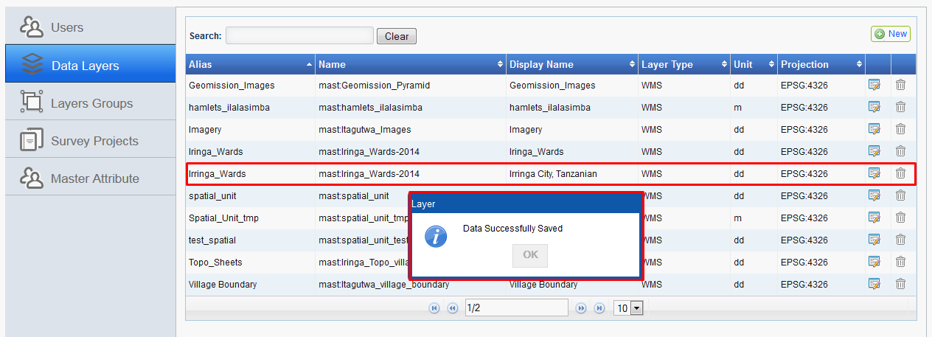Click on ‘Save’ button. Application will save edited details and will display an acknowledgement message.
6. 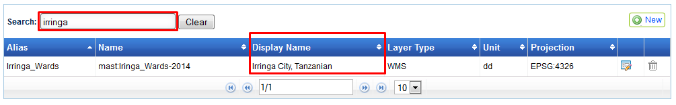Search for the same layer, Updated details will be displayed.

## Delete Layer

‘Delete Layer’ functionality facilitates administrator user to delete existing layer from the system.

**Steps:**

1. Login into the system with role as ‘Administrator’ and click on ‘Launch’ link available in ‘Administration Tool’ section.
2. Click on ‘Data Layers’ section available in left. Details of available layers will be displayed in grid along with associated ‘Edit’ and ‘Delete’ options.

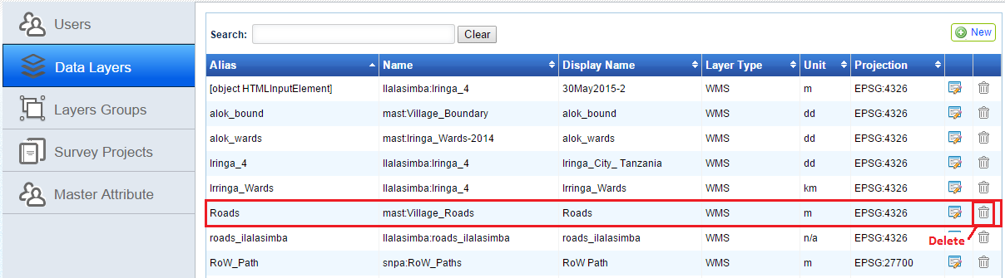

1. Click on ‘Delete’ option available with layer record, which is to be deleted.
2. 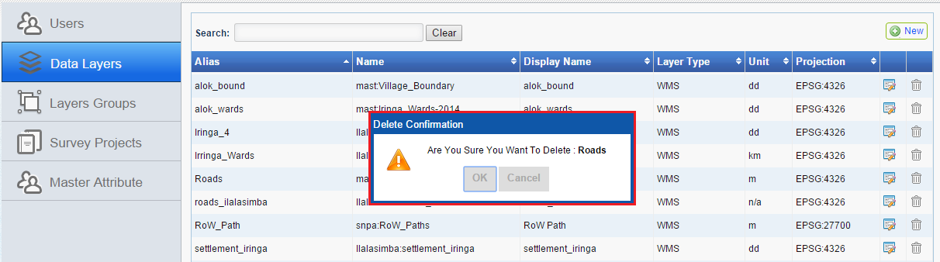Application will display a confirmation message. Click on ‘OK’ button.
3. 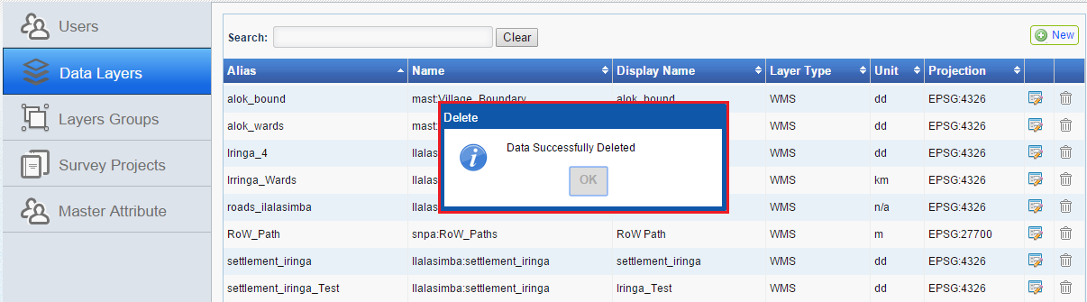Corresponding layer will be deleted and application will display an acknowledgement message.

# Layer Groups

This functionality facilitates administrator user to Manage Data Layers in the application (Edit or Delete) or Search Layers on the basis of their Names or Display Names.

It provides following set of functionalities for creation and management of layer groups

* + - Add New Layer Group
    - Edit Layer Group
    - Delete Layer Group

## Add New Layer Group

This functionality facilitates administrator user to add new layer group in the application.

**Steps:**

1. Click on ‘Layer Groups’ section available in left. Details of available layer groups will be displayed in grid along with associated ‘Edit’ and ‘Delete’ options.
2. 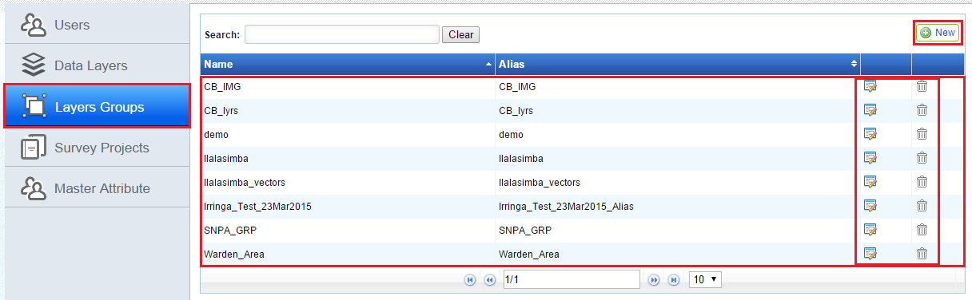On right top, ‘New’ button  will be available.
3. 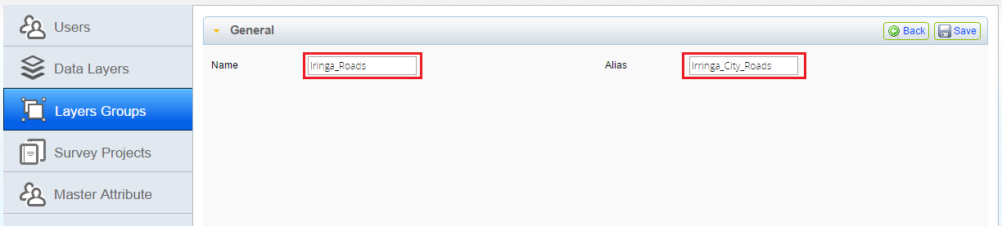Click on 'New' button. 'General' and 'Layers' accordions will be available. Provide inputs for 'Name' and 'Alias' input box available in General accordion.
4. 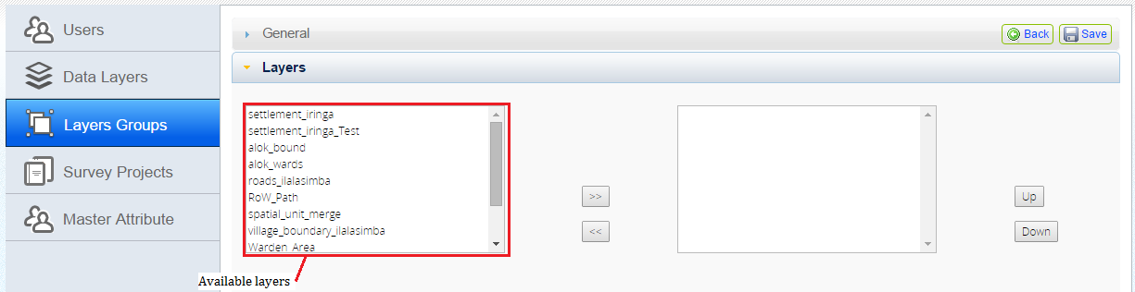Click on ''Layers' accordion. All available layers will be displayed in list box.
5. 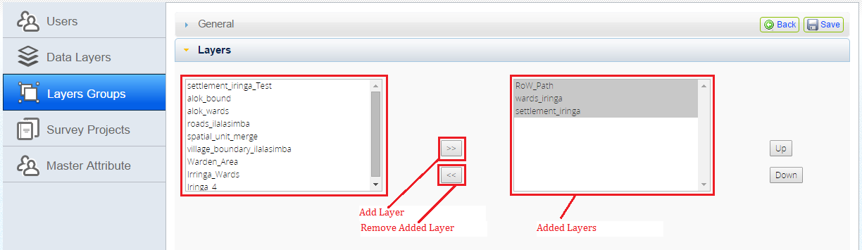Select required layers and click on ‘Add Layers’ button.
6. Selected layers will become available in 'Selected Layers' list box.
7. 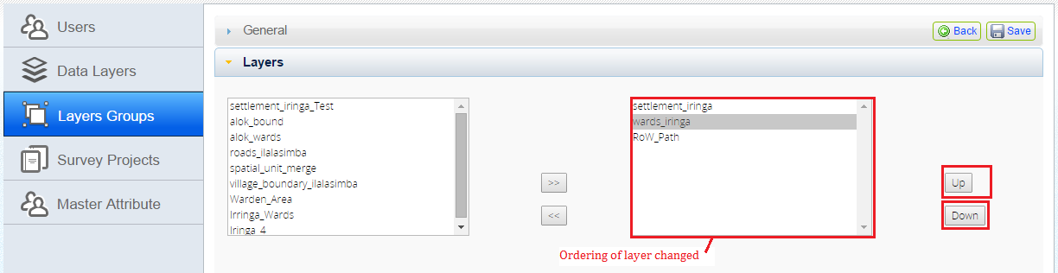Select a layer and click on UP/Down buttons to set the display order.
8. 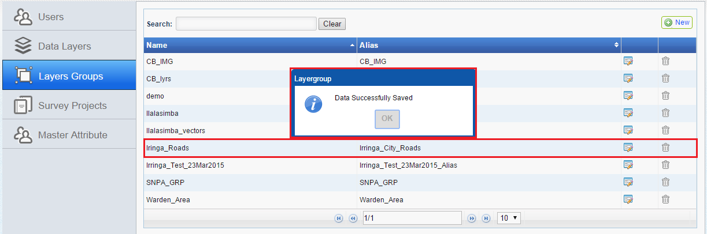Click on ‘Save’ button. Application will display a acknowledge message. Newly created layer group will be available in 'Layer Groups' list.

## Edit Layer Group

This functionality facilitates administrator user to edit existing layer group in the application. User can add new layer or remove any layer from any layer group.

**Steps:**

1. 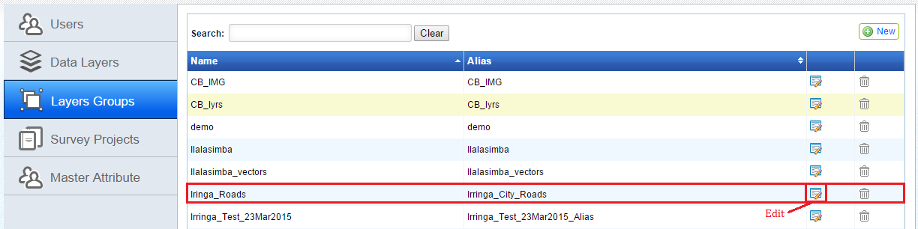Click on ‘Layer Groups’ section available in left. Details of available layer groups will be displayed in grid along with associated ‘Edit’ and ‘Delete’ options.
2. 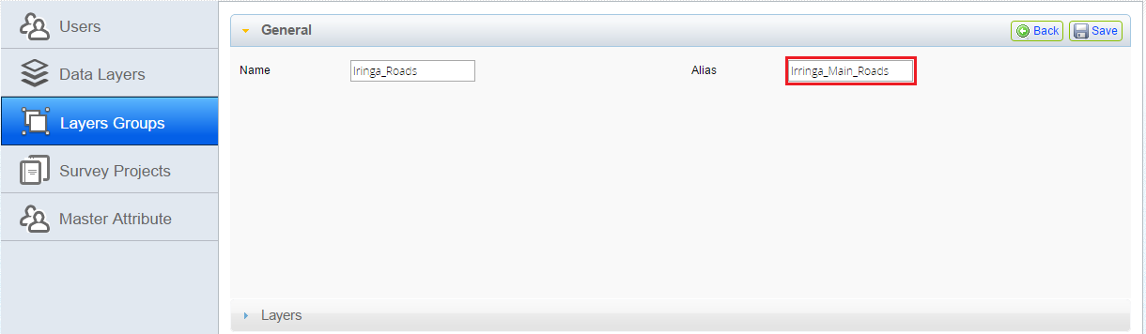Click on ‘Edit’ option associated with layer group record, which is to be edited. ‘General’ and 'Layers' accordions will be displayed along with details of corresponding layer group in edit mode.
3. Edit required details available in 'General' accordion. 'Name' will be non-editable.
4. 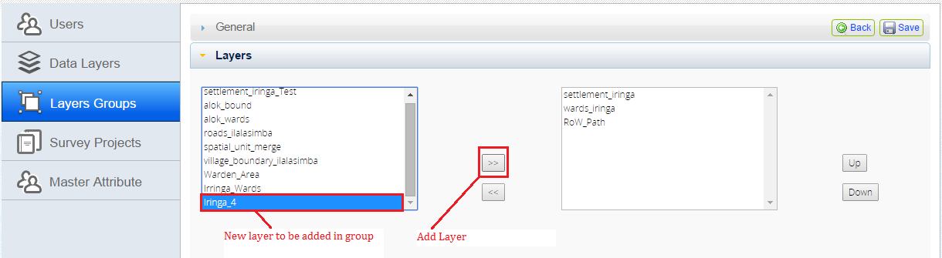Click on 'Layers' accordion, Add/Remove required layers. Select a layer in existing layers list.

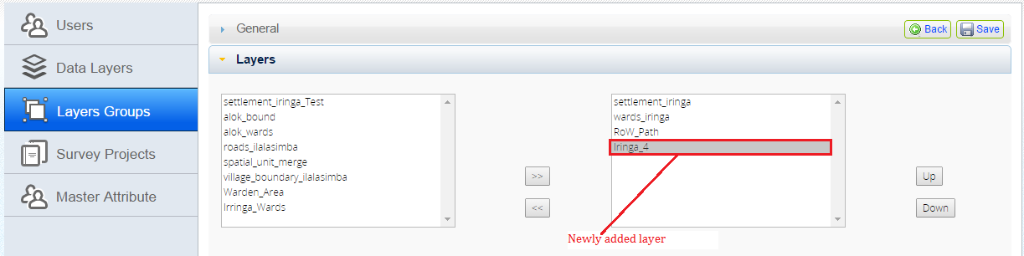

1. Click on ‘Add Layer’ button. New layer will be added in corresponding layer group.
2. 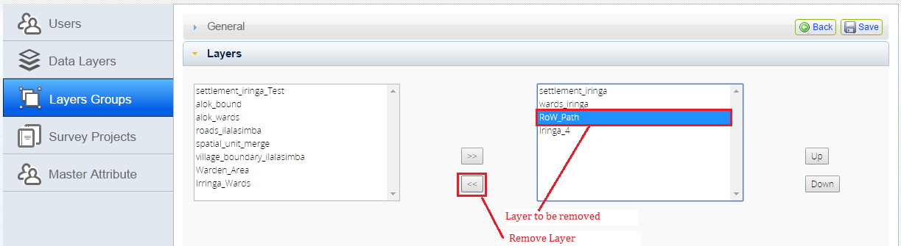Select a layer in available layers list. Click on ‘Remove Layer’ button.

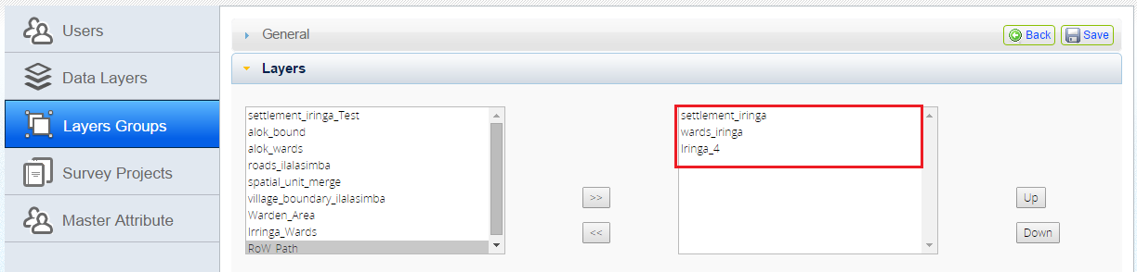

1. Selected Layer will be removed from corresponding ‘Layer Group’.
2. 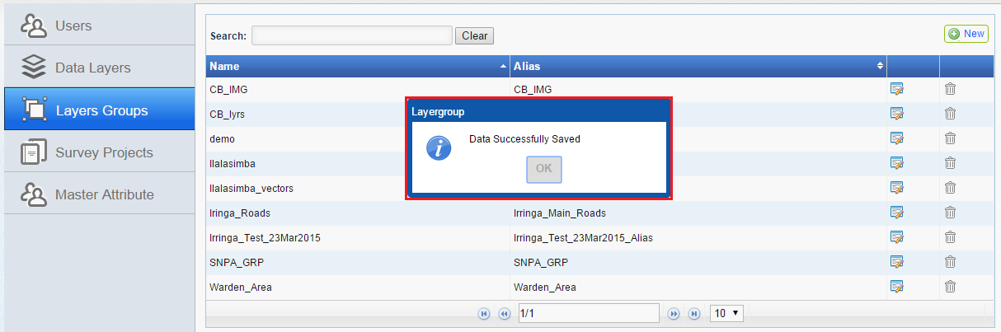Click on ‘Save’ button. Application will save edited details and will display an acknowledgement message.

## Delete Layer Group

This functionality facilitates administrator user to delete existing layer group from the application.

**Steps:**

1. Click on ‘Layer Groups’ section available in left. Details of available layer groups will be displayed in grid along with associated ‘Edit’ and ‘Delete’ options.
2. 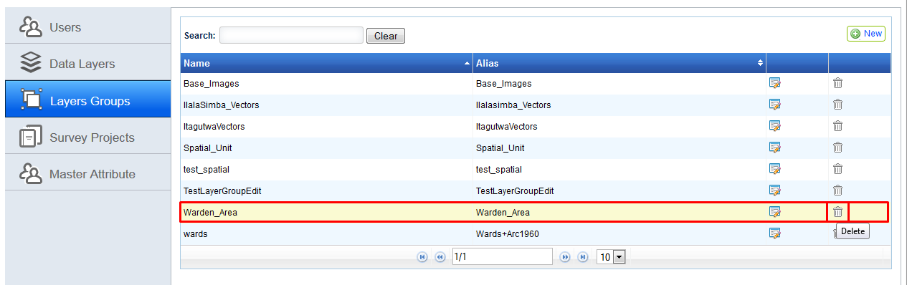Click on ‘Delete’ option associated with layer group record, which is to be deleted.

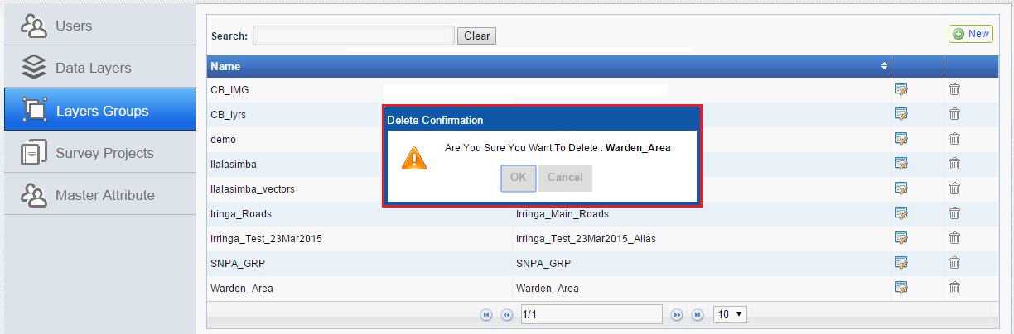

1. Application will display a confirmation message. Click on 'OK' button.
2. Selected 'Layer Group' will be deleted.
3. Application will display an acknowledgement message.

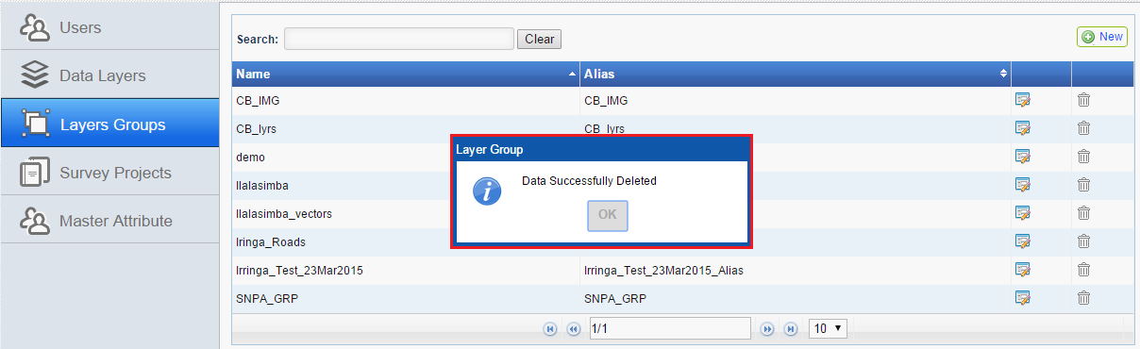

# Survey Projects

'Survey Projects' functionality facilitates administrator user to define survey projects in the System. Survey project functionality will provide the facility to manage all the details of a particular data collection project.

Following information sets are defined in a survey project.

* + - General Information of survey project – including country and region details of project
    - Users who will have access to the project in mobile application as well as for Data management application
    - Data Layers and layer groups which will be accessed and viewable in the project in mobile and web application

'Survey Projects' functionality provides following set of functionalities for creation and management of survey projects.

* + - Add Survey Project
    - Edit Survey Project
    - Delete Survey Project

## Add Survey Project

This facilitates administrator user to create new survey projects in the System.

**Steps:**

1. Login into the system with role as ‘Administrator’ and click on ‘Launch’ link available in ‘Administration Tool’ section.
2. Click on ‘Survey Projects' section available in left. Details of available survey projects will be displayed in grid along with associated ‘Edit’ and ‘Delete’ options. On right top, ‘New’ button will be available.
3. Click on ‘New’ button. Following accordions will be displayed

|  |  |
| --- | --- |
| * General | * Land Adjudication Committee Member(s) |
| * Layer Group | * Disclaimer |
| * Project Configuration | * Assign Users |
| * Hamlet |  |

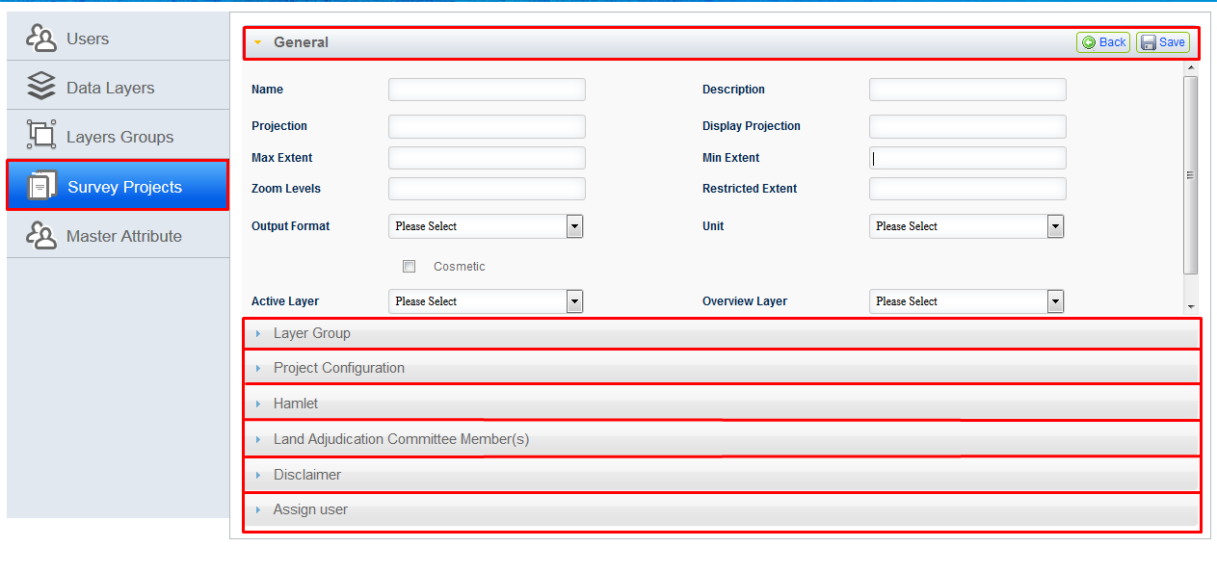

1. By default, 'General' accordion will be expended showing following input options

|  |  |
| --- | --- |
| * Name input box | * Description input box |
| * Projection input box | * Display Projection input box |
| * Max Extent input box | * Min Extent input box |
| * Zoom Levels input box | * Restricted Extent input box |
| * Output Format dropdown | * Unit dropdown |
| * Cosmetic check box | * Overview Layer dropdown |
| * Active Layer dropdown |  |

1. 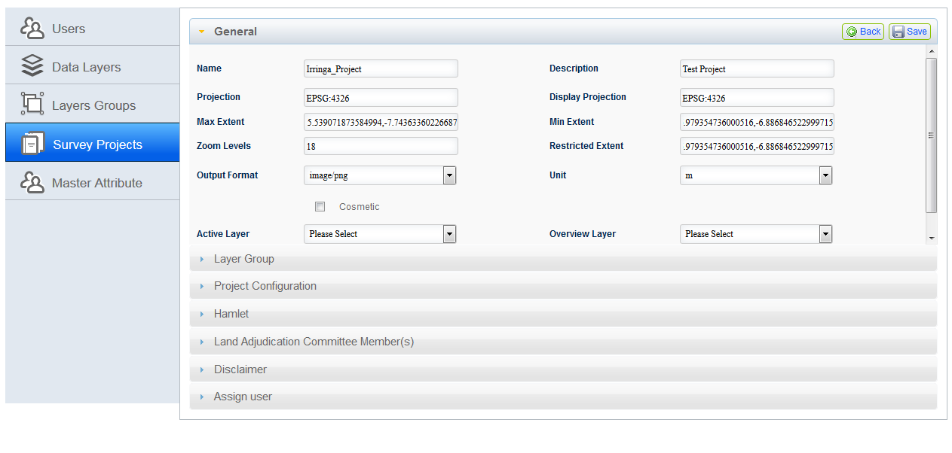Provide valid inputs for all input options. 'Active Layer' and 'Overview Layer' drop downs will be empty. Values in these drop downs will be populated depending upon layers selected in 'Layer Groups' accordion.
2. Click on 'Layer Groups' accordion.
3. Select option in drop down, Depending upon selected value, Base layers will be populated in 'Base Layers' drop down.
4. All existing layer groups will be available in 'Layer Groups' list along with check and sorting option.
5. 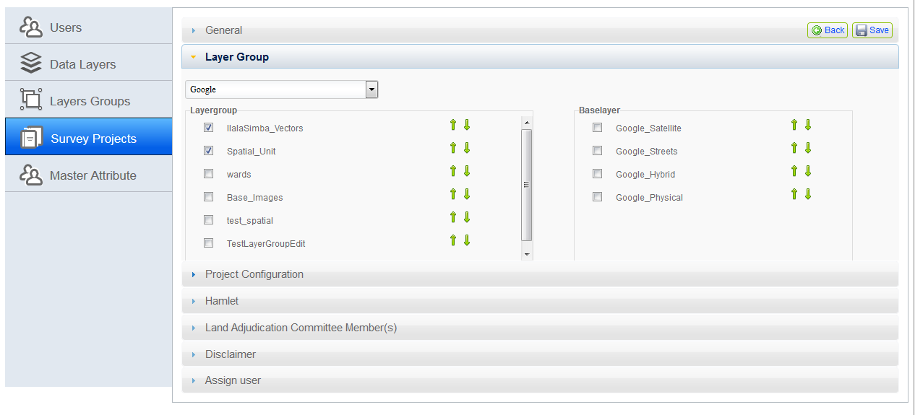Select layer groups and base layers which are to be configured for project.
6. 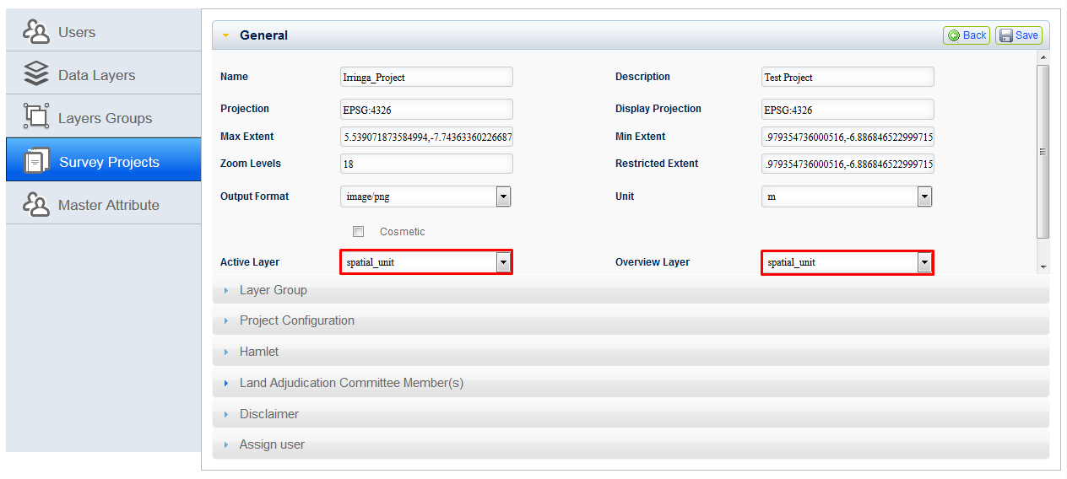Click on 'General' accordion, Select 'Active Layer' and 'Overview Layer' in corresponding dropdowns.
7. Click on 'Project Configuration' accordion. following input options will be available

|  |  |
| --- | --- |
| * Country | * Region |
| * District | * Village |
| * Village Code | * Village Postal Code |
| * Village Chairman | * Executive Officer |
| * Land District Officer |  |

1. 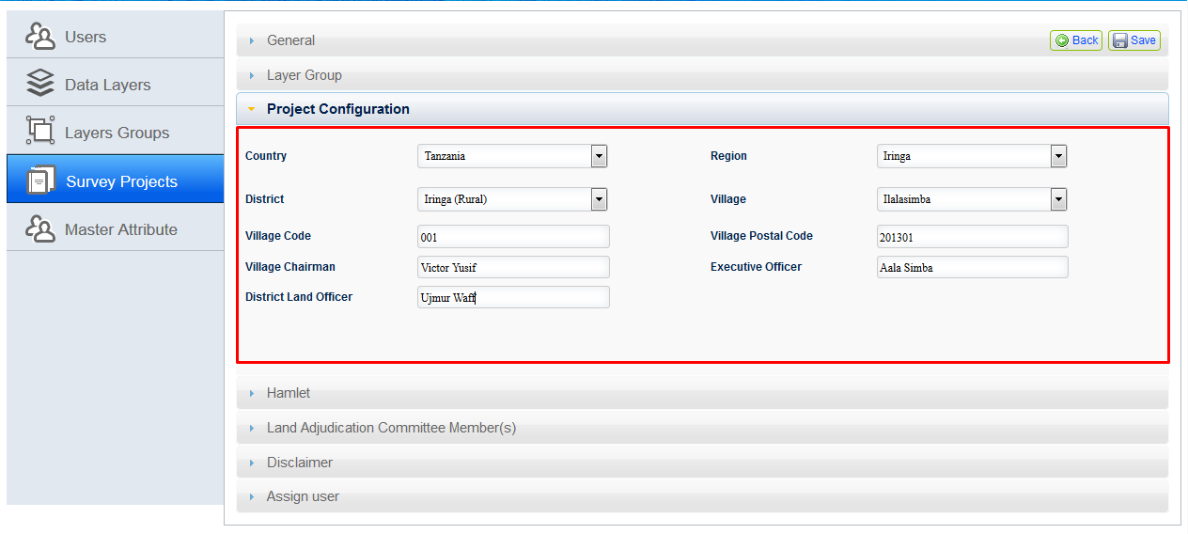Select country, values for 'District', 'Region' and 'Village' will be populated. Select required values.
2. Click on ‘Hamlet’ accordion. Click on ‘New’ button. Hamlet dialogue box will be displayed.
3. Provide valid details and click on ‘Save’ button.

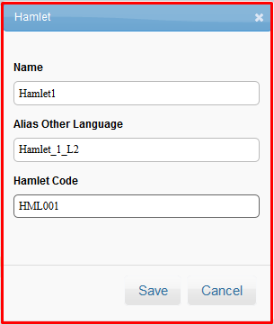

1. On successful creation of Hamlet, Hamlet details will become available in grid along with edit and delete options.

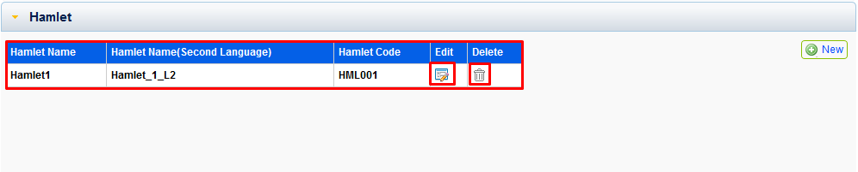

1. Click on ‘Land Adjudication Committee Member(s)’ accordion. Click on ‘New’ button. ‘Project Adjudicator’ dialogue box will be displayed.
2. Provide adjudicator name in corresponding input box and click on ‘Save’ button.

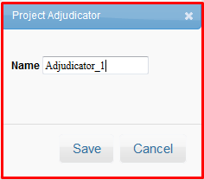

1. 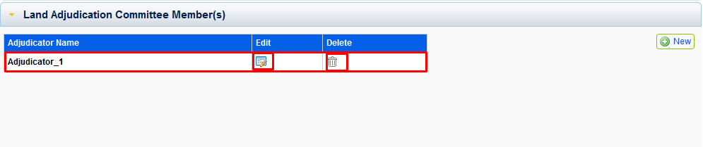On successful creation of adjudicator, corresponding details will become available in grid along with edit and delete options.
2. Click on 'Disclaimer' accordion. Check the 'Disclaimer' check box.
3. 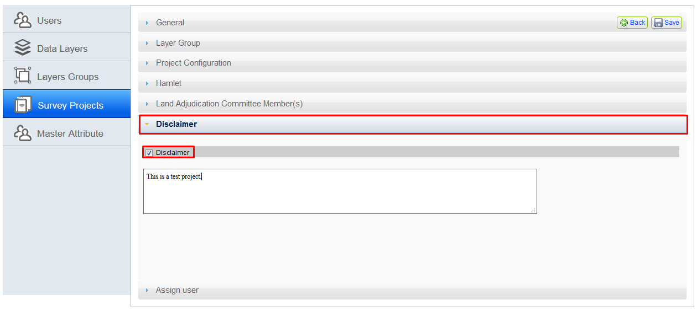'Disclaimer' input box will be displayed. Enter disclaimer text in 'Disclaimer' input box.
4. 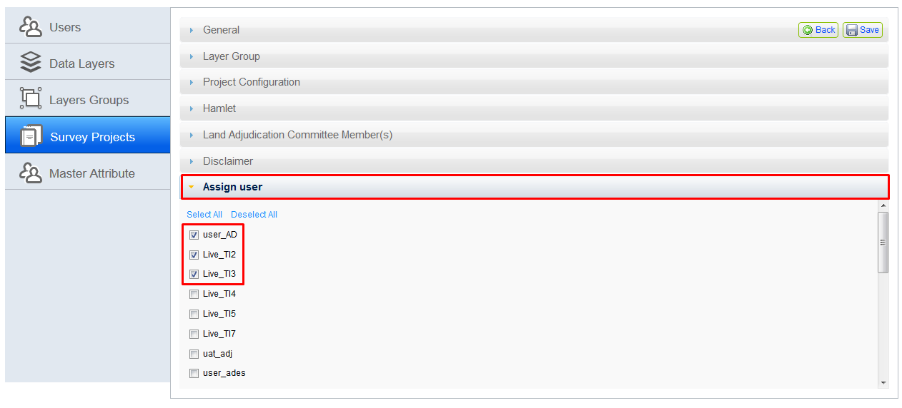Click on 'Assign Users' accordion. All existing users will be displayed in user list along with a check box. Check the check box associated with users, whom projects is to be assigned.
5. Click on 'Save' button. Application will display an acknowledgement message.

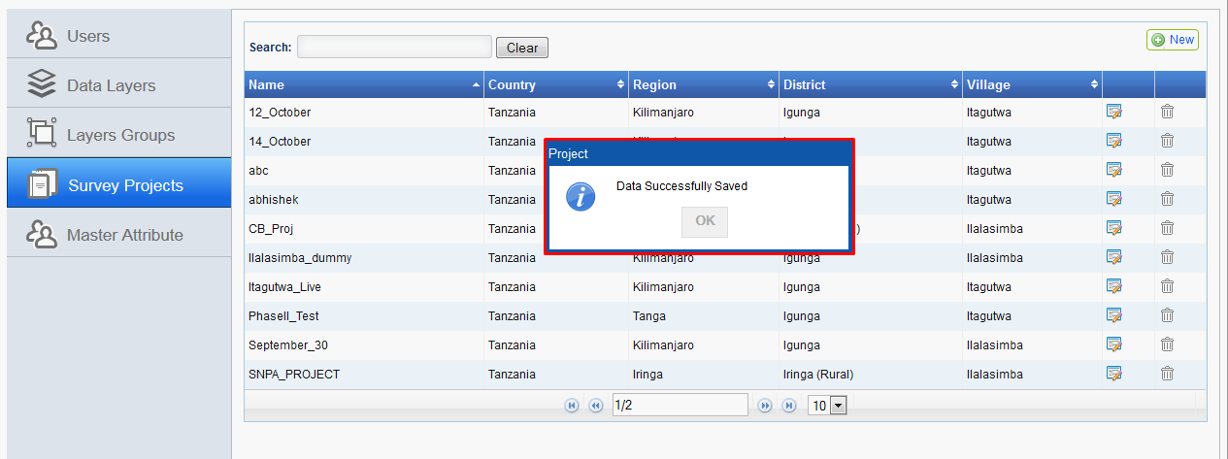

1. 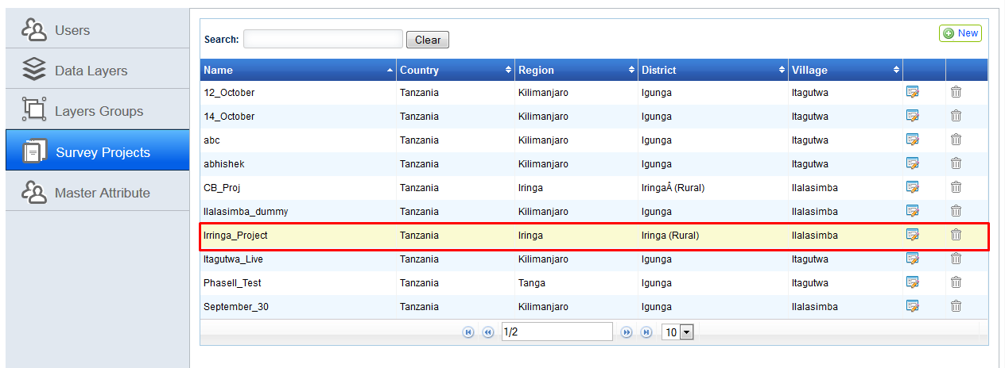New project will be created and will be available in project list.

## Edit Survey Project

‘Edit Survey Project’ functionality facilitates administrator user to edit the details of any existing project.

**Steps:**

1. Login into the system with role as ‘Administrator’ and click on ‘Launch’ link available in ‘Administration Tool’ section.
2. Click on ‘Survey Projects' section available in left. Details of available survey projects will be displayed in grid along with associated ‘Edit’ and ‘Delete’ options.

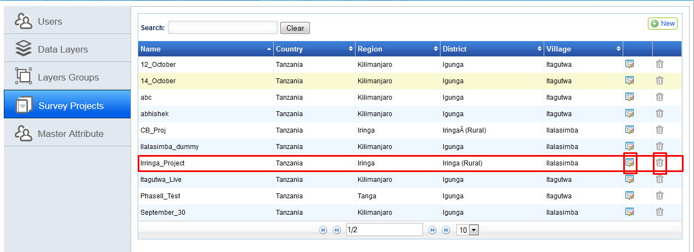

1. 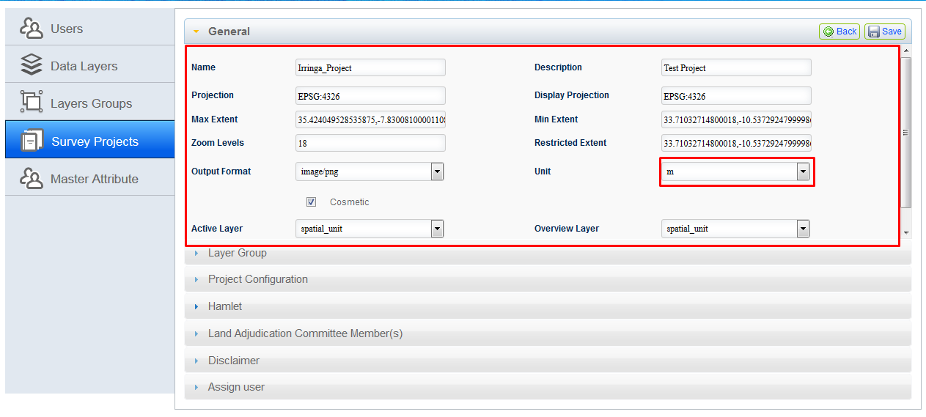Click on ‘Edit’ option associated with project detail, which is to be edited. Project details will be available in edit mode, by default; ‘General’ accordion will be expended. Edit details as required. ‘Project Name’ will be non-editable.
2. 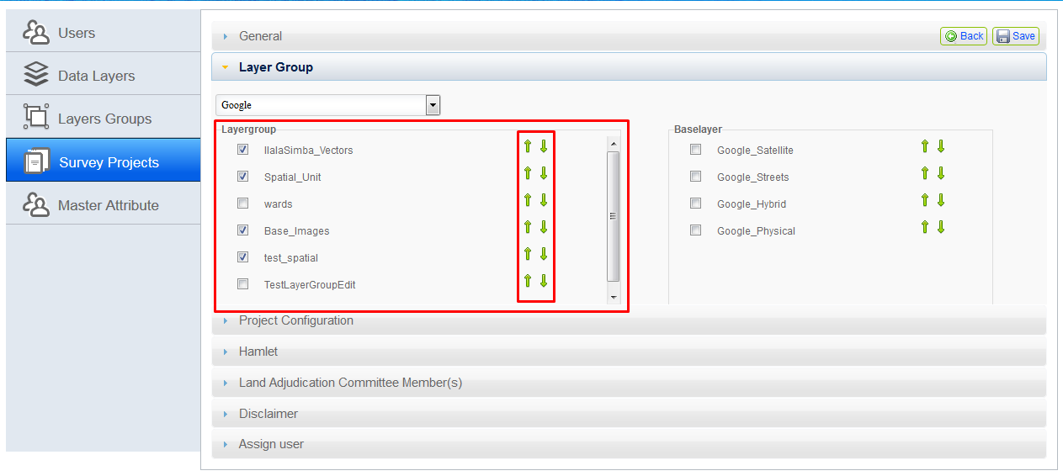Click on ‘Layer Groups’ accordion and edit required changes like adding new layer, changing sorting or removing layer.

1. 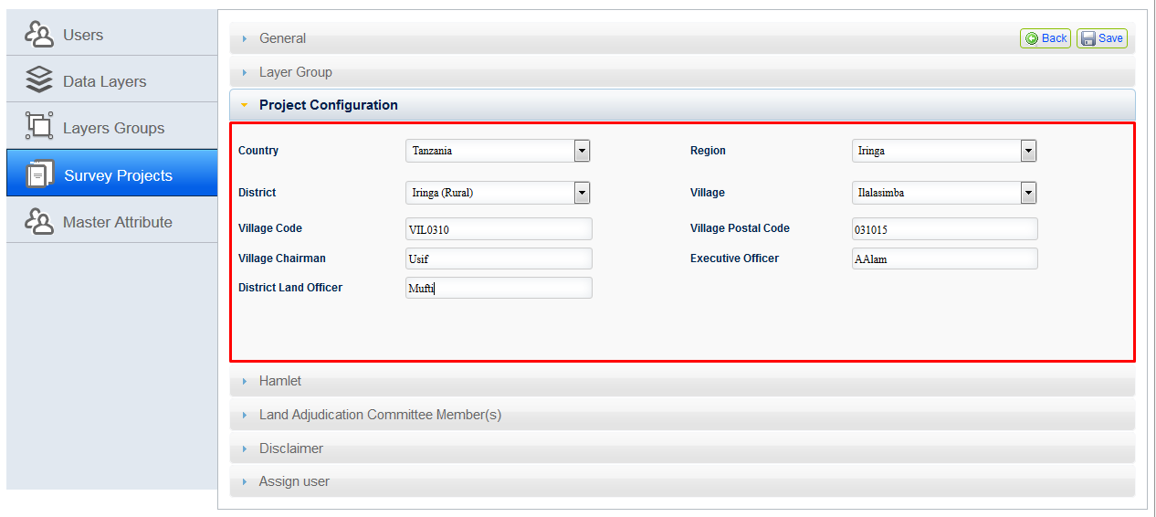Click on ‘Project Configuration’ accordion and edit required changes.
2. Click on ‘Hamlet’ accordion. Click on edit option associated with hamlet detail. To delete hamlet, click on delete option.

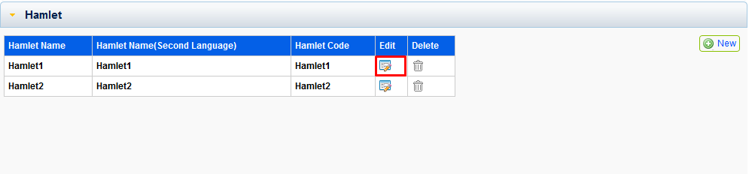

1. Hamlet dialogue box will be displayed, perform required editing and click on ‘Save’ button.

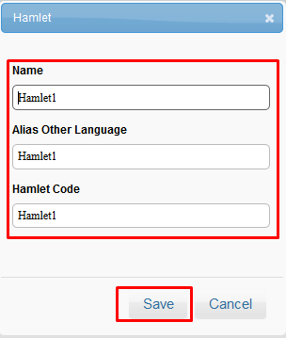

1. Click on ‘Land Adjudication Committee Member(s)’ accordion. Click on edit option associated with adjudicator detail. To delete adjudicator, click on delete option.

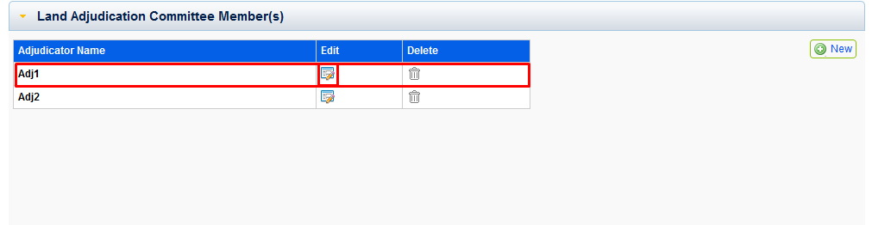

1. ‘Project Adjudicator’ dialogue box will be displayed, performs required editing and click on ‘Save’ button.

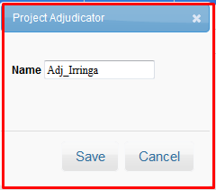

1. 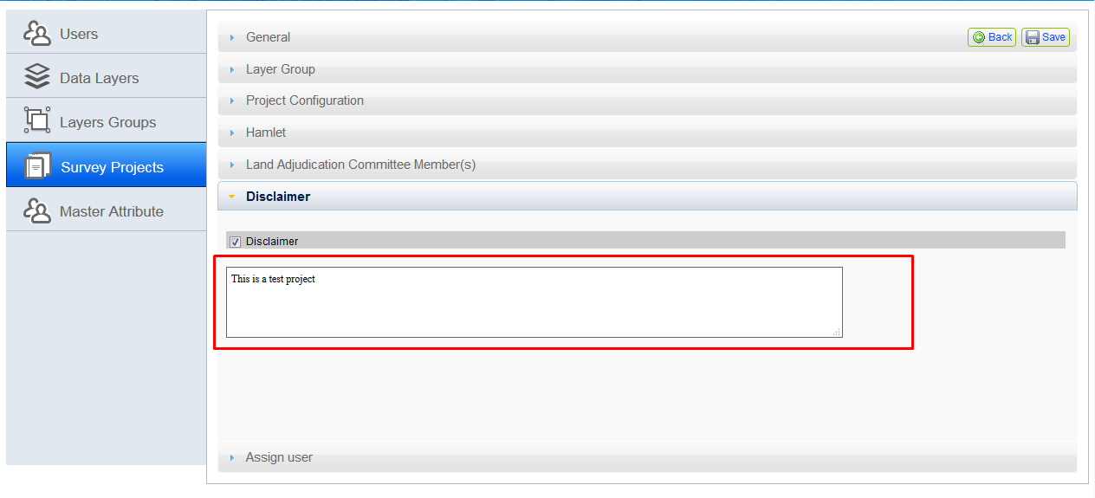Click on ‘Disclaimer’ accordion and edit Disclaimer text’ if required.
2. Click on ‘Assign Users’ accordion and add or remove users for the project.

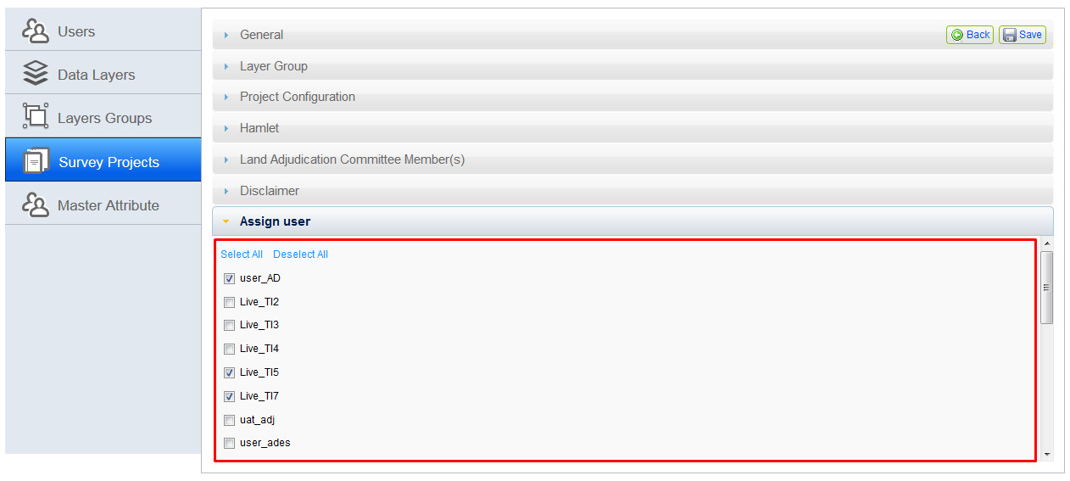

1. 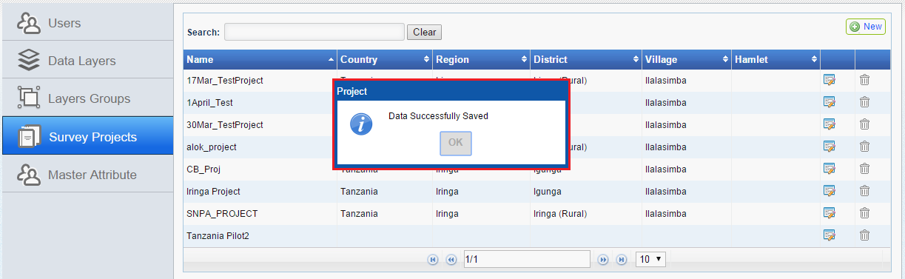Click on ‘Save’ button. Application will save edited details and will display an acknowledgement message.

## Delete Survey Project

‘Delete Survey Project’ functionality facilitates administrator user to delete any existing project.

**Steps:**

1. Click on ‘Survey Projects’ section available in left. Details of available projects will be displayed in grid along with associated ‘Edit’ and ‘Delete’ options.
2. 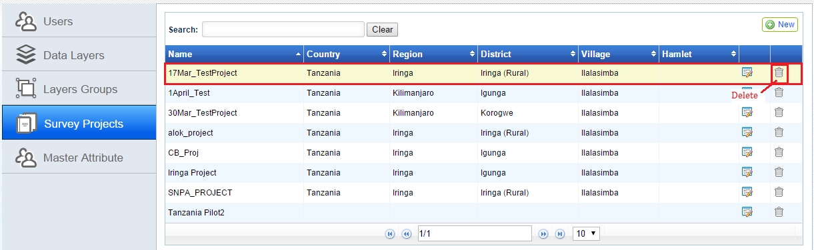Click on ‘Delete’ option associated with project detail, which is to be deleted.
3. 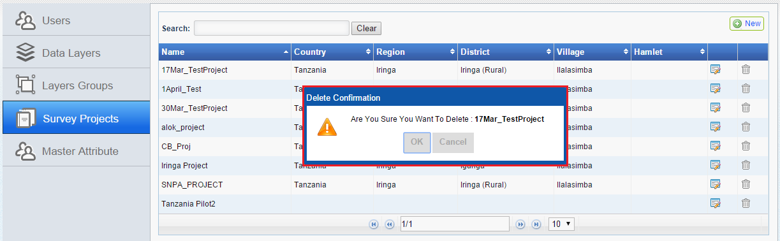Application will display a confirmation message.
4. 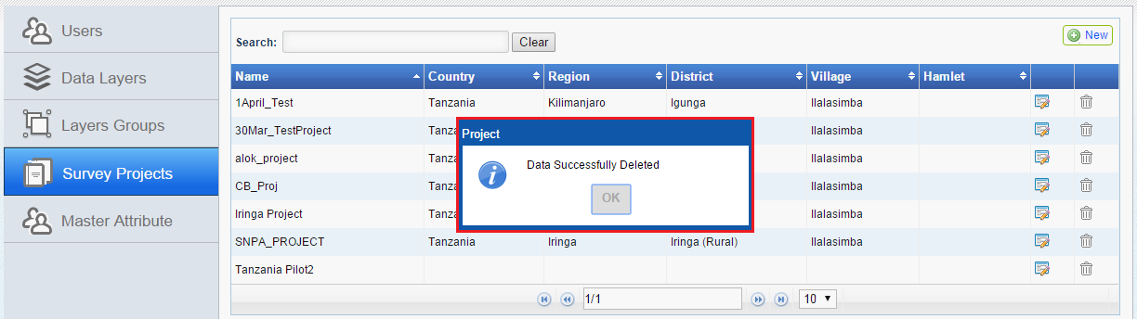Click on 'OK' button. Selected 'Survey Project' will be deleted. Application will display an acknowledgement message.

# Master Attribute

‘Master Attribute’ functionality facilitate administrator user to manage attributes which are to be used for configuration of a project to be accessed by MAST mobile application. This functionality enables admin user to add/edit or delete custom attribute in following categories.

* + - General
    - Multimedia
    - Tenure
    - Non Natural Person
    - Natural Person
    - Custom
    - General (Properties)
    - 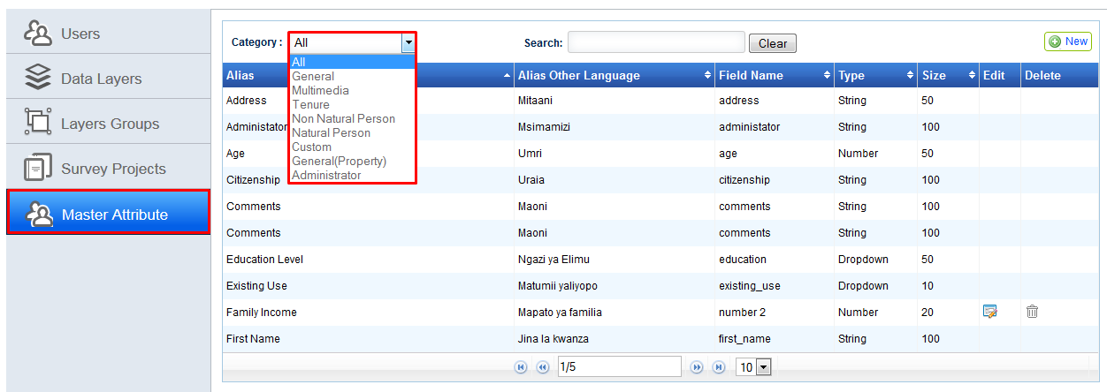Administrator

Following are the functionalities that are available with this.

* + - View attributes category wise
    - Add Attributes
    - Edit Attributes
    - Delete Attributes

Edit and Delete options will be associated with attributes other then default one.

## View attributes category wise

This facilitates admin user to view attributes of any selected category.

**Steps:**

1. Login into the system with role as ‘Administrator’ and click on ‘Launch’ link available in ‘Administration Tool’ section.
2. Click on ‘Master Attribute' section available in left. Details of available attributes (default and custom) will be displayed in grid. Custom attributes will be available with associated ‘Edit’ and ‘Delete’ options. In Left top, ‘New’ button will be available.
3. 'Category' drop down and 'Search' option will be available that facilitate user to view attributes of selected categories only and search a particular attribute.
4. 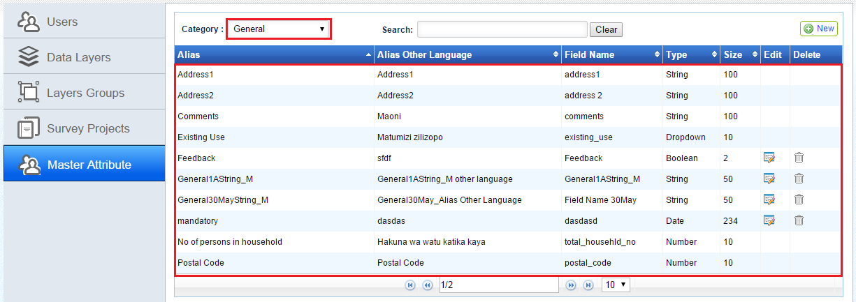Select any category in 'Category' drop down. Corresponding attributes will be displayed in grid.

## Add Attributes

‘Add Attribute’ functionality facilitate administrator user to add new attribute in specified category.

**Steps:**

1. 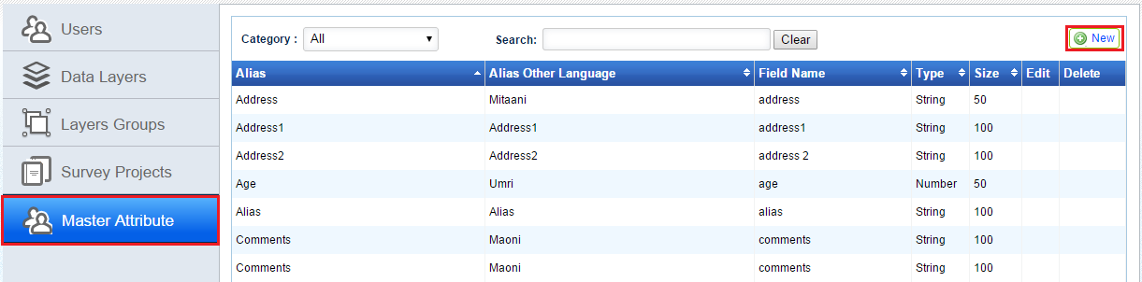Click on ‘Master Attribute' section available in left. Details of available attributes (default and custom) will be displayed in grid. In Left top, ‘New’ button will be available.
2. Click on 'New' button. Add Attribute’ dialogue will be displayed with following input options

|  |  |
| --- | --- |
| * ‘Alias’ input box | * ‘Size’ input box |
| * ‘Alias Other Language’ input box | * ‘Category’ dropdown |
| * ‘Field Name’ input box | * ‘Mandatory’ check box |
| * ‘Data Type’ dropdown |  |

1. 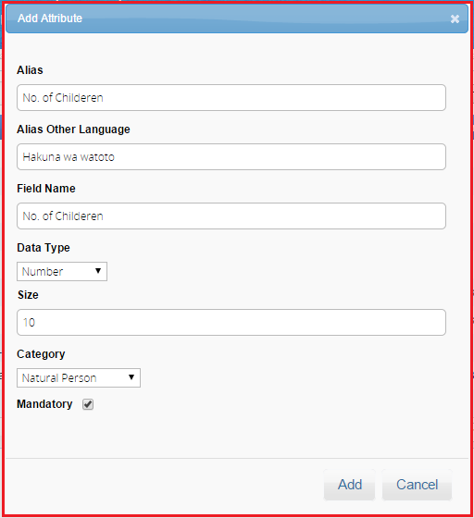Provide valid inputs in required input options
2. 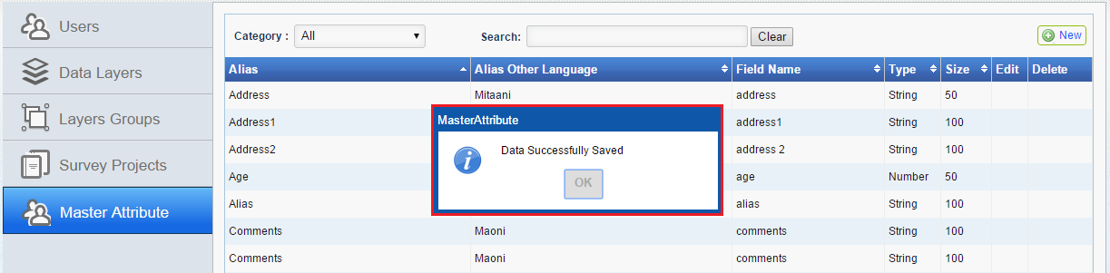Click on ‘Add’ button. Application will display an acknowledgement message.

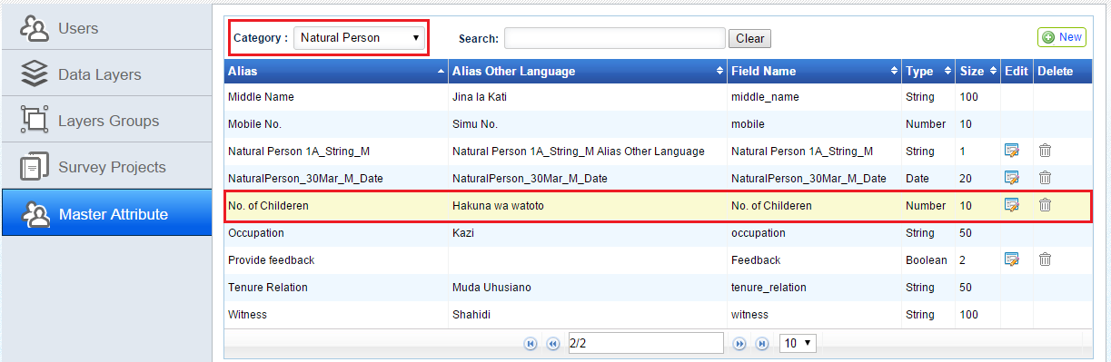

1. Newly added attribute will be available in grid.

## Edit Attributes

‘Edit Attribute’ functionality facilitate administrator user to edit details of custom attribute

**Steps:**

1. 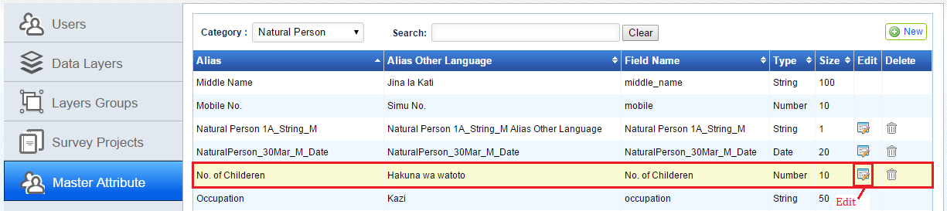Click on ‘Master Attribute' section available in left. Details of available attributes (default and custom) will be displayed in grid. Custom attributes will be available with associated ‘Edit’ and ‘Delete’ options.
2. 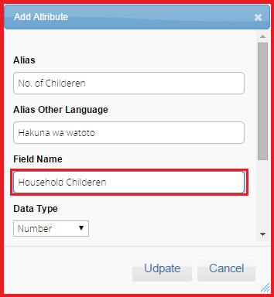Click on ‘Edit’ option associated with attribute detail, which is to be edited. A dialogue will be displayed with attribute details in edit mode.
3. 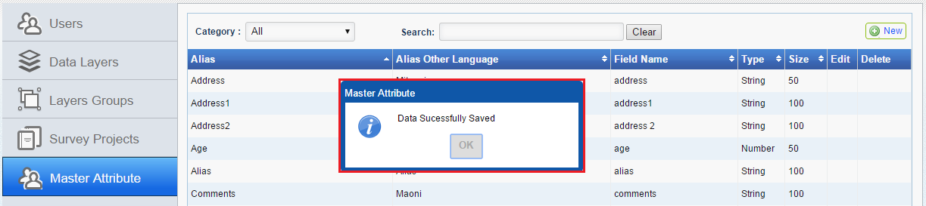Edit the required details and click on ‘Update’ button. Application will display an acknowledgement message.

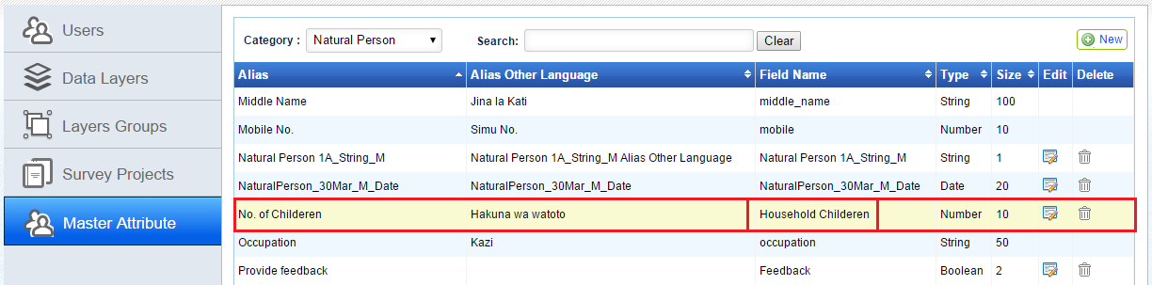

1. Updated details of attribute will be available in grid.

## Delete Attributes

‘Delete Attribute’ functionality facilitate administrator user to delete any custom attribute

**Steps:**

1. 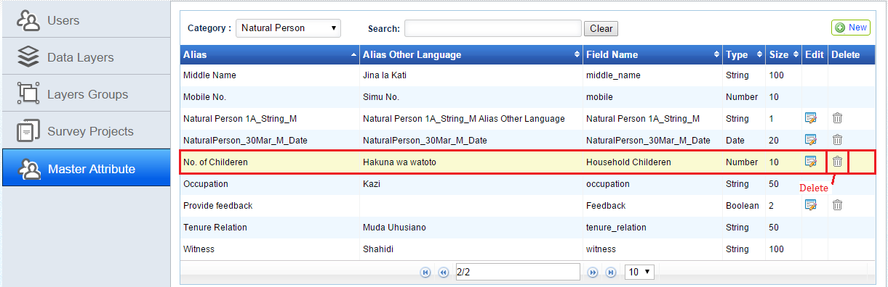Click on ‘Master Attribute' section available in left. Details of available attributes (default and custom) will be displayed in grid. Custom attributes will be available with associated ‘Edit’ and ‘Delete’ options.
2. 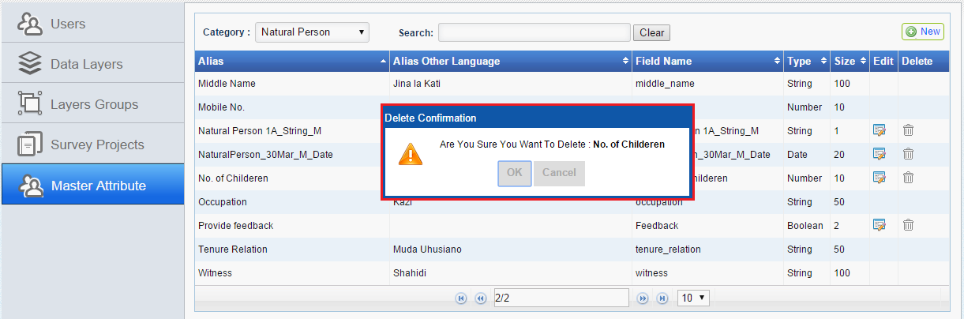Click on ‘Delete’ option associated with attribute detail, which is to be deleted. Application will display a confirmation message.
3. 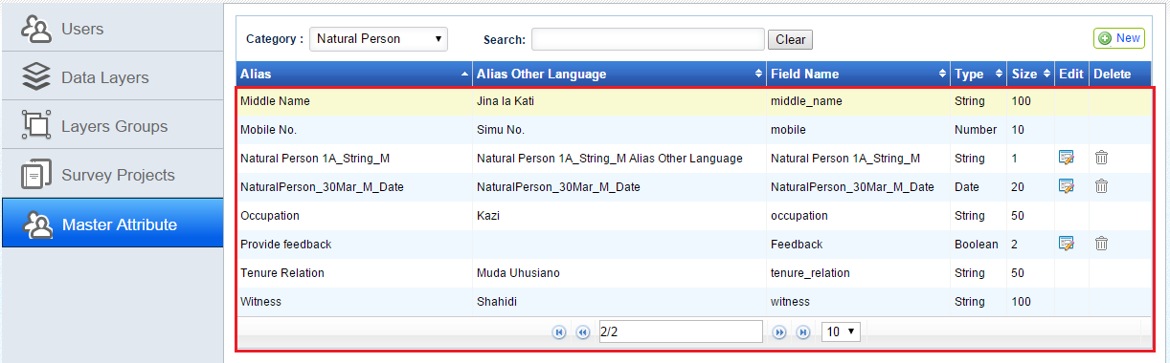Click on ‘OK’ button, Specified attribute will be deleted and will not be available in grid any more.

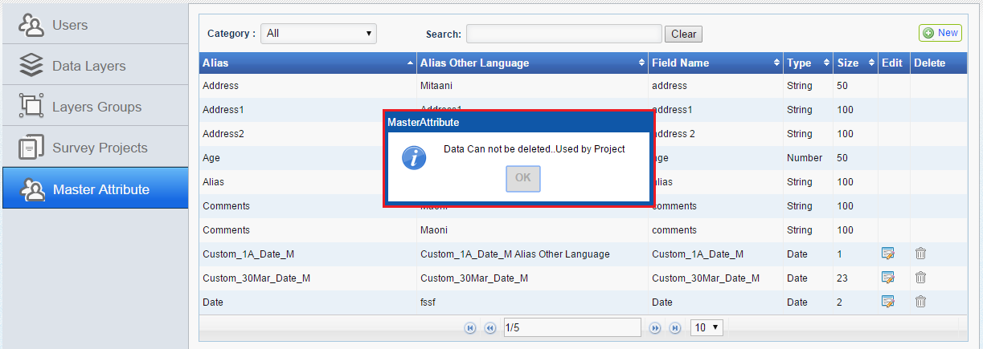**Note: If Administrator user attempts to delete an attribute which is already used in any project, Application will not delete such attribute and will display a relevant message.**

1. Mobile Configuration Tool

'Mobile configuration tool' facilitates user to configure mobile application according to project requirement. This module provides the functionality to configure the project attributes that will be collected using the mobile data capture application in the field.

Whenever a new survey project is created in the system, Project Manager/Administrator user will configure the attributes which will be utilized in the mobile data capture application to collect land rights information in the field for that specific project.

**Steps:**

1. Login into the system with role as ‘Administrator/Project Manager’.
2. 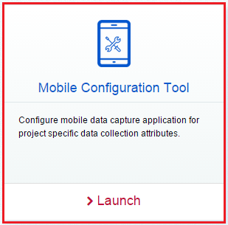Click on ‘Launch’ link available in ‘Mobile Configuration Tool’ section.
3. User will be navigated to ‘Mobile Configuration Tool’ page.

Following functionalities will be available with 'Mobile Configuration Tool'.

* + - Configure Attribute
    - 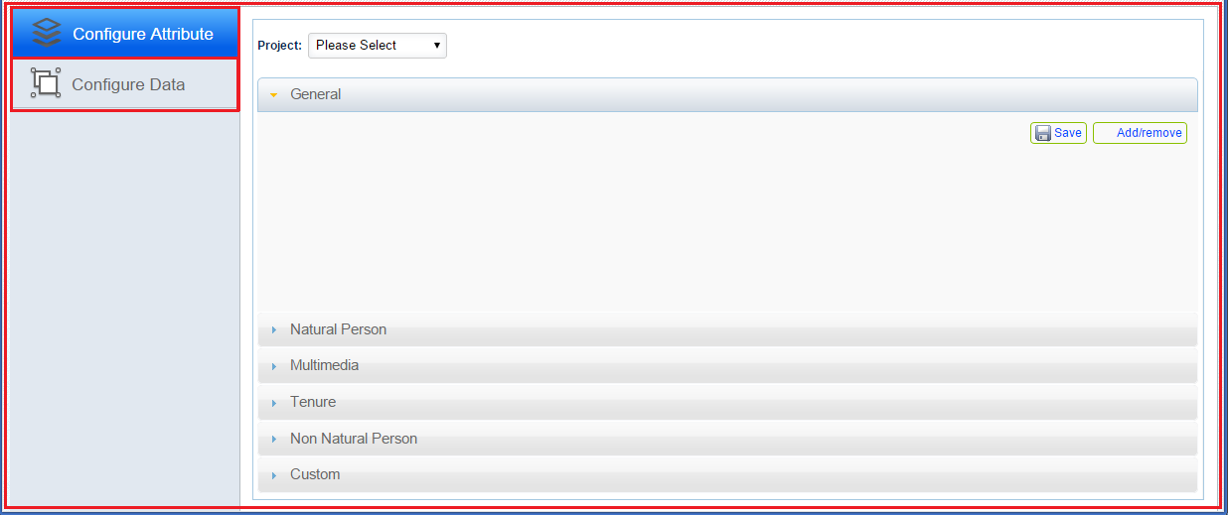Configure Data

# Configure Attribute

This functionality will allow the user to configure project attributes in the project from the master attribute repository.

**Steps:**

1. Login into the system with role as ‘Administrator / Project Manager’.
2. Click on ‘Launch’ link available in ‘Mobile Configuration Tool’ section.
3. By default, ‘Configure Attribute' option available in left panel will be selected. Following options will be available in main window
   * + ‘Project’ Drop down
     + 'General' Accordion
     + 'General Property' Accordion
     + 'Natural Person' Accordion
     + 'Multimedia' Accordion
     + 'Tenure' Accordion
     + 'Non Natural Person' Accordion
     + 'Custom' Accordion

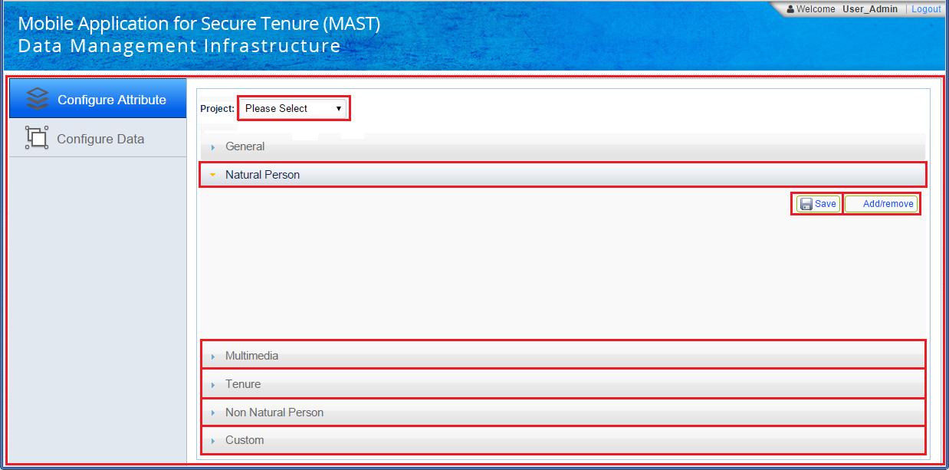In every accordion, there will be 'Save' and 'Add/Remove' button.

'Configure Attribute' provides following set of functionalities for managing attributes.

* + - Add Attributes
    - Remove Attributes

## Add/remove Attributes

‘Add Attributes’ functionality facilitate administrator to add/remove attributes in specific category of a selected project.

**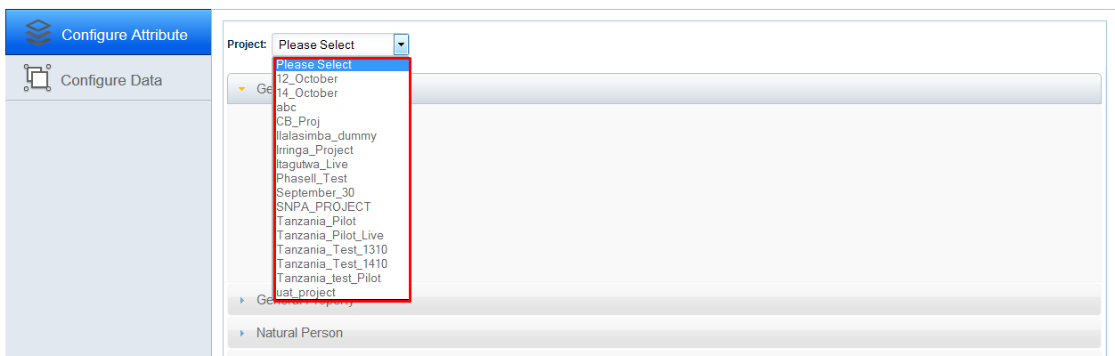Steps:**

1. Click on ‘Project’ drop down. Application will display all available projects.
2. Select project in corresponding dropdown, for which attributes are to be configured.
3. Click on ‘Add/Remove’ button, ‘’Attributes’ dialogue box will be display showing all attributes of corresponding category.
4. There will a check box associated with every attribute, Check required attribute.

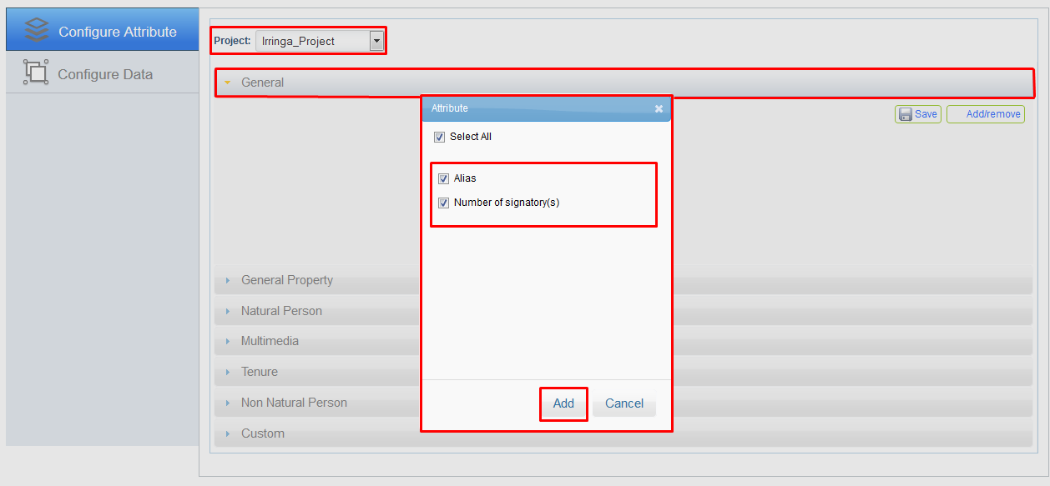

1. 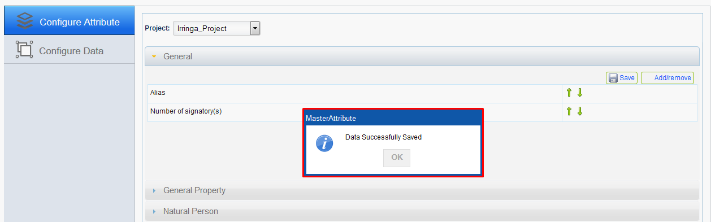 Click on ‘Add’ button. Application will display an acknowledgement message.
2. Once attributes are saved, user can set the ordering using ‘Up’ and ‘Down’ arrows associated with attributes.

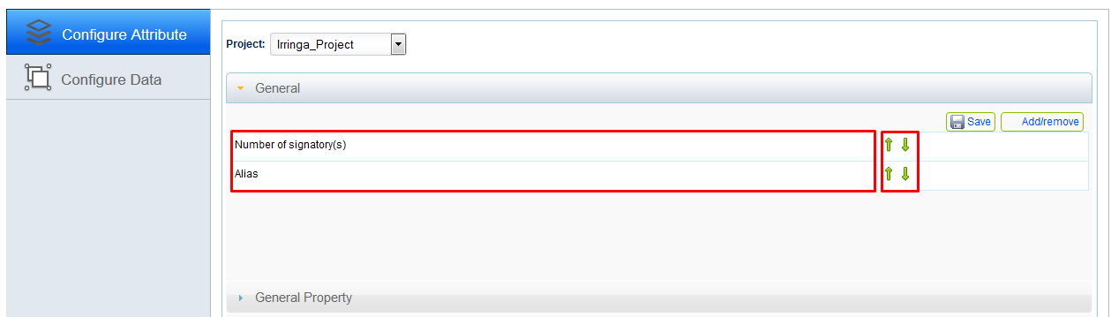

1. Click on ‘General Property’ accordion and add/Remove required attributes.

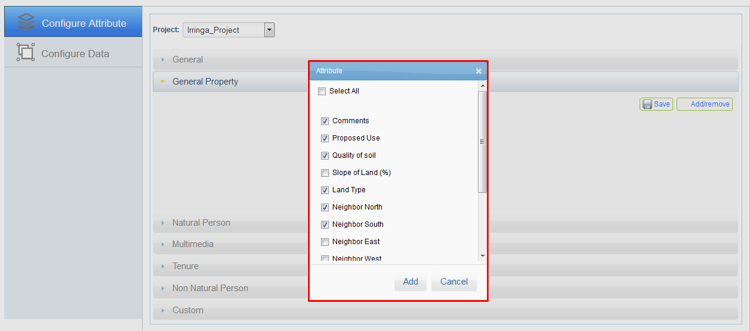

1. 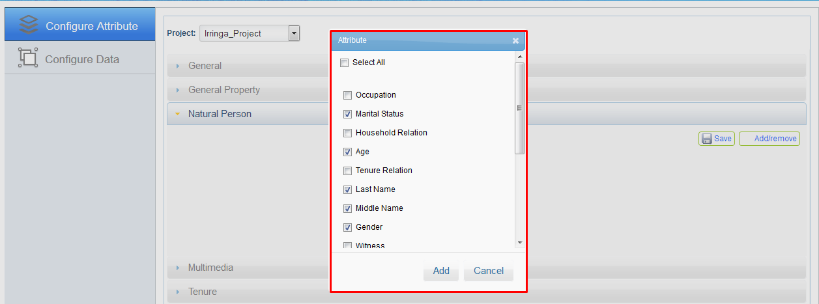Click on ‘Natural Person’ accordion and add/Remove required attributes.
2. Click on ‘Multimedia’ accordion and add/Remove required attributes.

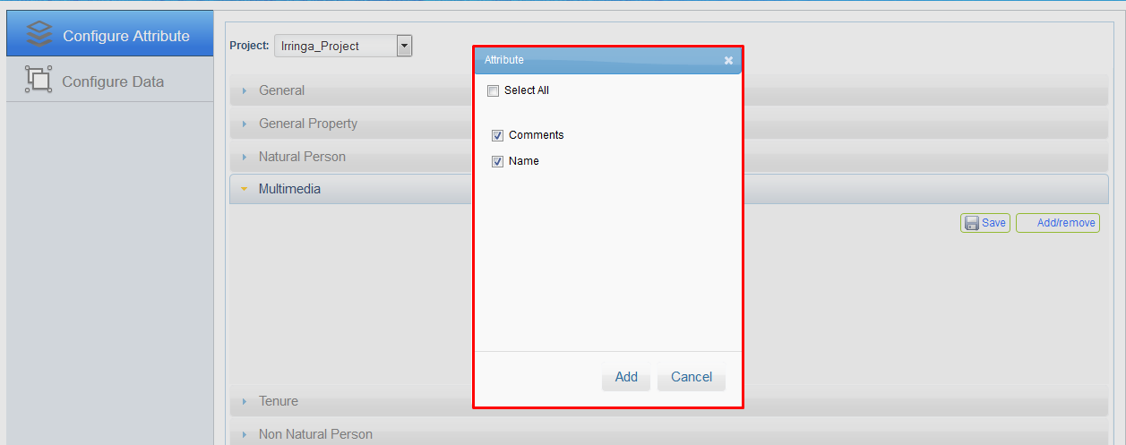

1. 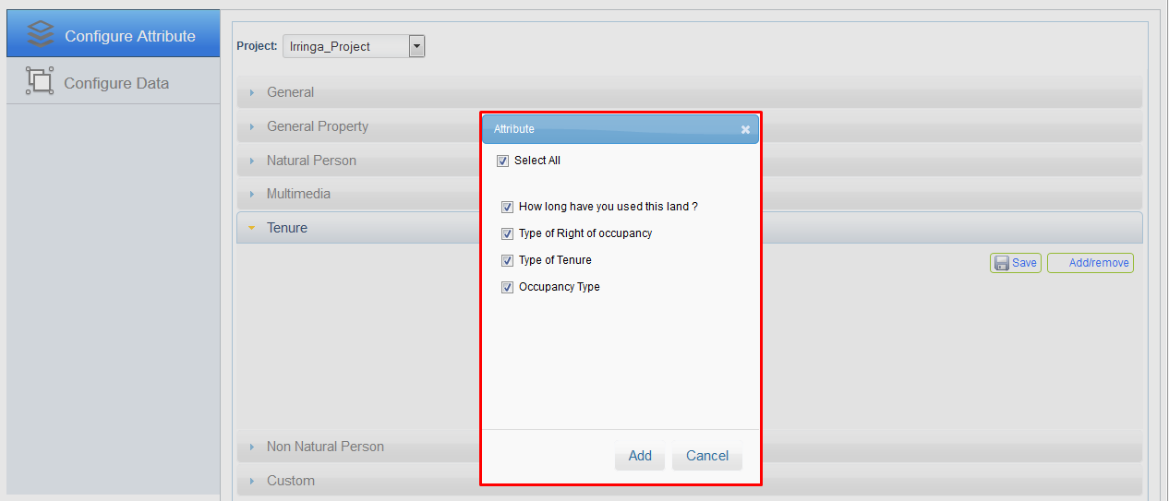Click on ‘Tenure’ accordion and add/Remove required attributes.
2. 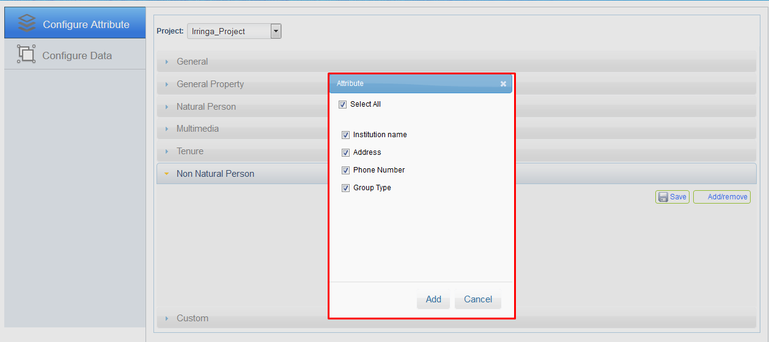Click on ‘Non Natural Person’ accordion and add/Remove required attributes.
3. 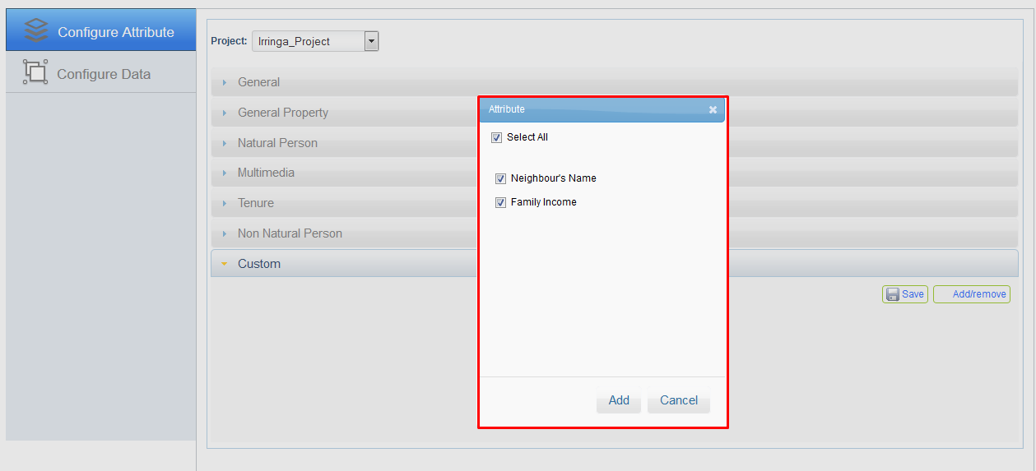Click on ‘Custom’ accordion and add/Remove required attributes.

# Configure Data

This module will provide the functionality to upload and configure the spatial data that can be downloaded on mobile device for reference purposes for data collection work in offline mode.

## Upload MBTiles

This functionality will allow the user to upload spatial data on server and configure it for a specific survey project.

**Steps:**

1. 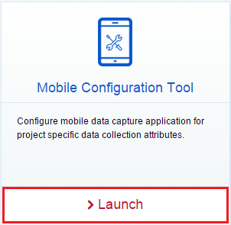Login into the system with role as ‘Administrator / Project Manager’. Click on ‘Launch’ link available in ‘Mobile Configuration Tool’ section.
2. 'Mobile Configuration Tool' page will be displayed. Click on ‘Configure Data' option available in left panel.
3. Available projects along with details of uploaded data will be displayed in grid. There will be a delete option associated with data record.
4. To upload data for a specific project, following options will be available.
   * + 'Select Project' drop down
     + 'Alias' Input box
     + 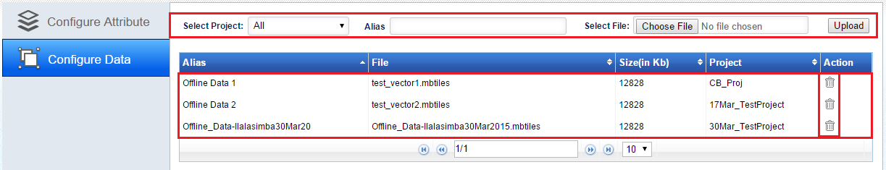'Select File' browse tool
5. 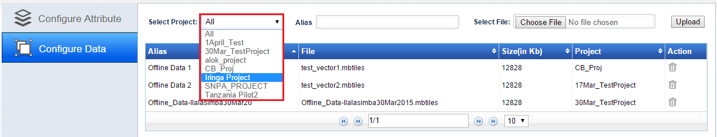Click on ‘Select Project’ drop down, list of available projects will be displayed.
6. Select required project, for which data is to be uploaded.
7. 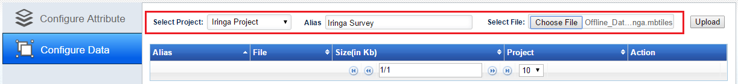Enter alias name in corresponding input box.
8. Click on ‘Choose File’ option and locate required ‘MBTiles’ to be uploaded.
9. Click on ‘Upload’ button. Once data is uploaded successfully, application will display an acknowledgement message.
10. 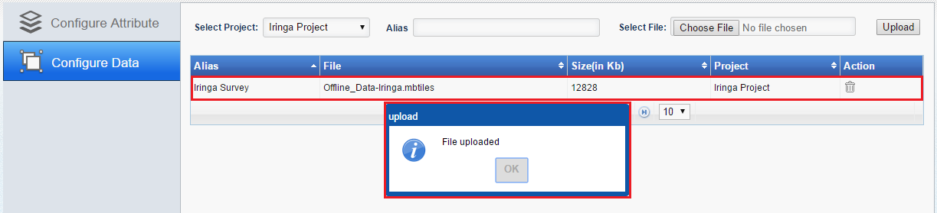Details of uploaded data and corresponding project will be displayed in grid.
11. Data Management Tool

Land Rights Data Management Infrastructure web application of MTP Framework provides a 'Land Data management' tool to manage land records collected in the field. This tool provides facility to authorized users to view, edit, review and approve data of spatial unit along with attributes and multimedia information collected in the field.

Project manager and Land Administration Officials can access the land data management tool to view data of allocated project and can further generates Reports on approved land records.

The key functionalities that are provided in the Land Data Management tool are:

* + - Map viewer
    - Land Records Dashboard

**Steps:**

1. Login into the system with role as ‘Administrator / Project Manager’. Click on ‘Launch’ link available in ‘Data Management’ section.
2. 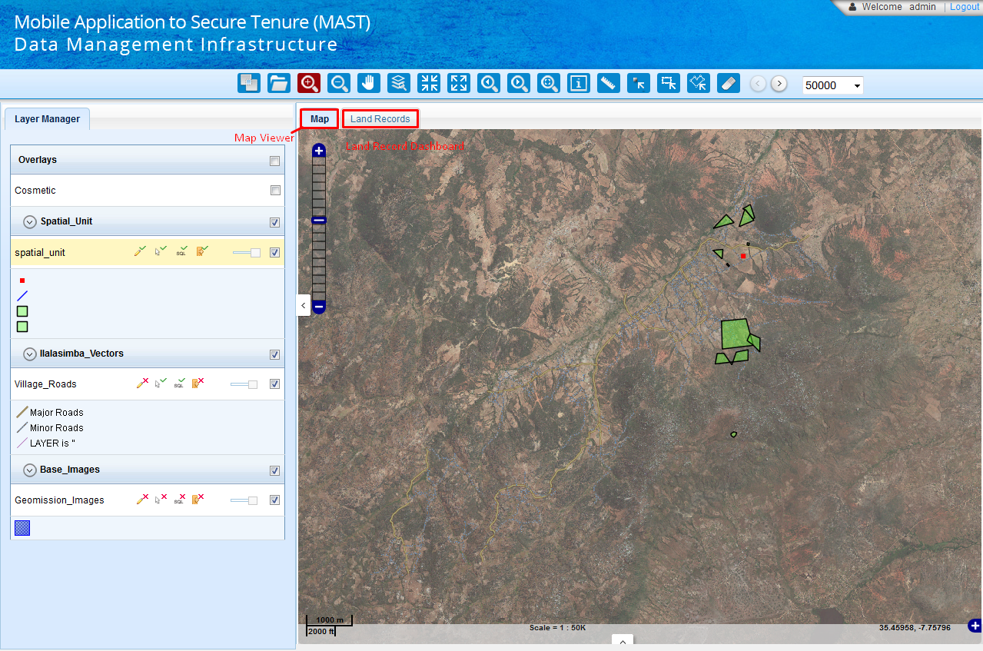‘Land Management Tools’ page will be displayed. By default, ‘Map Viewer’ will be available.

# Map viewer

'Map viewer' is the main screen part shown on the right hand panel of page with 'Map' tab, where user will be able to see the parcels of selected corresponding/assigned project on Map.

This functionality provides the functionality of map viewer in land data management tool. Map Viewer display all the base data layers configured for the project along with the display of spatial data of properties/spatial units collected in the field.

Following functionalities are provided by Administration Tool

* + - Layer Manager
    - Mapping Tools

## Layer Manager

This functionality provides the listing of layers configured for the selected project. User can display on/off a particular layer from the Layer Manager to view on the map.

Layer control functionality is provided to the users on map view control to control the display of selected layers on map (only project specific layers can be selected for display on/off).

Layer manager is the part of the application where user can see the layers group and associated layers of every layer group. The layer manager allows user to see the access rights on that layer and allows users to change the opacity of layers, hide or make visible the content of layers and layers groups. User can collapse and expand the layers group content on layer manager.

The layer manger’s first layers group will be Overlays as default, it contains cosmetic layer (if added to the user’s project by administrator).The Overlays layers group and its layers will be hidden on map canvas and boxes will be unmarked when the application initiated. As the application gets initiated, a layer highlighted with some colour (in fig.5, layer ‘RoW Path’ highlighted with yellow colour) is the active layer. This is by default active layer as it set by administrator. User can make any other layer as active by clicking on that layer in layer manager. Most of the tools work only on active layer.

To hide the layers group’s content, click on the icon in front of layers group name. It will collapse the member layers of that layers group. To expand it again, click on that icon again. Now to off the layers group’s content on map canvas, unmark the check box of that layers group and to make it visible mark the check box. Access on a layer can be seen on hovering on the images behind the layer name. It will show the access of user on that layer as Editable, Selectable, Queryable and Exportable. If these accesses are not on that layer, these images will have cross mark on them and on hovering mouse on them, it shows access as Not Editable, Not Selectable, Not Queryable and Not Exportable.

For a layer, user is allowed to set the layer opacity and he can on/off the layer features on map. To change the visibility of layer on map, move the slider of opacity bar towards left. Moving it to left will decrease the visibility of layer. To hide the layer features, unmark the check box of layer. Below the layer, symbols and description used for the layer can be seen.

User is also allowed to hide/unhide left panel (Layer Manager). For this task, there is an arrow mark on the mid of the panel. To hide the left panel, click on the mark. Clicking that icon again will make the left panel visible.

## Mapping Tools

Application facilitates user with tools to access map and use the map details as well as creating new and edit existing parcels.

Map viewer provides has navigation tools like zoom, pan etc. It also has other functionalities like measure, thematic, search, and search by coordinate, attributes query, and editing etc. A tool, which is being used currently, gets highlighted with red colour in tool bar.

**Steps:**

1. Login into the system with role as ‘Administrator / Project Manager’. Click on ‘Launch’ link available in ‘Data Management’ section.
2. ‘Land Management Tools’ page will be displayed. By default, ‘Map Viewer’ will be available.

Following are the tools available with map viewer.

|  |  |
| --- | --- |
| * Spatial Validation | * Select |
| * Open Project | * Select By Rectangle |
| * Zoom in | * Select By Polygon |
| * Zoom out | * Clear |
| * Pan | * Search |
| * Zoom to layer | * Zoom to XY |
| * Fixed Zoom in | * Print |
| * Fixed Zoom out | * Query Builder |
| * Zoom Previous | * Bookmark |
| * Zoom Next | * Export Data |
| * Full Zoom | * Mark up |
| * Info | * Editing |
| * Measure |  |

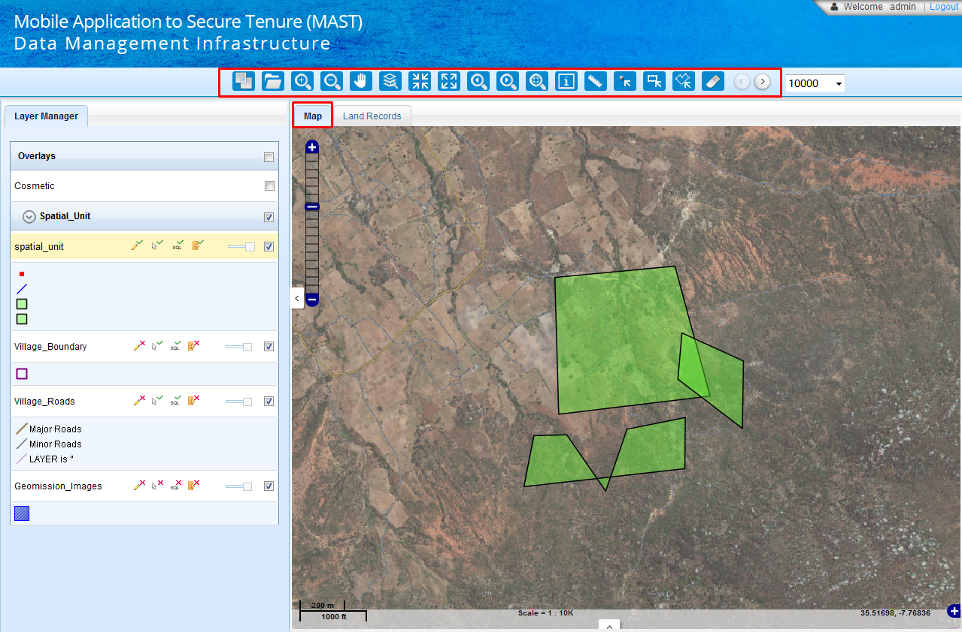

### Spatial Validations

‘Spatial Validations’ functionality facilitates user to validate parcels on map. If any validation error i.e. Intersecting or invalid geometry, is found in any of the parcel, this tool will help to trace that feature on map. User can specify parcels to be verified by drawing rectangle or based on selected hamlet.

**Steps:**

1. Login into the system with role as ‘Administrator / Project Manager’. Click on ‘Launch’ link available in ‘Data Management’ section.
2. ‘Land Management Tools’ page will be displayed. By default, ‘Map Viewer’ will be available.
3. Click on ‘Spatial Validation’ available in tool bar.



1. ‘Spatial Validation’ dialogue box will be displayed with following options.
   * + Select All
     + Select By Rectangle
     + Select By Hamlet

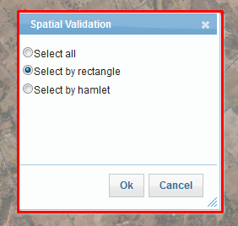

**Select All:**

‘Select all’ option facilitates user to validate all parcels of current active project.

**Steps:**

1. Select ‘Select all’ radio button available in ‘Spatial Validation’ dialogue box.
2. Click on ‘Ok’ button.
3. Application will perform spatial validation on all the spatial units belonging to current project.
4. Validation result will be displayed in Summary section.

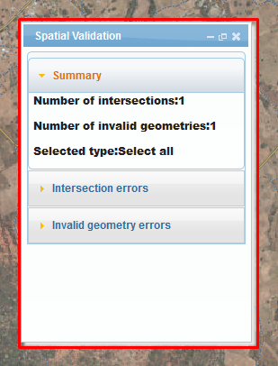

1. To see the detail of error, click on corresponding accordion. No of errors will be displayed in dropdown.

**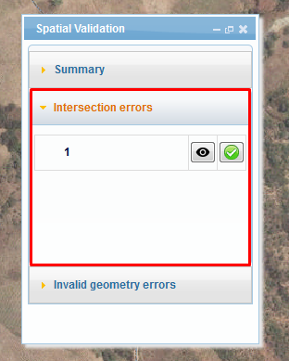**

1. Click on ‘Zoom’ option, map will be zoomed in on specified erroneous parcel.

**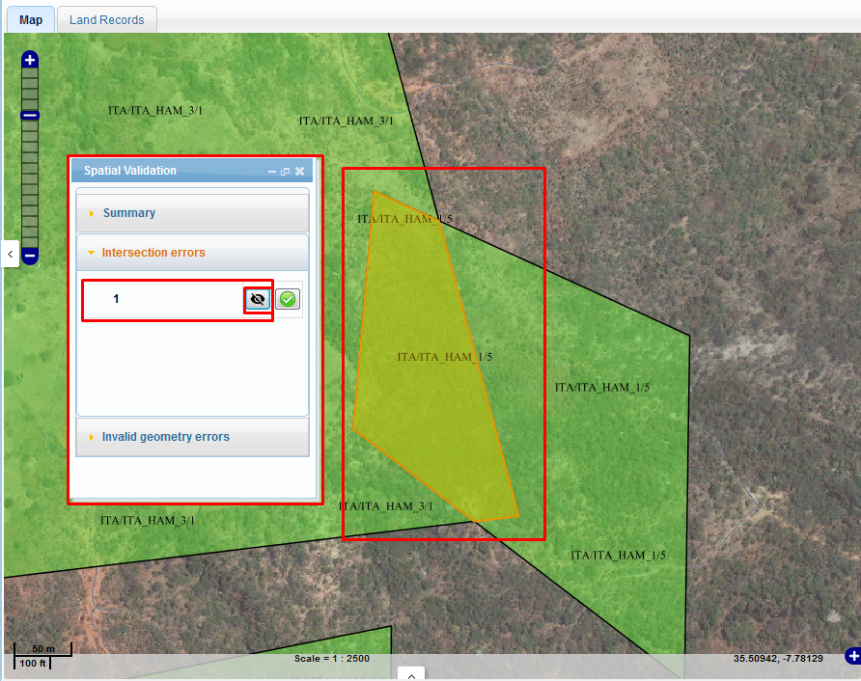**

**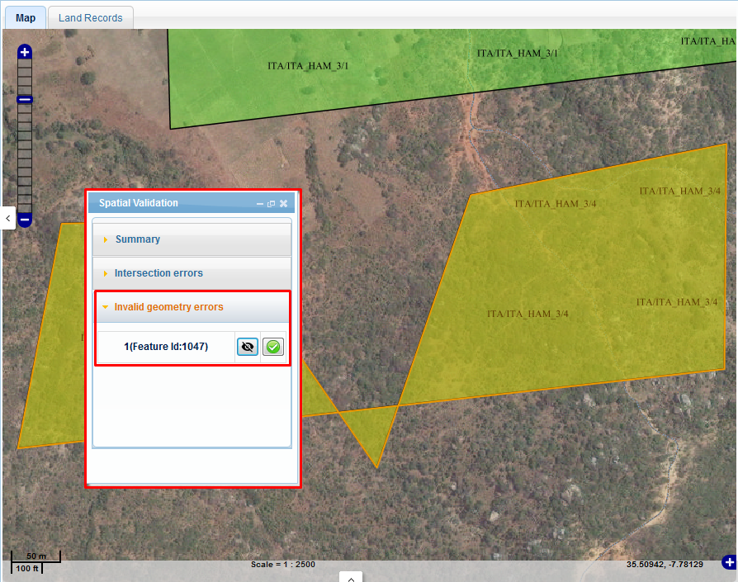**

**Select by rectangle:**

‘Select by rectangle’ option facilitates user to validate parcels which lies in drawn rectangle.

**Steps:**

1. Select ‘Select by rectangle’ radio button available in ‘Spatial Validation’ dialogue box and click on ‘Ok’ button.
2. Draw a rectangle on map covering parcels which are to be validated.

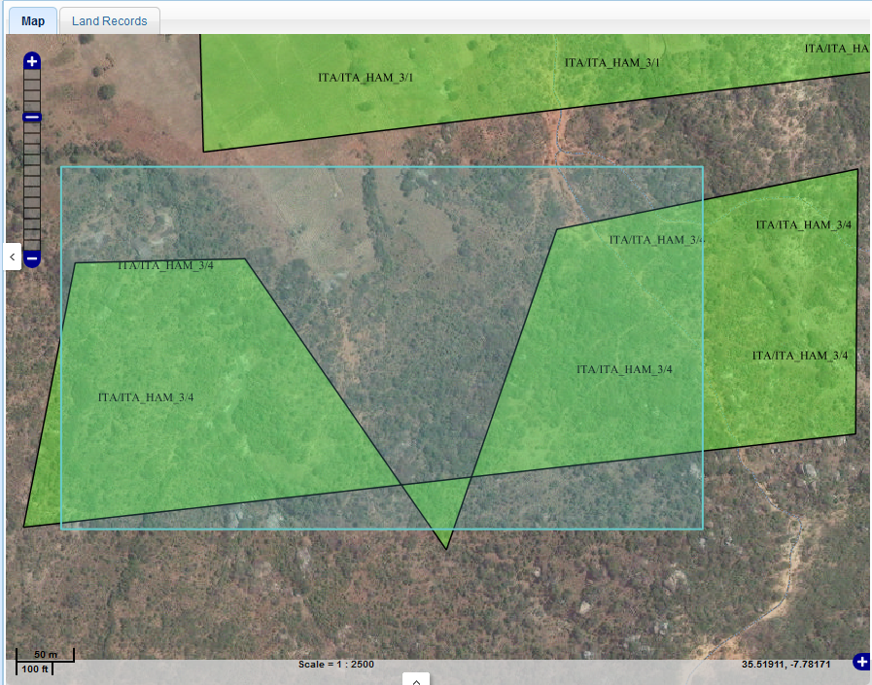

1. 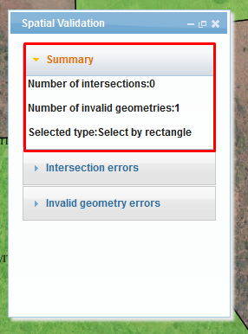Application will validate parcels covered under rectangle and validation result will be displayed in summary section. Details of errors can be seen by clicking on corresponding accordions.

**Select By Hamlet**

‘Select by Hamlet’ option facilitates user to validate parcels belonging to specified hamlet.

**Steps:**

1. Select ‘Select by hamlet’ radio button available in ‘Spatial Validation’ dialogue box, hamlet dropdown will be displayed with all available hamlets.

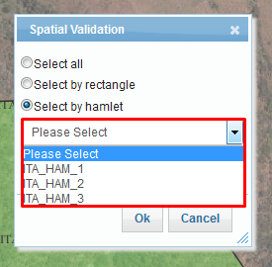

1. Select hamlet in dropdown, click on Ok button.
2. Application will validate parcels of specified hamlet and validation result will be displayed in summary section. Details of errors can be seen by clicking on corresponding accordions

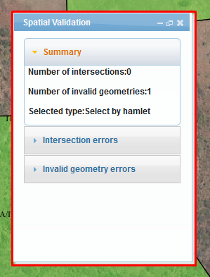

### Open Project

‘Open Project’ functionality facilitates user to select the working Project for which land data management work is to be done. This is the first step in the land records management tool and thereafter all the data accessible in the land data management tool will be for the selected and authorized project.

**Steps:**

1. Login into the system with role as ‘Administrator / Project Manager’. Click on ‘Launch’ link available in ‘Data Management’ section.
2. ‘Land Management Tools’ page will be displayed. By default, ‘Map Viewer’ will be available.
3. Click on ‘Open Project’ available in tool bar.
4. 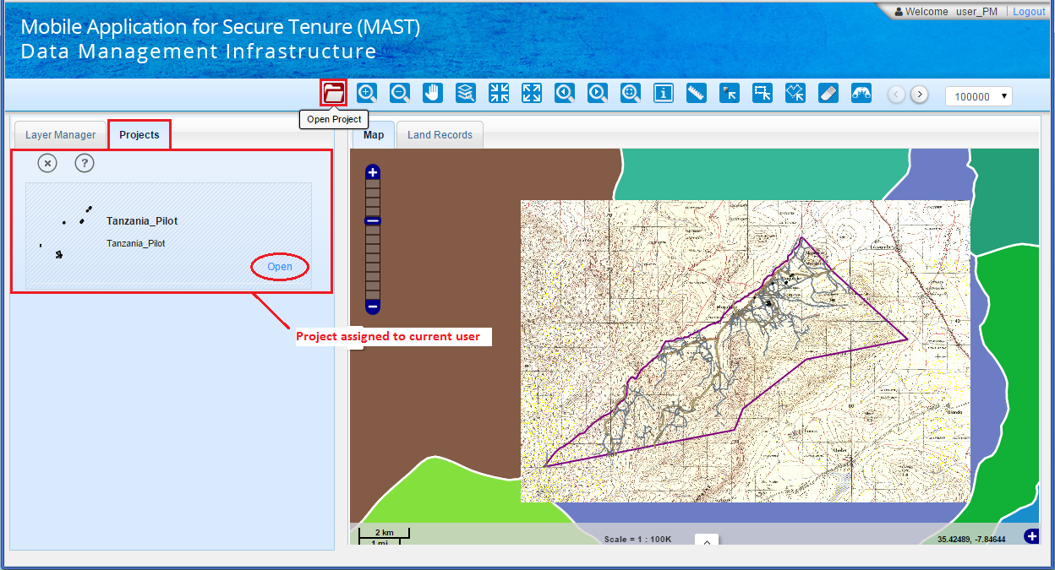‘Projects’ tab will be displayed showing list of all projects assigned to login user. There will be an ‘Open’ link associated with every project.
5. Click on ‘Open’ link.
6. Data like ‘layers groups’, parcels on land base and ‘Land Records’ of selected project will be available in ‘Map Viewer’ and ‘Land Records’ dashboard.

**Note: If a user switches to another project then he can switch to the default project by clicking on “Default button”**

### Zoom in

‘Zoom In’ tool facilitates users to zoom in a particular area or location.

**Steps:**

1. Click on the ‘Zoom In’ tool available in tool bar.
2. Click on the map view at that location. Application will zoom in map to that location by a predefined extent.
3. To zoom in to a specific extent, click on the tool and draw a rectangle at required location on the map canvas. Application will zoom in the area to an extent such that the area inside the rectangle will cover the entire map canvas.

### Zoom out

‘Zoom Out’ tool facilitates users to zoom out the map view.

**Steps:**

1. Click on ‘Zoom Out’ tool available in tool bar.
2. Click on map canvas at a required location. Application will zoom out the map vies to fixed extent. The location where user clicked will be at the centre of map canvas.
3. To zoom out to a greater extent click on the ‘Zoom Out’ tool and draw a rectangle. Application will zoom out the map view to a map extent according to drawn rectangle (smaller rectangle will result in larger zoom out on map view).

### Pan

‘Pan tool’ facilitates users to pan the map view.

**Steps:**

1. Click on the ‘Pan Tool’ available in tool bar.
2. Click on the map. Without releasing the mouse button, move the map in desired direction and release the button at desired location.
3. Application will pan the map in that direction till mouse button release.

### Zoom to layer

‘Zoom to layer’ tool facilitates users to zoom to the extent of a particular layer.

**Steps:**

1. First make that layer active layer then click on the ‘Zoom to Layer’ tool available in tool bar.



1. Application will zoom in/out the map view to fit the map view to the layer’s extent.

### Fixed Zoom in

‘Fixed Zoom In’ tool facilitates users to zoom in the map to a fixed scale.

**Steps:**

1. Click on the ‘Fixed Zoom In’ tool available in tool bar.
2. Application will zoom in the map view to a predefined ratio of scale and the slider of zoom bar will move one steps towards ‘+’sign.

### Fixed Zoom out

‘Fixed Zoom Out’ tool facilitates users to zoom out the map with a fixed scale.

**Steps:**

1. Click on ‘Fixed Zoom Out’ tool available in tool bar.
2. Application will zoom out the map to a fixed ratio of scale and the zoom bar’s slider will move one step towards the ‘–‘sign.

### Zoom Previous

‘Zoom previous’ tool facilitates user to go to the previous zoom level of map. This tool can be used only if user has worked on more than a static map view for a browser session.

**Steps:**

1. Click on the ‘Zoom Previous’ tool available in tool bar.
2. Application will zoom to the previous view of the current view.

### Zoom Next

‘Zoom Next’ tool facilitates users to go to the next extent of map. This tool can be used only if the ‘Zoom Previous’ tool is already used.

**Steps:**

1.  Click on the ‘Zoom Next’ tool available in tool bar.
2. Application will zoom to the next view of current view which user has visited earlier.

### Full Zoom

‘Full Zoom’ tool facilitates users to zoom to full extent of current project.

**Steps:**

1. Click on ‘Full Zoom’ tool available in tool bar.
2. Application will zoom in/out the map according to current extent, to take map to project’s extent.

### Map Info

‘Info’ tool facilitates users to see the attributes of a parcel by clicking on it.

**Steps:**

1. 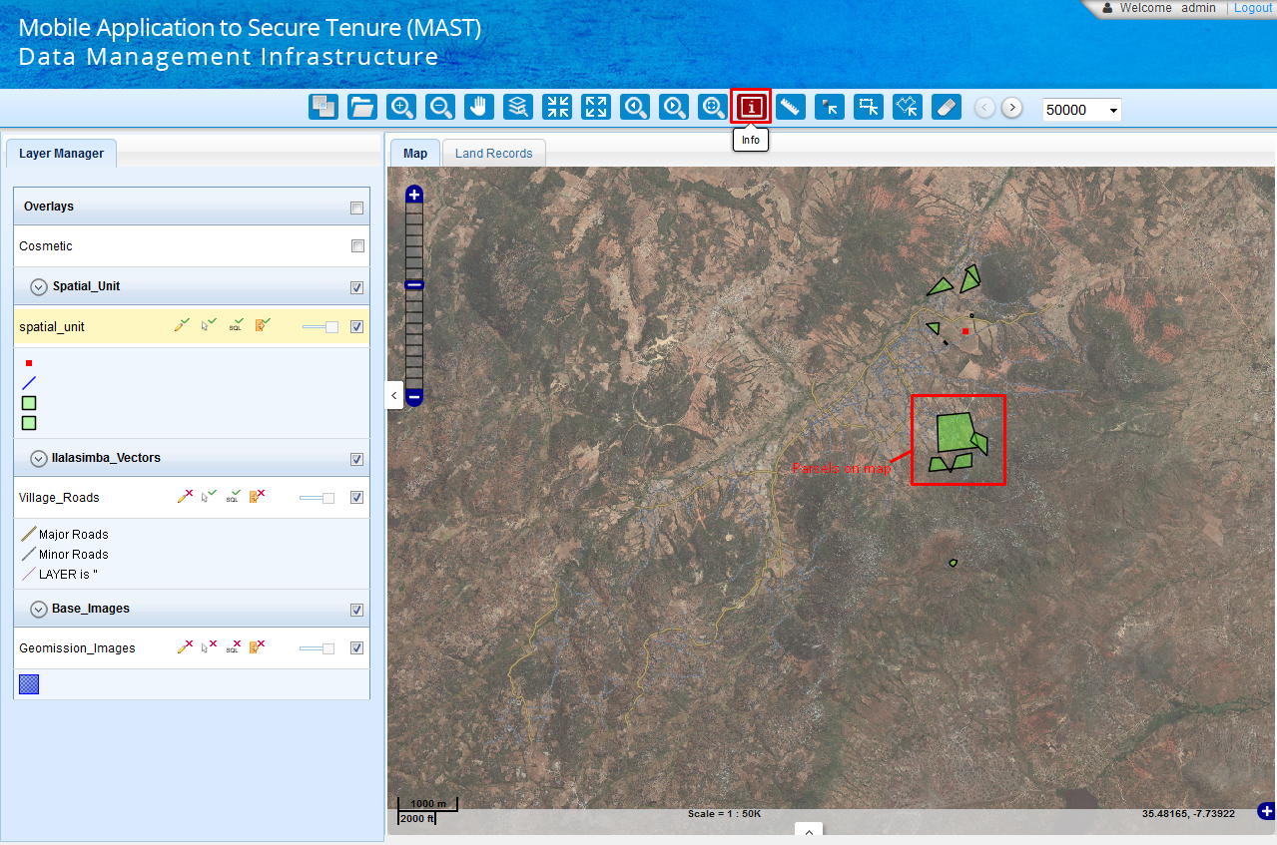Zoom to a parcel available on map.
2. Click on ‘Info’ tool available in tool bar. Info tool will be enabled.
3. Now click on a desired feature.
4. 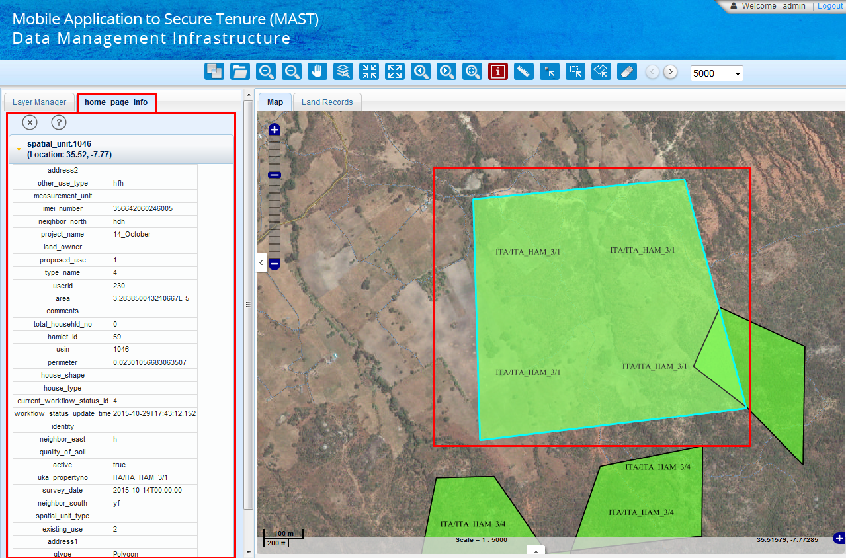Application opens a new tab ‘Info’ in left panel and attribute details of specified parcel will be displayed in ‘Info’ tab.

### Measure

‘Measure’ tool facilitates user to measure a desired length or area. On click of ‘Measure’ tool available in tool bar. Application will show ‘Measure’ tab on left panel. That will provide different tools to measure length or area on map.

These tools are listed below

* + - Length
    - Area

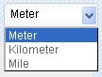**Steps:**

1. Click on ‘Length’ tool (if area tool clicked earlier) and select required unit form drop down list available in ‘Measure’ tab on left panel.
2. 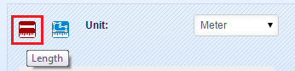Click on ‘Length’ tool. By default, ‘Length’ tool will be selected.
3. Draw a line as required for measuring the length (double click to complete the line).
4. User can create more than one segment in a line to measure a length of line with multiple nodes.
5. 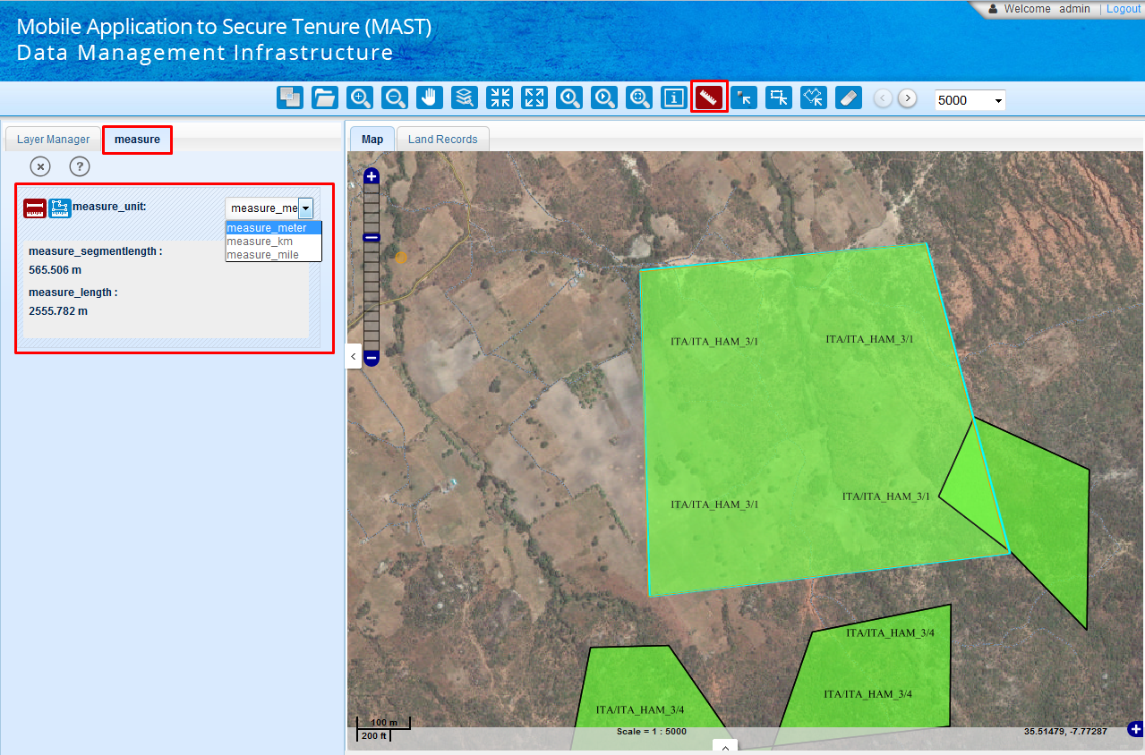 As user draws first segment the segment length and length will be same but on drawing second segment, application will show the current segment’s length as ‘Segment Length’ and total length of the line will be shown as ‘Length’.

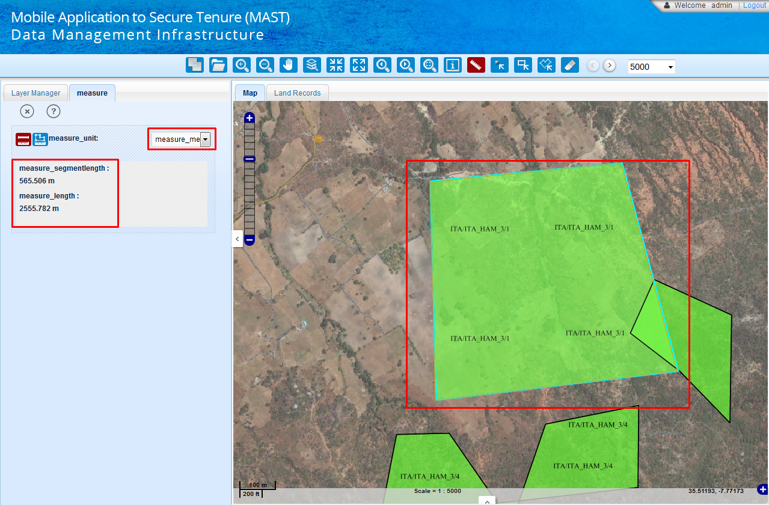To measure area, Click on ‘Area’ tool. Click on at least three locations on map. Application will display area covering all specified point on map. Area will be displayed in selected area unit.

### Select

‘Select’ tool facilitates user to select single feature of active layer.

**Steps:**

Zoom map to such scale that the layer’s features should be visible.

1. Click on ‘Select Feature’ tool available in tool bar.
2. Click on the parcel to be selected. The parcel gets highlighted on map canvas and attributes of selected parcel will be shown in the result panel.

### Select By Rectangle

‘Select by Rectangle’ tool facilitates user to select multiple parcels by drawing a rectangle on map.

**Steps:**

1. To select parcels of a layer, make that layer active by clicking on that layer in layer manager.
2. Draw a rectangle on required location to select the parcels.
3. To draw a rectangle, click on map and without leaving the mouse button drag and release the button to complete the rectangle.
4. On completion of rectangle, results panel pops-up and show the details of the parcels selected (intersected with the drawn rectangle).
5. Now user can use the tools available on result panel on selected parcels.
6. To clear the selection, click on clear tool.
7. If no parcel lies within the drawn rectangle, application will show a pop-up message “No Records Found”. Click ‘Ok’ on this message.

### Select By Polygon

‘Select by Polygon’ tool works similar as ‘Select by Rectangle’ tool but in this, instead of rectangle user has to draw a polygon on map canvas to select a parcels.

**Steps:**

1. Click on ‘Select by Polygon’ tool available in tool bar.
2. Draw a polygon on desired location in map.
3. To draw a polygon, click on map and add nodes to create polygon.
4. Double click to complete the polygon.
5. As user creates the polygon, application pops-up the result panel with the selected parcels details in tabular format.
6. To unselect the parcels, click on clear.

### Clear

‘Clear’ tool facilitates users to clear the selection of parcels on map. It also allows user to clear color thematic and to clear results from the result panel also.

**Steps:**

1. Click on the ‘Clear’ tool available in tool bar.
2. Application will clear all the records form result panel and if features are highlighted due to selection, application will clear them too. If some color thematic is used for features it also clears the color thematic too.

### Search

‘Search’ tool facilitates users to search parcels based on their attribute values within whole map or in defined extent boundary. It provides options to search parcels under a specific boundary and also this tool facilitates user to search parcels with attributes having similar value.

**Steps:**

1. Click on search tool available in tool bar.
2. 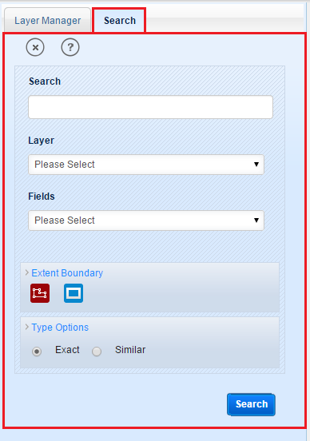‘Search’ tab will be displayed in left panel along with input options like Search, Layer and Fields and ‘Search’ button. ‘Extent Boundary’ and ‘Type Options’ sections will be available.
3. Enter the value in ‘Search’ input box.
4. Select the layer form ‘Layer’ drop-down, corresponding values will be populated in ‘Fields’ drop down.
5. Select field value from corresponding drop-down.
6. In the drop-down list there is an option available as ‘All’. If user selects ‘All’ for the fields then application will search for the results in all the fields of selected layer.
7. If user does not selects any of the options from ‘Extent Boundary’ and ‘Type Options’ and clicks on ‘Search’ button. Application will search the result in entire layer with ‘Exact’ option as default.
8. If entered value matches with attribute values, application will pop-up the result panel with the searched parcels’ attributes.
9. Now For the same search user can specify type option as ‘Similar’ (Note: Similar option does not work for numeric values)
10. If type option is chosen as ‘Similar’, application will show all the results which are similar to the entered value.

Users can also search features within a defined boundary.

1. Click on ‘Search’ tool and specify the attribute value in Search text box.
2. Select Layer and field in corresponding drop downs.
3. Click on ‘Extent Boundary’ link. Two tools Polygon and Rectangle will be shown to user.
4. Click on Polygon tool draw a polygon on the map canvas.
5. Click on the type options link and specify type as ‘Exact’ or ‘Similar’.
6. Click on ‘Search’ button. If entered value matches with some of the features’ attribute value of specified layer and field inside the drawn polygon, application will pops-up the result panel with the details of these features.
7. If the entered value does match with any features attribute of the specified layer and field, application shows a pop-up message of no record found. Click ‘Ok’ to exit from the message.
8. Similarly user can search features inside an extent boundary by drawing a rectangle on map canvas using ‘Rectangle’ tool.

### Zoom to XY

‘Zoom to XY’ tool facilitates users to zoom to a location of known coordinates on the map canvas. This tool also facilitate user to pan the map to specified coordinates.

1. Click on the ‘Zoom to XY’ tool available in tool bar.
2. Application will open a new tab on left panel as ‘Zoom to XY’. The tab contains two input boxes: ‘Easting’ and ‘Northing’ and two buttons: ‘Zoom To’ and ‘Pan To’.
3. 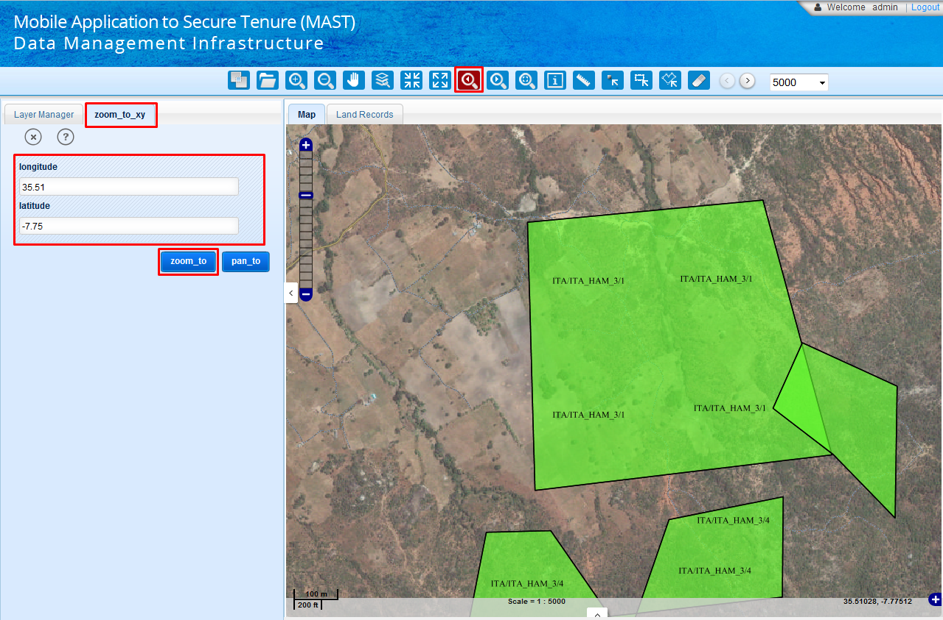Enter corresponding ‘Easting’ and ‘Northing’ coordinates in input boxes.
4. Click on ‘Zoom to’ button.
5. 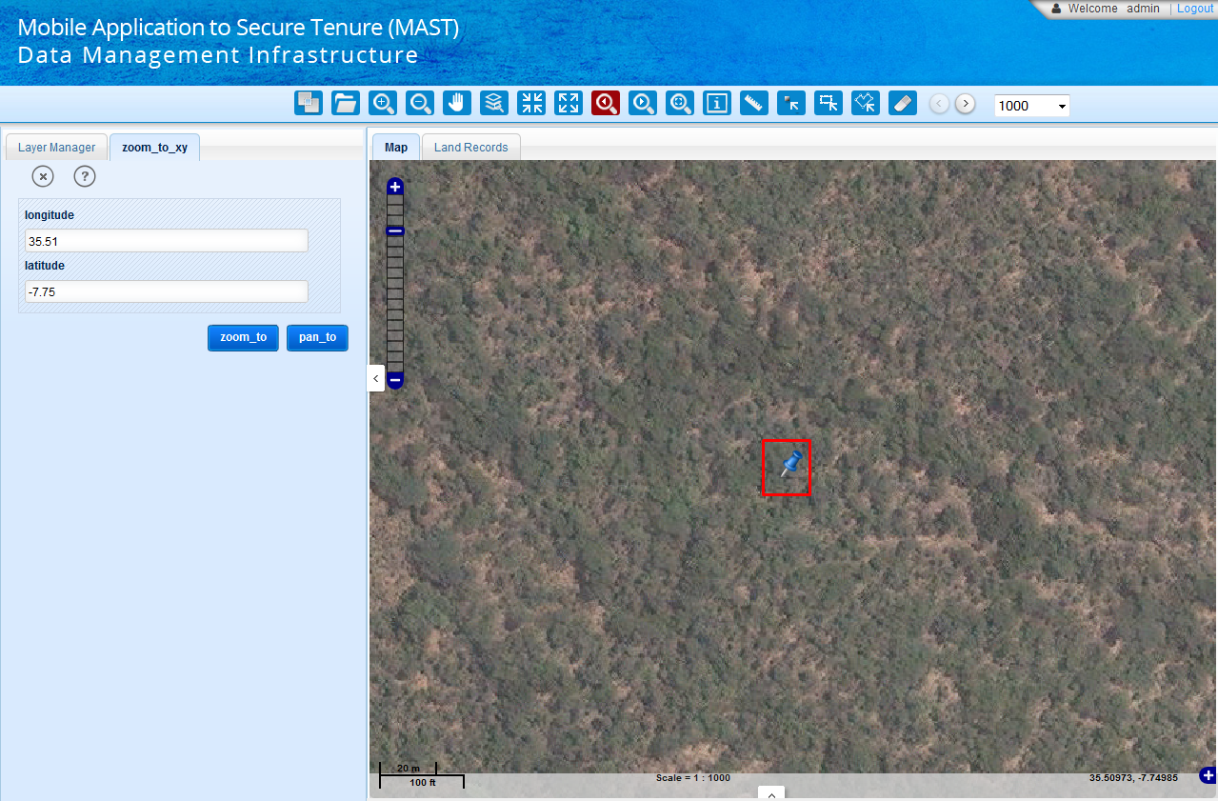Map extent will be changed and application will zoom in the map to the specified location pointed by entered coordinates. A marker will be placed on map showing the location of entered coordinates.
6. Instead of click on ‘Zoom To’ button, if user click on ‘Pan to’ button.
7. Map extent will remain same and application will pan the map to the specified location pointed by entered coordinates. A marker will be placed on map showing the location of entered coordinates.

### Print

‘Print’ tool facilitates users to take the prints of map as available in map viewer.

**Steps:**

1. Pan the map to the area which is to be printed.
2. Click on the ‘Print’ tool available in tool bar.
3. Application will open a new tab on left panel as ‘Print’. This tab contains one input boxes: ‘Map Title’ and one buttons: ‘Print’.
4. Print Preference window will appear with following radio buttons:

* Parcel Details
* Map layout

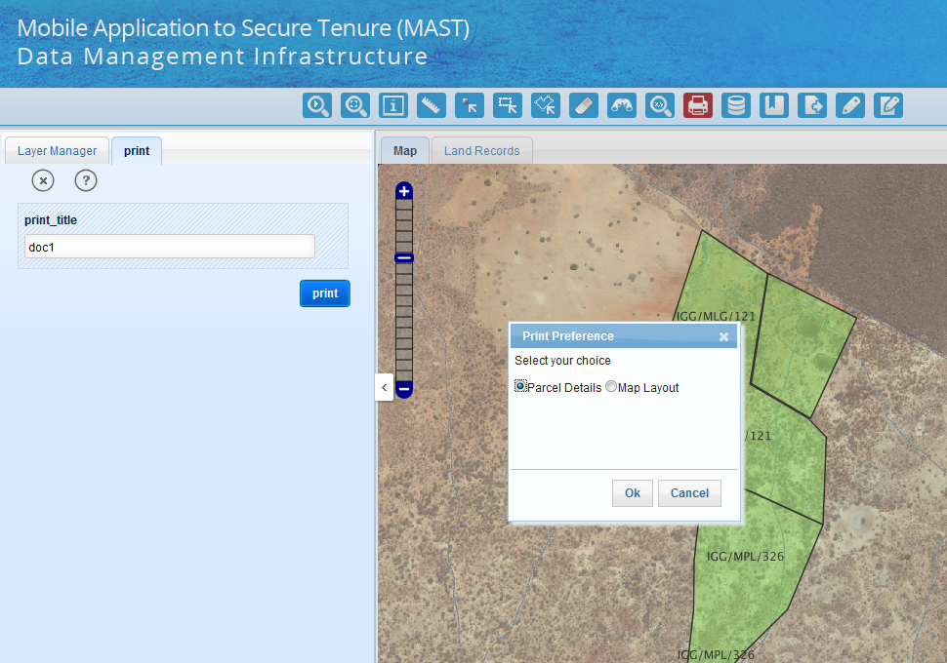

User selects ‘Parcel Details’ button and click on ‘OK’ button. Application will display Parcel details with Map and other details.

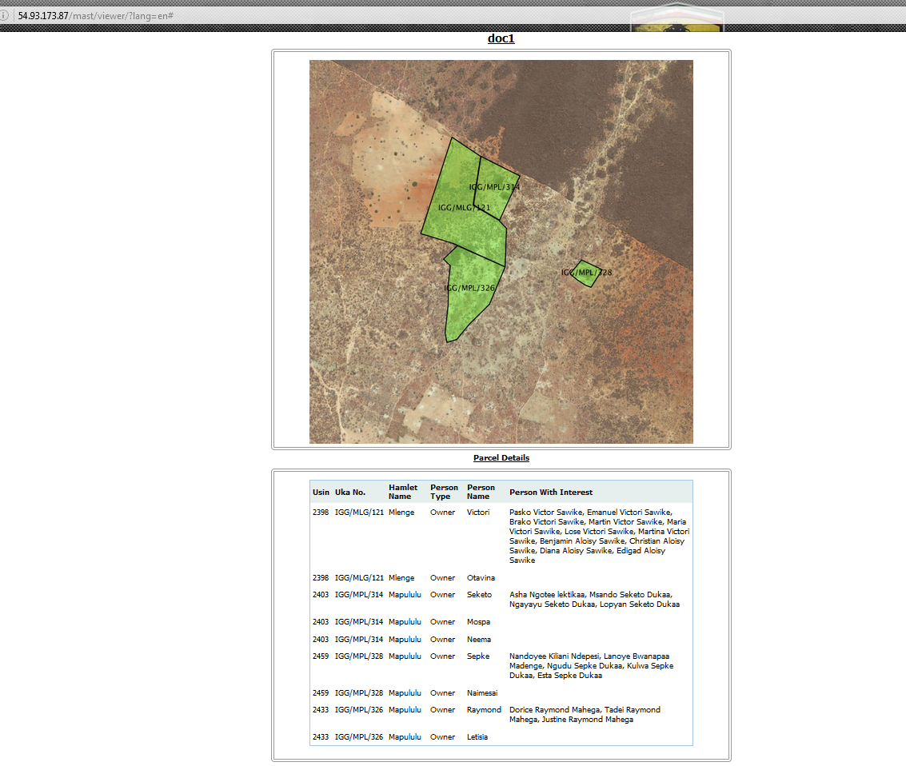

1. Application will display ‘Print Preferences’ dialogue. Select the preference and click on ‘Ok’ button.
2. Application will open corresponding map view in other browser window in a printable PDF printable format.

### Query Builder

‘Query Builder’ tool facilitates user to query parcels according to the attributes values, for this purpose application allows many operators to be used. User can make selection through the query builder and search other layer’s details around the selected features by using the relate option of query builder.

**Steps:**

Click on the ‘Query Builder’ tool available in tool bar.



Application opens a new tab ‘Query’ in left panel. This tab consists of two buttons: ‘Help’ and ‘Close’ in upper right corner, below of them one drop down list box ‘Select Layer’ is there. Then it has three drop-down list boxes: ‘Fields’, ‘Operators’ and ‘Values’. Below to Values list box ‘See More’ link is there. The Values list box can have a list of 100 values at a time so to add more values to it one has to click on the see more link. It adds hundred more values for the selected attributes on every click on that link until the attribute all attribute values are added. A drop down box ‘Load Query’ is there. This list box consists of the list queries saved by the user earlier. And user can select a query from the list. Then the query tab has a text box ‘Where Clause’ in which user can see the query and the selected fields, operators and field’s values will be updated here automatically while selecting from respective list above. Above this text box a link ‘Clear’ is there to clear all the selected details from the where clause text box and from the fields, operators and values list boxes. Below to where clause text box a link ‘Save Query’ is there to save a query of user for future use. As user clicks on this link it expands with two text boxes: ‘Query Name’ and ‘Query Description’. At the bottom, query tab has two buttons: ‘Save Query’ and ‘Run Query’. ‘Save Query’ button is used with the ‘Save Query’ link to save the query details. And ‘Run Query’ button is used to run the query which is shown in where clause. Refer the figure below. **(Note: ‘Not’ operator should be used before the field name (for example: NOT objected=10, it will select the result which has not object as 10))**

#### Run Query

‘Run Query’ facilitates user to run a correctly build query.

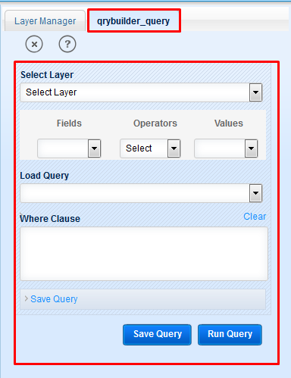

To simply run a query:

1. Select layer from the drop- down list on which query is desired.
2. Select field from ‘Fields’ list box.
3. Select operator from ‘Operators’ list box.
4. Selected ‘Fields’ and ‘Operator’ will be populated in ‘Where Clause’ text area.
5. Write the field value in ‘Where Clause’ text area.
6. User can create a query in which more than one field and more than an operator is used.
7. User can see the whole query in the ‘Where Clause’ text box.
8. If the query is all correct then click on the ‘Run Query’ button.
9. Application will pops-up the result panel with the queried features’ details on it.
10. Now user can clear the where clause text box by clicking on clear link.

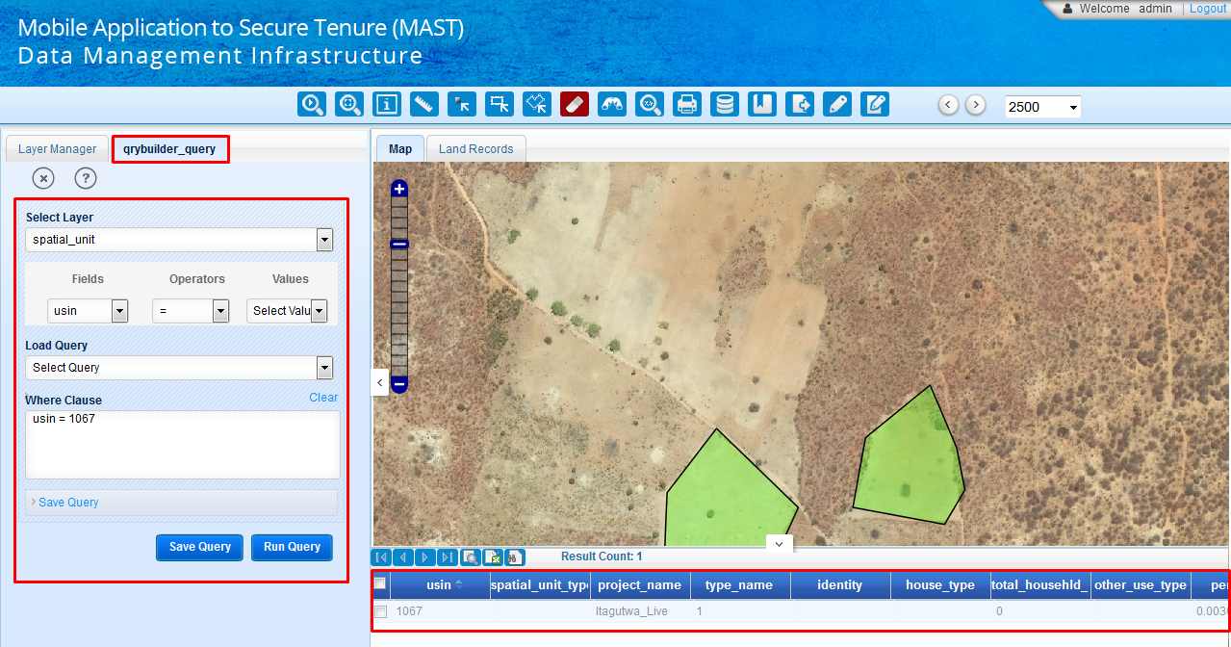

#### Save Query

‘Save Query’ facilitates user to save query which is going to be used frequently or may be used in future.

**Steps:**

Select layer, fields, and operator and Write the field value in ‘Where Clause’ text area.

Click on ‘Save Query’ link.

Enter the query name in ‘Query Name’ text box and enter the description of query in ‘Description’ text box.

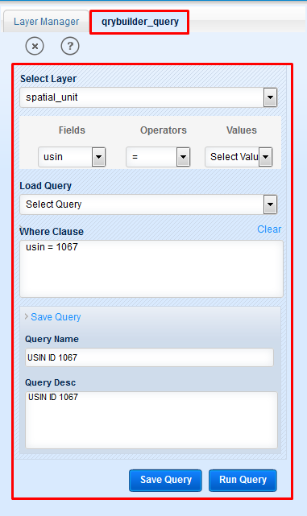

1. 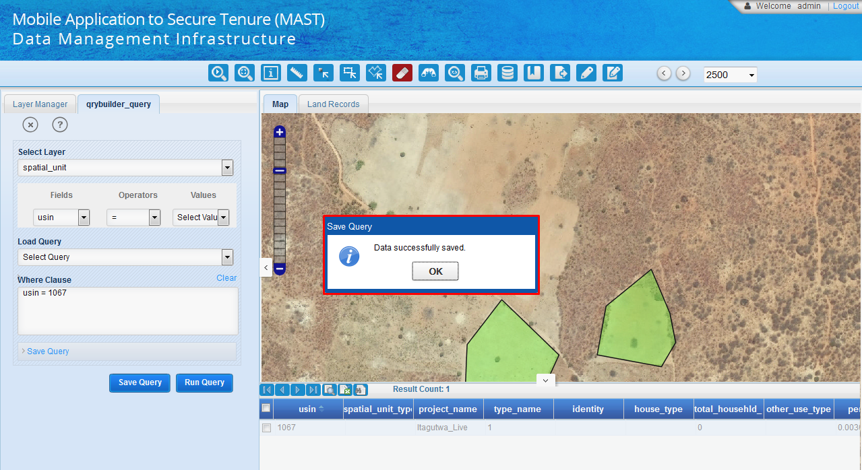Click on ‘Save Query’ button. Application will shows a pop-up message on successfully saving the query to the server.

#### Load Query

‘Load Query’ facilitates user to run a saved query.

1. Select the layer for which query is saved.
2. 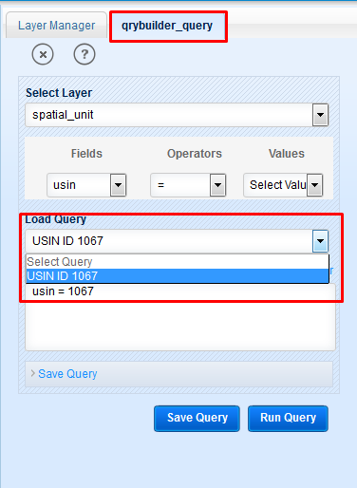Query belonging to selected layer will be populated in ‘Load Query’ drop down.
3. Select the saved query from the drop-down list from ‘Load Query’ list box, application will show the query in where clause.
4. 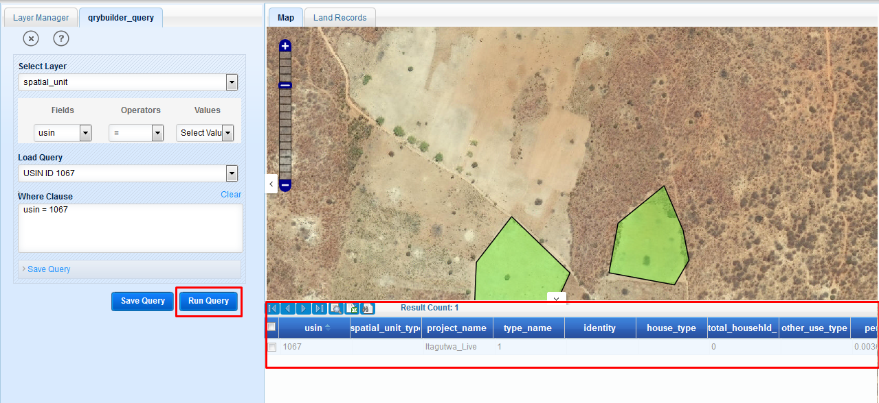Click on ‘Run Query’ button. The results will be shown in results panel.

### Bookmark

‘Bookmarks tool’ facilitates users to save a particular area of interest of map canvas for future reference. This also facilitates user to manage and use available bookmarks. .

**Steps:**

Click on ‘Bookmark’ tool available in too bar.

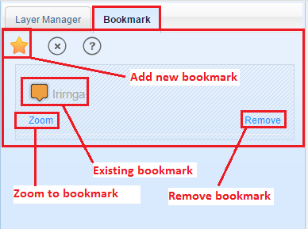Application will open a new tab ‘Bookmark’ in left panel. This tab contains one button as star to add new bookmark on top-left, tow more button like any other tool in right-top: ‘Help’ and ‘Close’. Below to these tools the tab contains the list of previously saved bookmarks with tool links: ‘Zoom’ and ‘Remove’.

#### Create Bookmark

1. ‘Create Bookmark’ facilitates user to create a new bookmark.
2. User clicks on bookmark tool.
3. In bookmark tab click on the star shaped button, application shows a text box below the tool with a link ‘Save’.
4. Now set the map view to the required extent on required zoom level.
5. 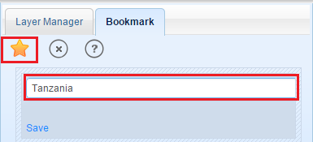Enter the name of the new bookmark on the text box.
6. 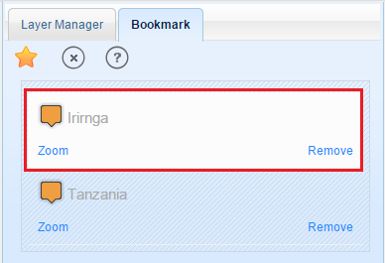Click on the link ‘Save’. Application will save the bookmark to the server and the saved bookmark will be shown in the bookmark list.
7. This bookmark can be used in future to go that extent and location.

#### Zoom to Bookmark

To go to a previously saved bookmark, click on the link ‘Zoom’ below the saved bookmark. Application will set the map view to the bookmark’s extent.

#### Remove Bookmark

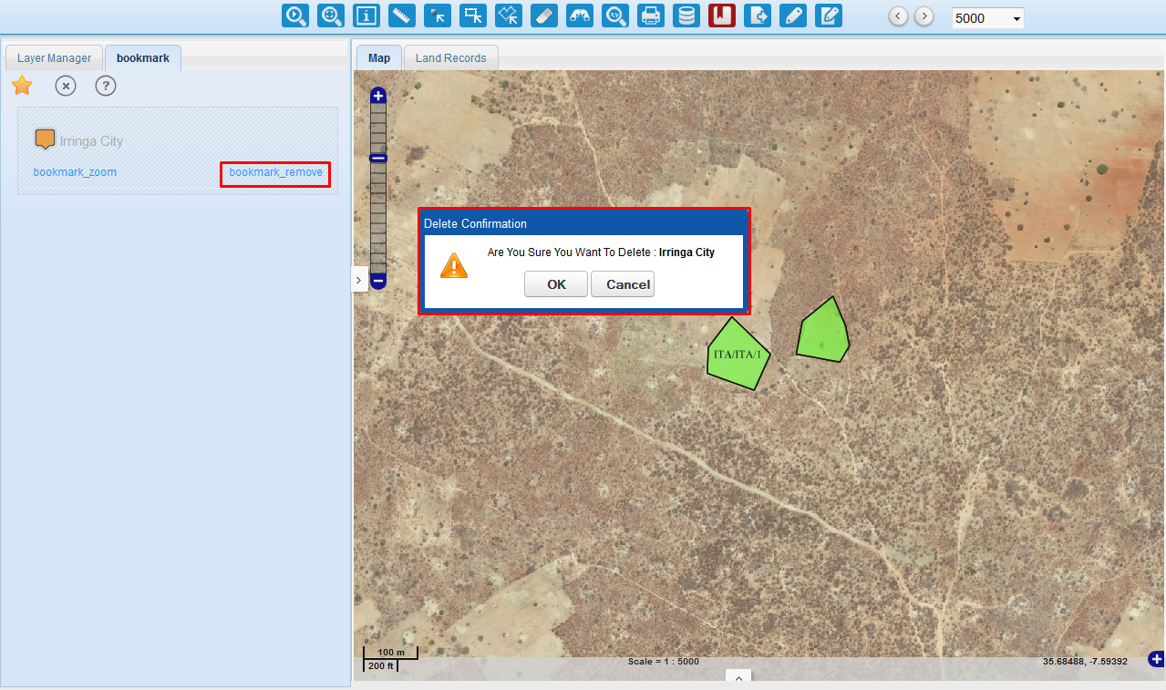User can remove a saved bookmark by clicking on the link ‘Remove’ below of that bookmark. Application pops-up the confirmation message. Click ‘Ok’ to remove the bookmark or click ‘Cancel’ to exit from the message without removing the bookmark.

### Export Data

‘Export Data’ tool facilitates user to export data of selected land records in excel sheet. Data of all the key attributes will be exported to the excel sheet for filtered land records.

**Steps:**

1. User clicks on ‘Export Data’ tool available in tool bar.
2. Application will open a new tab on left panel as ‘Export’. This tab contains one drop down: ‘Formats’ and accordion names ‘Export Options’ along with ‘Download’ button.
3. Select the format in which, data is to be exported.
4. 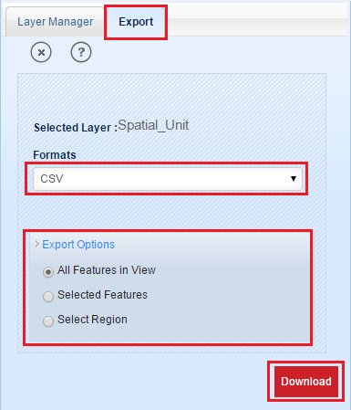Select any of the Export option like - 'All Features in View', 'Selected Features', 'Select Region'.
5. Click on Download button.
6. Application will invoke ‘Save As’ dialogue. Save the data on local drive.

### Markup

Markup  functionality allows users to create point, line, polygon, and circle and text label for reference and illustration purpose. User can customize features and labels and save them for future retrieval. All the mark-ups created by user are saved in cosmetic layer. Markup functionality also allows users to delete mark-ups before saving them and allows user to clear all the previously saved mark-ups. As user click on this tool a new tab ‘Markup’ is opened on the left panel. This tab consists of multiple tools to manage mark-ups. These markup tools are listed below:

* + - New—It clears (removes) all the previously saved mark-ups in a projects.
    - Save—It saves all the created mark-ups and labels.
    - Delete—It allows users to delete mark-up feature by clicking on that mark-up (before saving).
    - Delete All—It allows users to delete all the mark-ups and labels before saving them.
    - Point—It used to draw point mark-up.
    - Line—Used to draw line mark-ups.
    - Polygon—Used to draw polygon mark-ups.
    - Circle—Used to draw circles as mark-ups.
    - Rectangle—Allows users to draw rectangle mark-ups.
    - Label /Text—Allows users to create text mark-ups or labels.

#### Point Markup

Point mark-up is by default active tool in mark-up tab.

1. To create a point mark-up, click on ‘Point’ tool. A form will be displayed to enter the details the point lookup. The form has two parts ‘Fill’ and ‘Stroke’. Fill part has fields to enter the fill properties of point. And stroke part has fields to enter the outline details of point.
2. In fill part select fill colour in ‘Fill Colour’ colour box.
3. Specify the opacity of fill in ‘Fill Opacity’ spin box.
4. Specify the radius of point in ‘Point Radius’ spin box.
5. In stroke part, select stroke colour, specify stroke opacity, stroke width (outline width).
6. Select ‘Stroke Linecap’ (point shape) form drop down list.
7. Now click on map at required location, a point will be drawn at the clicked location.
8. Click on ‘Save’ tool to save that point.

#### Line Markup

1. To make custom lines (markups) click on Line tool. Application will show a form to fill the line details.
2. Select ‘Stroke Colour’ (Line colour) by clicking on colour box.
3. Select a colour with the colour picker.
4. Select line opacity by using ‘Stroke Opacity’ Spin box (opacity limit 0 to 1).
5. Select line width by using ‘Stroke Width’ spin box.
6. Select line-cap style using ‘Stroke Linecap’ drop-down list box.
7. Select line style from the ‘Stroke Dashstyle’ drop-down list box.
8. Now draw the line on required location.
9. Double click to finish the line and click on ‘Save’ tool to save that line.

#### Polygon Markup

1. For polygon mark-ups, click on polygon, application shows a form to customize polygon.
2. Select the colour for polygon fill.
3. Click on the ‘Fill Colour’ box, a colour- picker will be shown to user.
4. Select the required colour.
5. Set the opacity for polygon fill by using ‘Fill Opacity’ spin box.
6. Now for stroke part, select outline colour with ‘Stroke Colour’.
7. Set outline opacity using ‘Stroke Opacity’ spin box.
8. Enter outline width in ‘Stroke Width’ spin box.
9. Select outline cap style from the ‘Stroke Linecap’ drop-down list box.
10. Select outline style from the ‘Stroke Dashstyle’ list box.
11. Click on the map at required location, create polygon and double click to finish the polygon.
12. Click on ‘Save’ tool to save the markups.

#### Circle Markup

1. To create a circle markup click on circle tool. A form will be shown in ‘Markup’ tab.
2. Select ‘Fill Colour’ by clicking on the colour box. A colour picker will be shown.
3. Set the opacity of circle fill in ‘Fill Opacity’ spin box.
4. Select outline colour for circle in ‘Stroke Colour’ box.
5. Set the outline opacity in ‘Stroke Opacity’ spin box.
6. Specify outline width in ‘Stroke Width’ spin box.
7. Select outline cap style from the ‘Stroke Line cap’ List box.
8. Select outline style for circle from the ‘Stroke Dash style’. .
9. Click on the required location and without releasing the mouse button drag it to the circumference of circle and release the mouse button.
10. Click on ‘Save’ tool to save the markups.

#### Rectangle Markup

Creation of rectangle is similar to polygon creation.

1. Click on Rectangle icon.
2. Select ‘Fill Colour’ by clicking on the box and then selecting the required colour from the colour picker as shown.
3. Specify the ‘Fill Opacity’ using the spin box.
4. Select outline colour in ‘Stroke Colour’ box.
5. Set outline opacity in ‘Stroke Opacity’ spin box.
6. Set outline width in ‘Stroke Width’ spin box.
7. Select outline cap style from the ‘Stroke Linecap’ list box.
8. Select outline style from the ‘Stroke Dashstyle’ drop-down list box.
9. After filling all the details, click on the required location on map canvas and without releasing the mouse button, drag it to the other end of rectangle and release the mouse button.
10. Then click on ‘Save’ tool to save these markups.

#### Text Markup

To label on mark-ups or any feature or just a text mark-up:

1. Click on ‘Text’ tool. Application shows the text details.
2. Select a font type from the ‘Font’ list box.
3. Select the style from the ’Font Style’ list box as ‘Normal’ or ‘Italic’.
4. Select ‘Font Width’ as ‘Normal’ or ‘Bold’ form the list.
5. Select colour for the text by clicking on ‘Colour’ box. A colour picker will be shown.
6. Select required colour from the colour picker and click on ‘Close’ button on the colour picker.
7. Specify the size for the text in ‘Size’ spin box.
8. Now click on the map canvas at required location. Application shows a text box at clicked location.
9. Enter the text in it and press enter. The text will be shown in the specified details.
10. Click on ‘Save’ button to save text mark-up.
11. User can exit from the ongoing mark-up creation by pressing ‘Escape’.

#### Save Markup

Mark-up is saved only if user will click on ‘Save’ tool. Users can create multiple and different type of mark-ups and save them together.

#### Delete Markup

To delete a specific markup before saving, click on the ‘Delete’ tool and then click on that markup. Application will delete that markup.

#### Delete All

To delete all the created markups before saving them, click on the ‘Delete All’ tool. Application will delete all the markups; those are made recently and not saved.

#### New

Click on ‘New’ tool to delete all the markups from the map canvas. This functionality allows users to delete all type of marks either saved or not.

### Editing

‘Edit’ functionality facilitates users to create new feature in selected layer. Using this tool, user can create new parcel only using direct editing feature. For creation/editing of other features, user needs to select features from the application.

It also allows users to edit features of a layer. User can reshape, resize, move, rotate and delete features under editing functionality. Users are also allowed to edit attributes of features of selected layer.

**Steps:**

1. User Clicks on ‘Edit’ tool available in tool bar.
2. Application shows a new tab ‘Editing’ in the left panel. This tab displays active layer’s name on the top, on which all the editing will be done. Below of this five tools: ‘Select’, ’Clear’, ’Undo’, ‘Redo’ and ‘Save’ are there. Below of these tools tab has four links:
   * + Create: to create new parcel.
     + Edit: to edit existing Parcel.
     + Edit Attributes: shows attributes fields and allows to edit attributes of parcel.
     + 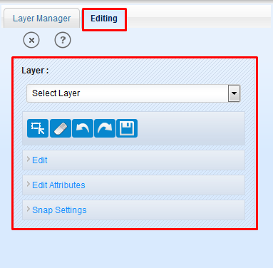Snap Settings: allows users to set snapping options to avoid gaps and overlaps.

### General Tools

**Select  :** This tool is used to select features for editing or snapping (selection of features changes them from WMS to WFS, since WMS features are not editable). To select feature/features, click on ‘Select’ tool and draw a rectangle on map at required location. The features of selected layer, covered by that rectangle will get selected.

**Clear :** This tool used remove features from the selection.

**Undo :** The undo tool allows user to undo the last activity in editing (except attribute editing).

**Redo :** Redo tool can be used after the use of undo tool. It redoes the activity that was last undone by user.

**Save :** Save tool allows users to save all the editing made by user. After editing features users must have to click on save button to remain the changes done.

### Edit

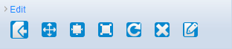Edit functionality contains a list of tools to edit an existing feature. When user clicks on the ‘Edit’ link these tool be shown to user, refer figure below.

To use the editing tools, user has to select the layer first whose features will be edited.

**Import Feature:** Import tool  allows user to import feature from the Cosmetic layer to selected layer. A markup can be imported to selected layer if the selected markup is layer compatible feature i.e. the selected markup geometry must be as the selected layer’s geometry. To import a feature, click on import tool and click on that markup feature. Then click on ‘Save’ tool. Now that markup can be seen in the selected layer.

**Move:** Move tool  facilitates users to move a selected feature to a desired location on map.

1. To move a feature, make its layer as active layer.
2. Click on ‘Edit’ link.
3. Click on select tool and select a feature by drawing a rectangle on map. The selected features will be highlighted.
4. Click on ‘Move’ tool.
5. Click on the required feature among the selected features. Application shows a node.
6. Click on that node and without releasing the mouse button, move that node to required location. Then click in save button. Here user can use ‘Undo’ tool before saving the changes.

**Resize:** Resize tool  allows users to change the size of a feature (except points). For resizing a feature:

1. Click on ‘Edit’ link. Select parcel by ‘Select’ tool.
2. Click on ‘Resize’ tool in edit and click on the feature. Application shows a node for resizing.
3. Click on that node and without releasing mouse button move the node towards to feature to make the feature smaller or move away from the feature to make its size larger and release mouse button on desired size.
4. Click on ‘Save’ button to save the changes.

**Reshape:** Reshape tool  allows users to change the shape of the features (except point features). In reshape tool user can move an existing vertex of the feature or insert a new vertex or delete an existing vertex.

1. Click on ‘Select’ tool and select that feature. Now click on ‘Reshape’ tool.
2. Click on that features. All the vertices will highlighted with that feature.
3. Now user can click any of the vertices and move it to a required location.
4. To insert a new vertex, user has to click on the mid-point of two vertices and move it required location. Midpoint of every segment is also highlighted but with lower visibility.
5. To delete a vertex from the feature, keep the cursor on that vertex and press ‘Ctrl+Delete’.
6. After doing all the changes, click on ‘Save’ button to save editing.

**Rotate:** Rotate tool  allows users to rotate a feature (except point features) clockwise or anti-clockwise.

1. Click on ‘Select’ tool and select that feature.
2. Click on ‘Rotate’ tool and click on selected feature. A node will be shown in the map near to feature.
3. Click on that node and without releasing mouse button move it clockwise or anti-clockwise as required. Release the mouse button after rotating feature to required angle.
4. Now click on ‘Save’ button to save the changes.

**Remove Feature:** Remove  feature functionality allows users to delete a feature permanently from layer. User can remove any type of features (point/polygon/line).

1. Click on ‘Select’ tool and select that feature.
2. Click on ‘Edit’ link (if not expanded) and select ‘Remove Feature’ tool.
3. **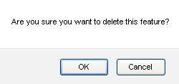**Now click on that feature. Application will show a pop-up message to confirm the deletion of that feature.
4. Click ‘Ok’ to confirm or ‘Cancel’ to go back without deleting feature.
5. As user clicks ‘Ok’ on that pop-up message, that feature will be highlighted.
6. Now click on ‘Save’ tool to remove the feature from layer and server.

**Edit Attribute:** Edit attribute  tool allows users to edit attributes of a selected feature. The fields of a selected feature will be shown in the link ‘Edit Attributes’ in the left panel. User can expand this link by clicking on it. Or it will be expended by application while using edit attribute tool.

To edit attributes of a feature, click on ‘Select’ tool and select feature on map.

1. Click on ‘Edit Attribute’ tool and click on the selected feature.
2. Application will expand the link ‘Edit Attributes’ (if it is not opened already). All the editable attributes will be shown in that list.
3. Edit required fields by clicking on the text boxes of those attributes.
4. After editing the attributes, click on ‘Apply’ button on the ‘Edit Attributes’ link.
5. And to save these changes, click on ‘Save’ button.

### Edit Attributes

This link is related to ‘Edit’ and ‘Create’ links. And this functionality can be used only if user want to edit attributes of a feature through ‘Edit Attributes’ tool in ‘Edit’ link or when user want to create a new feature. The two uses of this functionality are described below:

When user creates a new feature under any layer, After creating feature successfully if user clicks on ‘Edit Attributes’ link all the fields of the feature will shown to user according to attribute fields of that layer. User can fill the attribute details of new feature here.

After completing the attribute filling, click on ‘Apply’ button and then click on ‘Save’ tool.

If mandatory fields are not filled, on clicking ‘Apply’ button these fields will be marked with pink colour. The new feature will be saved with the attribute details.

The other use of this functionality is to edit attributes of existing features:

1. To edit attributes, select the feature first by ‘Select’ tool.
2. Click on ‘Edit Attributes’ tool.
3. Click on that feature. Attributes of that feature will be shown in left panel in ‘Edit Attributes’ link.
4. Edit desired fields then click on ‘Apply’ button.
5. Click on ‘Save’ tool to save all these changes.

### Snap Settings

Snap Settings functionality allows user to avoid gaps and overlaps while creating features or reshaping a feature. To activate the snap functionality the features should be in selected mode to those a new feature or an editing feature going to be snapped. Click on the ‘Snap Settings’ and applications shows a ‘Tolerance’ spin box where user can set (decrease/increase) the tolerance for snapping. Below this, four options are available with checkbox as shown in figure 85. The list of options is:

* + - Snap to Closest Feature
    - Snap to Nodes
    - Snap to Vertices
    - 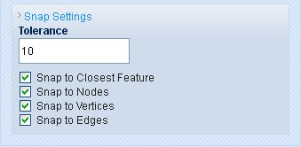Snap to Edges

By default all these four options are marked.

User can set the options according to his preferences. If user wants to snap on larger tolerance, increase the tolerance value for snapping in the spin box.

1. First of the four options is to deactivate all other snap settings. If user un-marks the check box of ‘Snap to Closest Feature’ check box, all the check boxes will be unmarked.
2. ‘Snap to Nodes’ is used to snap to nodes of nearest line feature under specified tolerance.
3. ‘Snap to Vertices’ can be used to snap to the vertices of a feature under given tolerance.
4. ‘Snap to Edges’ allows user to snap to edges of nearest feature under the specified tolerance.
5. To remove snapping, either set the tolerance at 0 or unmark the check box of ‘Snap to Closest Feature’.

# Land Records Dashboard

This functionality facilitates user to view all the data of Land Rights information for the selected project. Dashboard provides a consolidated view of the land rights data collected in the field and also enable the user to take further review and approval actions on it.

‘Land Records’ tab provides a search facility that enables user to search a spatial record based on its 'USIN ID', 'UKA ID', 'Status', 'From' and 'To' dates.

User can take following actions on a particular land data record by clicking on respective icon for that particular action in front of the record.

* + - Generate UKA
    - Update Hamlet
    - Edit Attributes
    - Approve Status
    - Reject Status
    - Adjudicate Spatial Attribute
    - Show on map
    - Finalize Data
    - Upload Document
    - Generate Adjudication Form
    - Generate CCRO Certification

**Steps:**

1. Login into the system with role as ‘Administrator / Project Manager’. Click on ‘Launch’ link available in ‘Data Management’ section.
2. ‘Land Management Tools’ page will be displayed. Click on ‘Land Records’ tab.

## Search Land Record

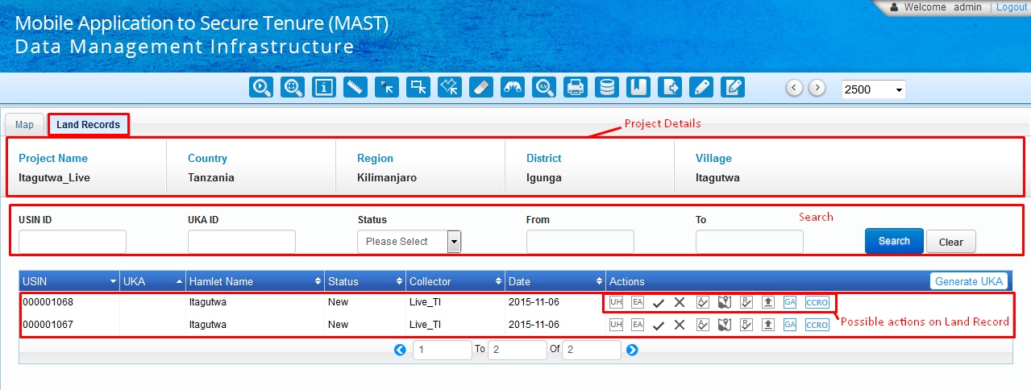‘Land Records’ tab provides a search facility that facilitates user to search a spatial record based on its 'USIN ID', 'UKA ID', 'Status', and Date (From' and 'To').

**Steps:**

1. 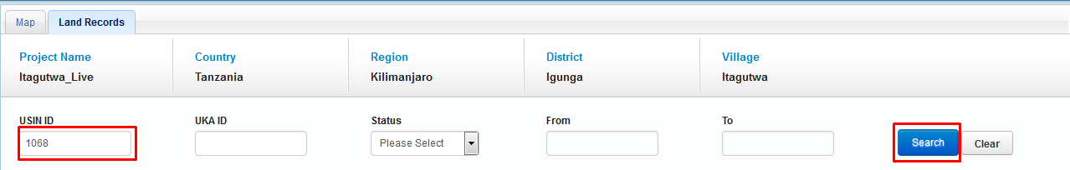Enter valid input in any of the corresponding input option like 'USIN ID', 'UKA ID', 'Status', and Date (From' and 'To').
2. Click on Search button.

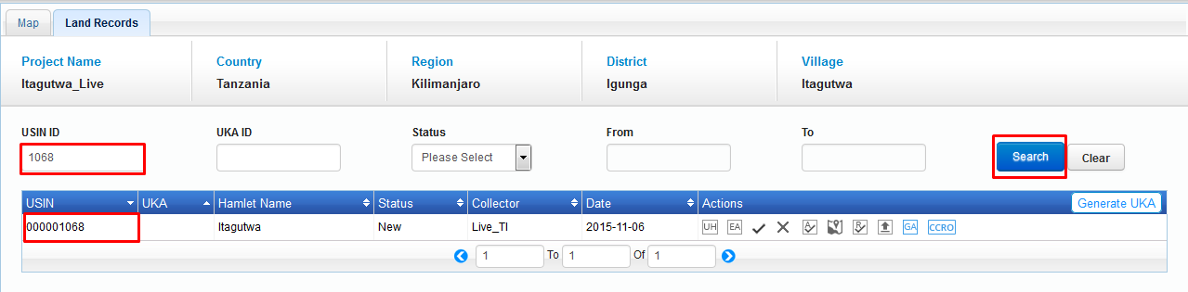

1. Search result will be populated in grid.
2. Click on ‘Clear’ button, Search result will be clear from the grid and all available records will be populated.

## Actions on Land Records

This functionality facilitates user to view all the data of Land Rights information for the selected project. Dashboard provides a consolidated view of the land rights data collected in the field and also enable the user to take further review and approval actions on it.

User can take following actions on a particular land data record by clicking on respective icon for that particular action in front of the record.

* + - Generate UKA
    - Update Hamlet
    - Edit Attributes
    - Approve Status
    - Reject Status
    - Adjudicate Spatial Attribute
    - Show on map
    - Finalize Data
    - Upload Document
    - Generate Adjudication Form
    - Generate CCRO Certification

### Generate UKA

‘Generate UKA’ tool facilitates user to generate ‘UKA’ number of parcel which don’t have assigned UKA.

**Steps:**

1. 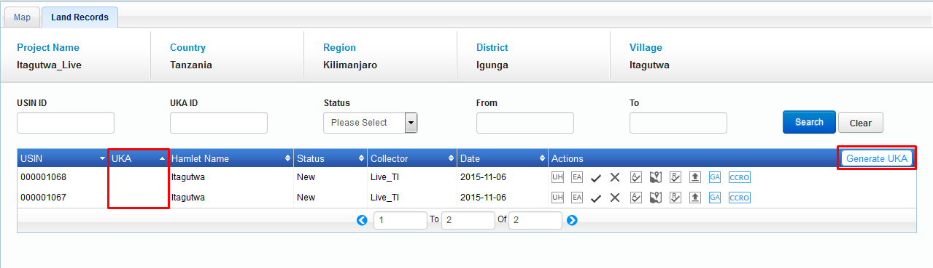Click on ‘Generate UKA’ button available on left top of grid.
2. Application will update ‘UKA Number’ for parcels which don’t have UKA no. and same will be displayed in parcel details available in grid.

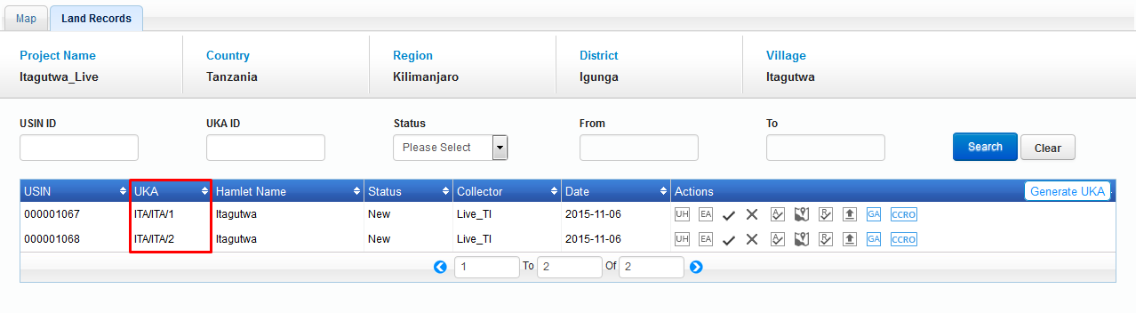

### Update hamlet

‘Update Hamlet’ tool facilitates user to update hamlet of spatial unit.

**Steps:**

Click on ‘Update Hamlet’ option associated to corresponding parcel.

#### Screenshot_65.png

Update Hamlet Name’ dialogue will be displayed with ‘Hamlet Name’ dropdown that consist of list of available Hamlets, current hamlet will be available in dropdown.

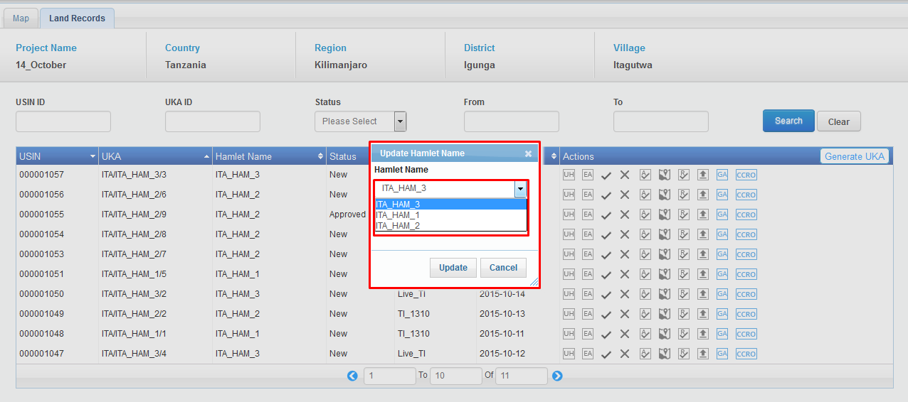

Select the required hamlet name in dropdown, click on ‘Update’ button. Application will update hamlet for corresponding spatial unit and an acknowledgement message will be displayed.

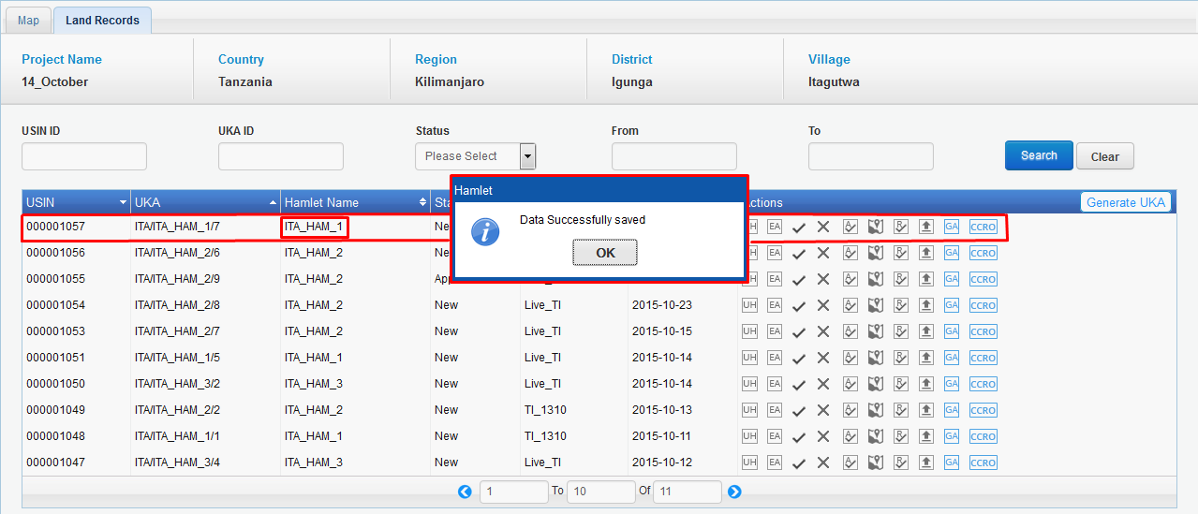

### Edit Attributes

‘Edit Attribute’ Tool facilitates user to edit land rights attributes of spatial units. User can select a ‘Edit Attribute’ tool associated with record and can directly view/edit attribute information of existing spatial units.

**Steps:**

1. 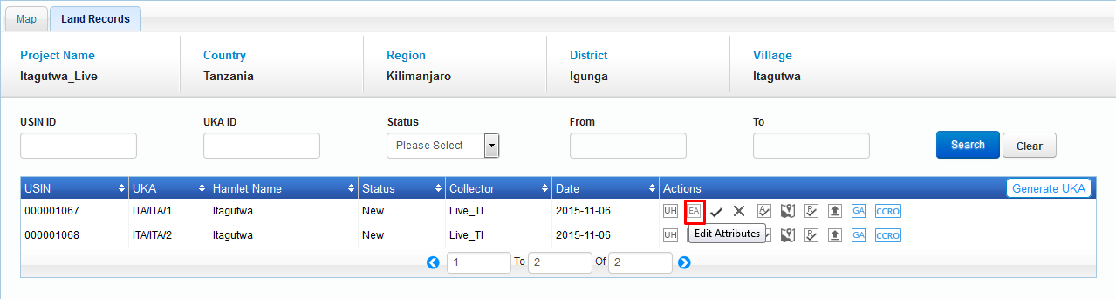Click on ‘Edit Attribute’ option associated to corresponding parcel details.
2. ‘Edit Attributes’ dialogue will be displayed with tabs- ‘General Info’, ‘Natural Person’, ‘Non Natural Person’, ‘Person of Interest’, ‘Deceased Person’, ‘Tenure Info’ and Multimedia. By default, ‘General Tab’ will be selected.

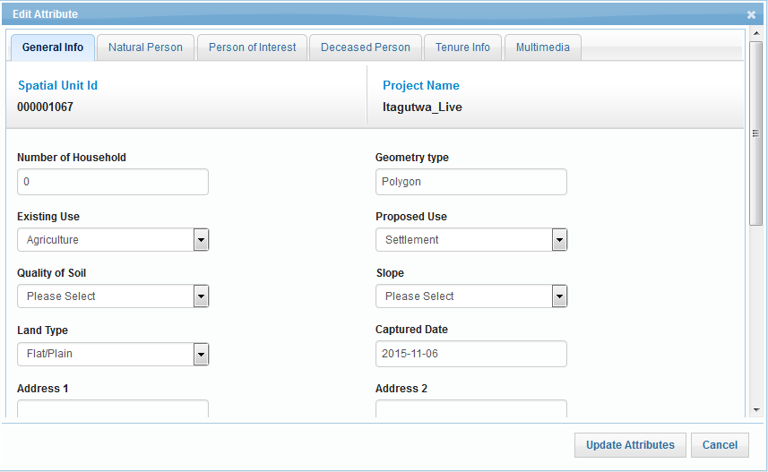

#### Update General Info

This tab facilitates user to update General info of a specified parcel.

**Steps:**

1. Click on ‘Edit Attribute’ option associated to corresponding parcel details.
2. 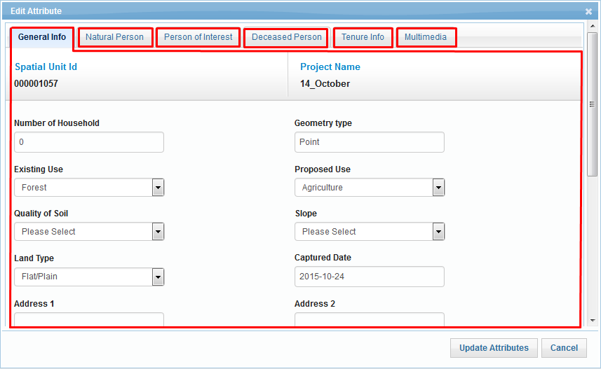‘Edit Attributes’ dialogue will be displayed. By default, ‘General Tab’ will be selected.
3. 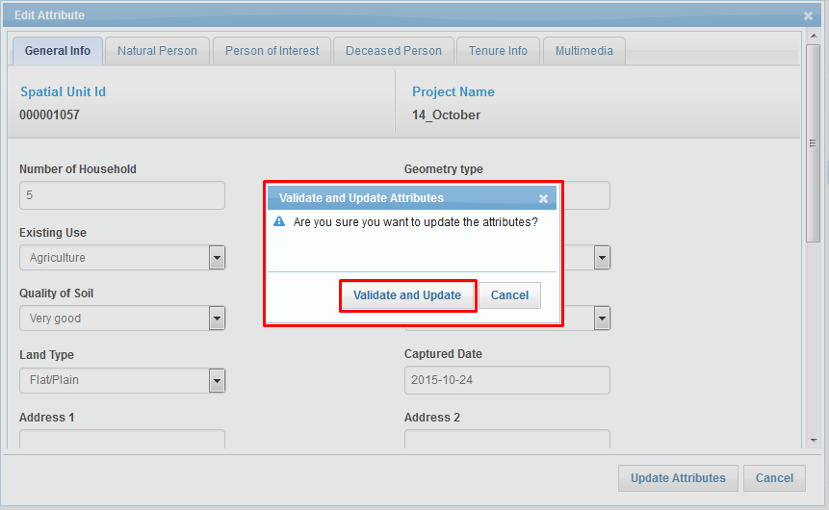Corresponding attribute details of specified parcel will be available in edit mode. Edit the required details and click on ‘Update Attribute’ button. Application will display a confirmation message.
4. Click on ‘Validate and Update’ button, Application will validate the data, if any validation error is encountered, appropriate message will be displayed.

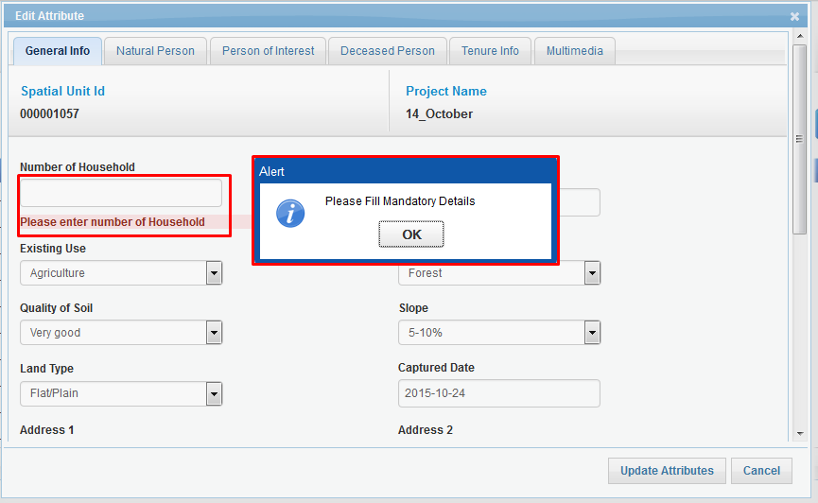

1. If no validation error occurs, application will save the edited details and will display an acknowledge message.

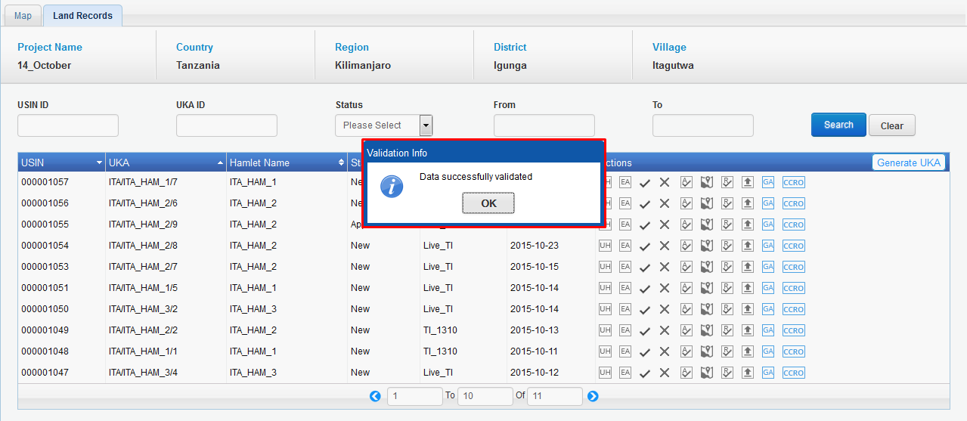

#### Update Natural Person Detail

This tab facilitates user to update natural person’s details of a specified parcel.

**Steps:**

1. Click on ‘Edit Attribute’ option associated to corresponding parcel details.
2. ‘Edit Attributes’ dialogue will be displayed with tabs- ‘General Info’, ‘Natural Person’, ‘Non Natural Person’, ‘Tenure Info’ and Multimedia. By default, ‘General Tab’ will be selected.
3. 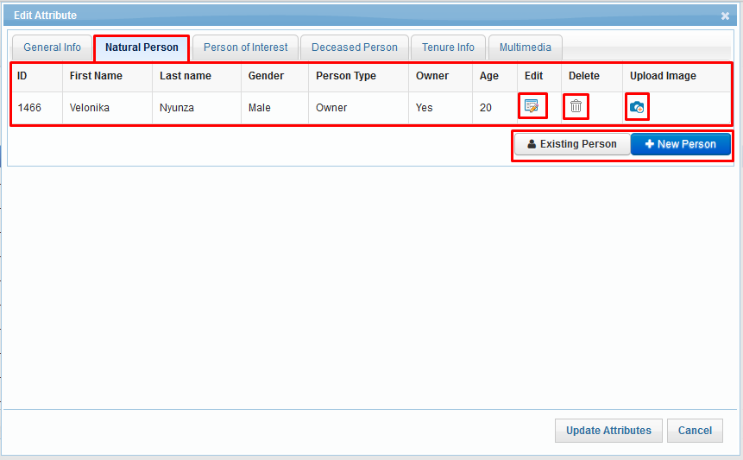Click on ‘Natural Person’ tab, corresponding attribute details of specified parcel will be displayed in grid along with ‘Edit’ and ‘Delete’ and ‘Upload Image’ options. There will be options to add existing person or add a new person.
4. 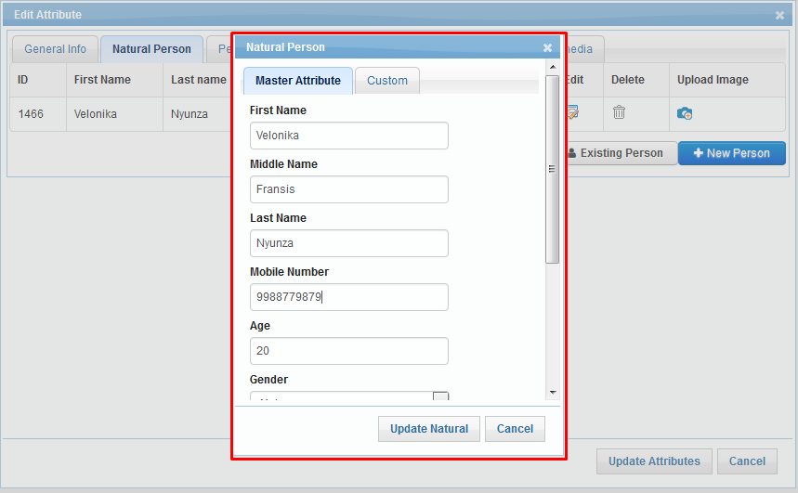Click on ‘Edit’ option, ‘Natural Person’ dialogue will be displayed with ‘Master Attributes’ and ‘Custom’ tabs and ‘Update Natural’ button. Corresponding details will be available in edit mode.
5. 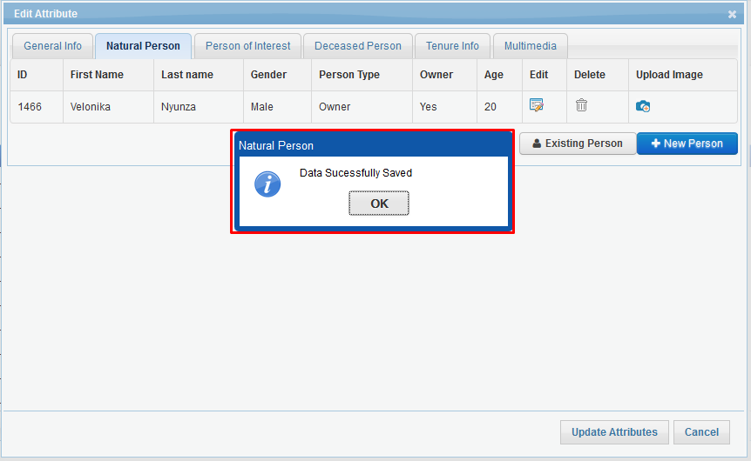Edit the required details and click on ‘Update Natural’ button. Application will save the edited details and will display an acknowledge message.
6. To upload image of corresponding person, click on ‘Upload Image’ option. Application will display current available image with browse option.

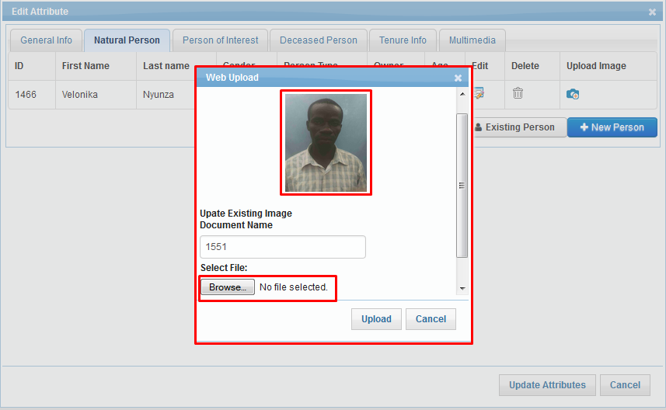

1. Locate required image and click on ‘Upload’ button. Application will upload new image and an acknowledgement message will be displayed.

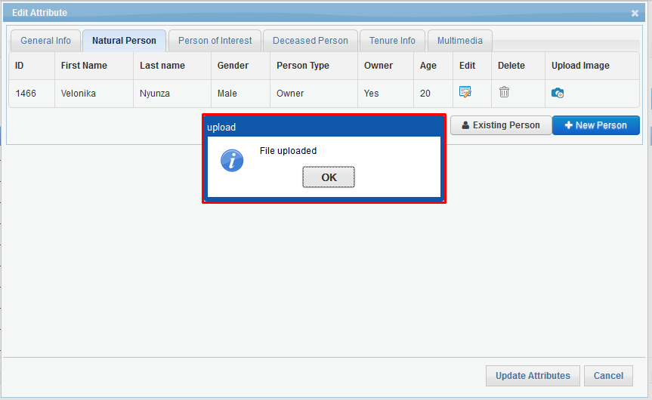

1. Click on ‘Upload Image’ option. Application will display newly uploaded image.

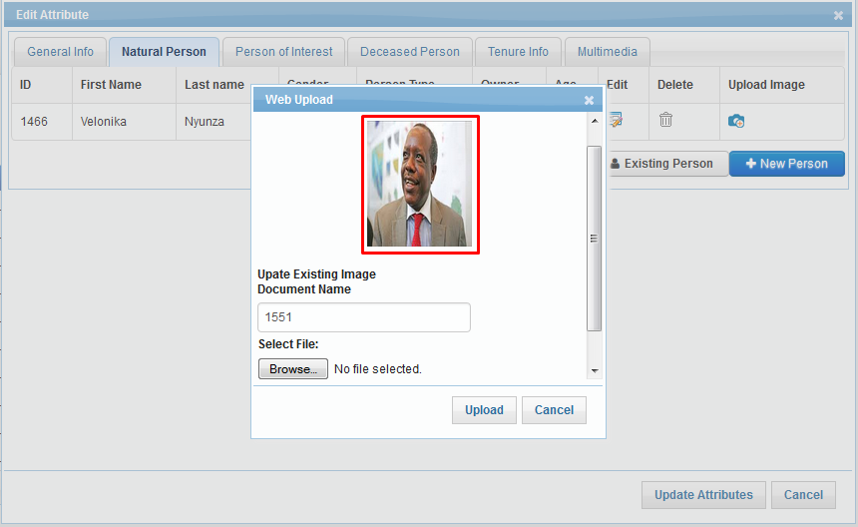

1. 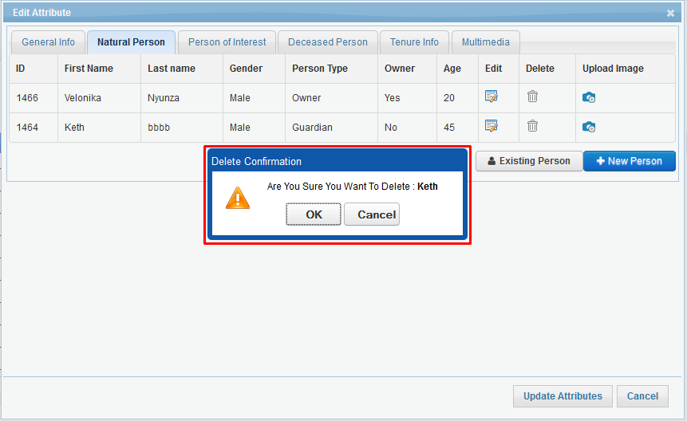If more than one person exist, User can delete the record of any person, click on ‘Delete’ option, Application will display a confirmation message.
2. Click on ‘OK’ button, Application will delete specified natural person. Corresponding details will be removed from the grid and an acknowledgement message will be displayed.

**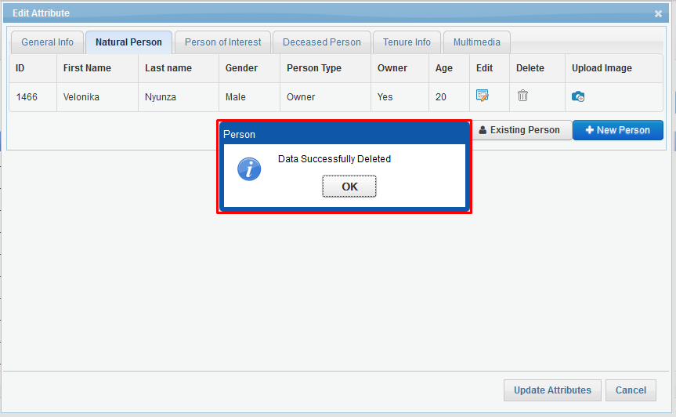Existing Person:**

‘Existing Person’ facilitates user to associate person with spatial unit who has been deleted previously.

**Steps:**

Click on ‘Existing Person’ button, ‘Add Natural Person’ dialogue will be displayed with details of available persons along with ‘Add Person’ option.

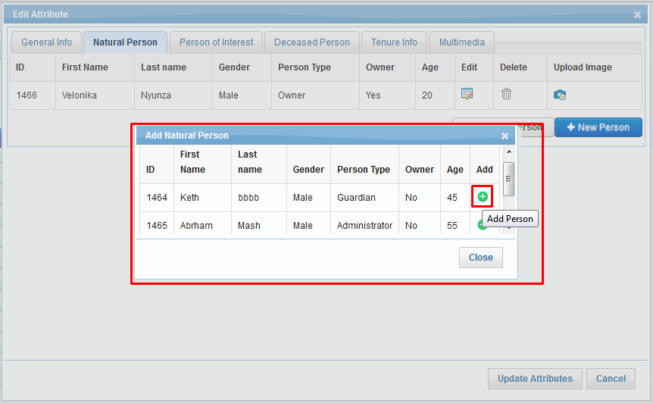

Click on ‘Add Person’ option associated with person details. Application will associate that person with spatial unit and an acknowledgement message will be displayed.

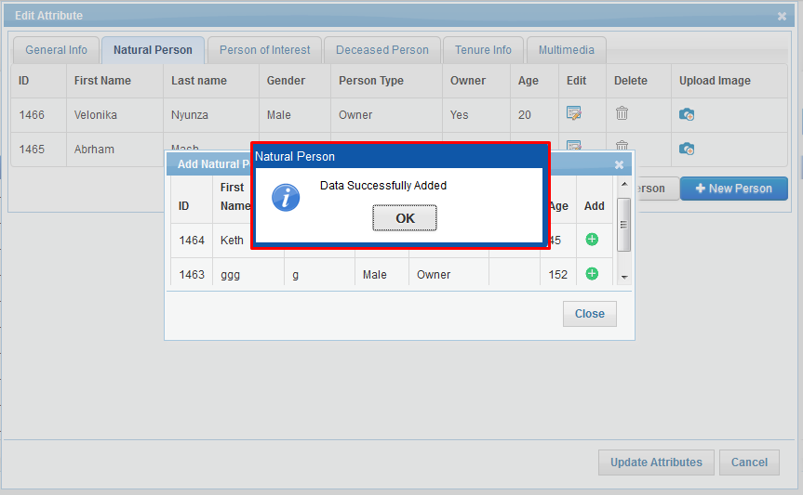

Selected person will become available in ‘Natural Person’ tab.

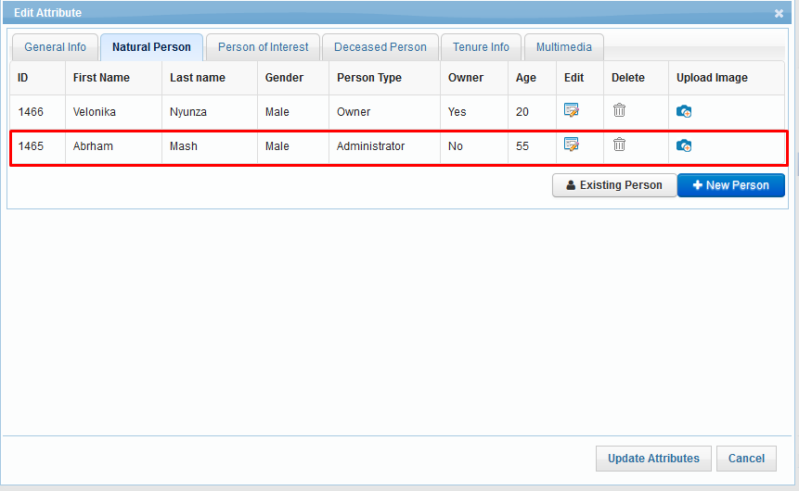

**+New Person:**

‘Add New Person’ facilitates user to add new person and associate person with spatial unit.

**Steps:**

1. Click on ‘+New Person’ button, ‘Natural Person’ dialogue will be displayed.
2. Enter valid values in mandatory fields and click on ‘Save’ button.

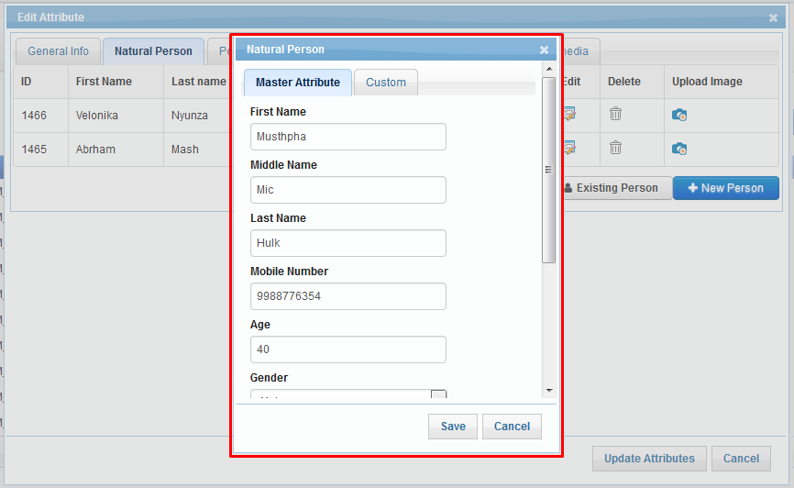

1. Details of person will be saved and will become available in ‘Natural Person’ tab.

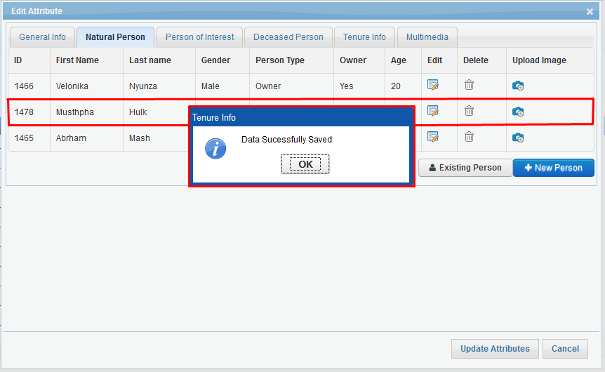

1. Once editing in all tabs are done, Click on ‘Update Attributes’ button. Application will display an confirmation message. Click on ‘Validate and Update' button, Application will validate the data, if any validation error is encountered, an appropriate message will be displayed. If no validation error occurs, application will save the edited details and will display an acknowledge message.

#### Update Non-Natural Person

This tab facilitates user to update non natural person’s details of a specified parcel.

**Steps:**

1. 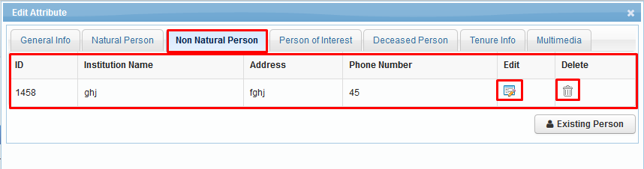Click on ‘Non Natural Person’ tab, corresponding attribute details of specified parcel will be displayed in grid along with ‘Edit’ and ‘Delete’ options.
2. 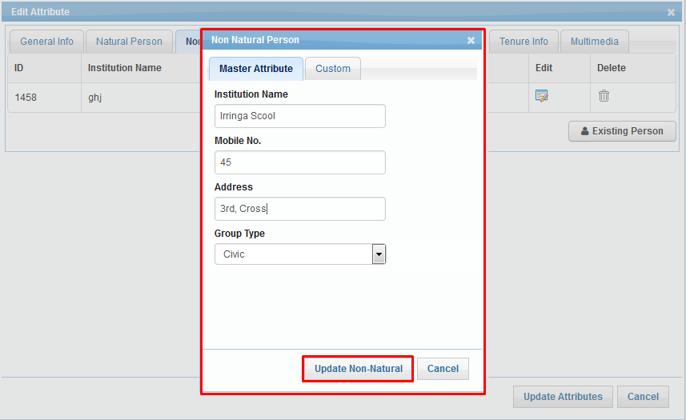Click on ‘Edit’ option, ‘Non Natural Person’ dialogue will be displayed with ‘Master Attributes’ and ‘Custom’ tabs and ‘Update Non Natural’ button. Corresponding details will be available in edit mode.
3. 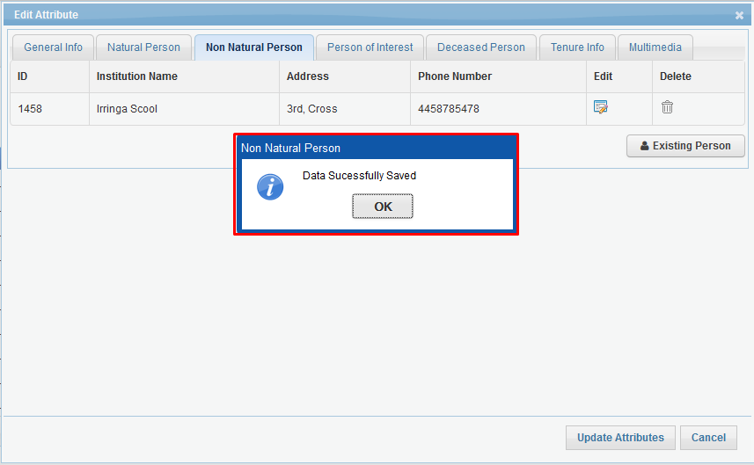Edit the required details and click on ‘Update Non Natural’ button. Application will save the edited details and will display an acknowledge message.
4. To delete the record, click on ‘Delete’ option, Application will display a confirmation message.
5. Click on ‘OK’ button, Application will delete specified non natural person details and will display an acknowledgement message.

#### Update Person of Interest

This tab facilitates user to add/update person of interest for a specified parcel.

**Steps:**

1. Click on ‘Person of Interest’ tab, Details of available persons will be displayed in grid along with ‘Edit’ and ‘Delete’ options. There will be an option to add new person of interest.

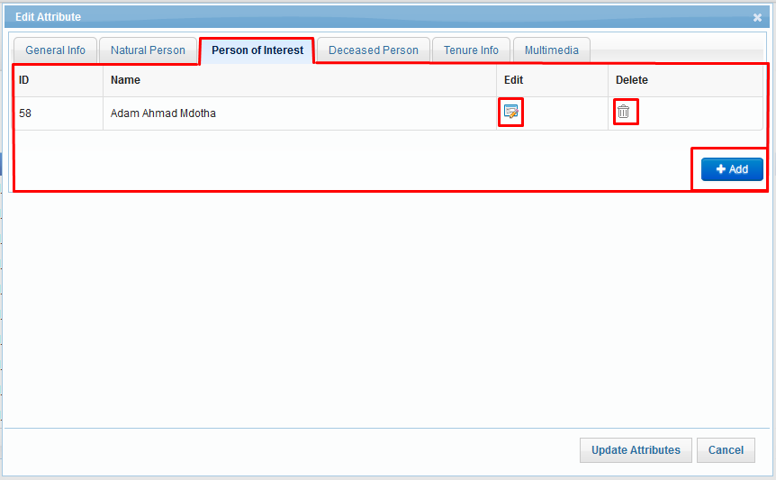

1. 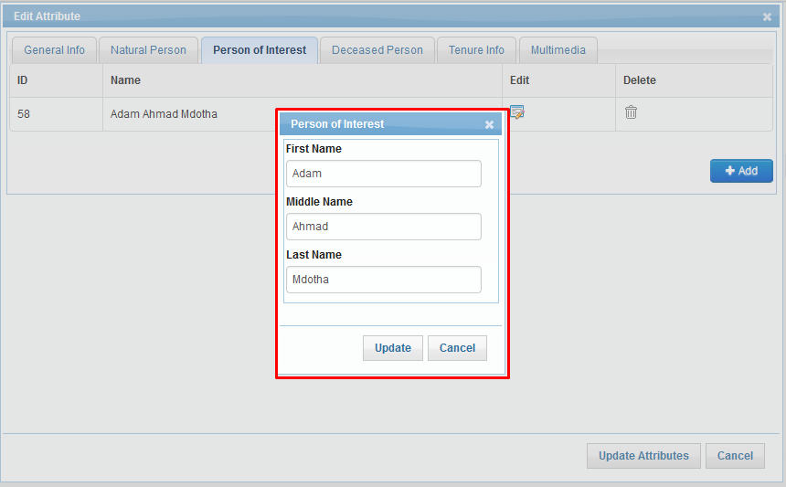Click on ‘Edit’ option, ‘Person of Interest’ dialogue will be displayed. Details of Corresponding person will be available in edit mode.
2. 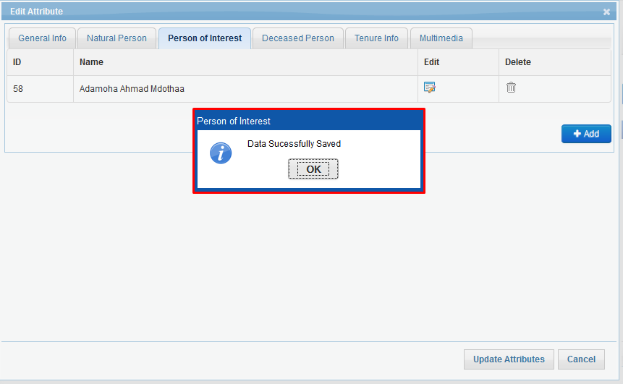Edit the required details and click on ‘Update’ button. Application will save the edited details and will display an acknowledge message.
3. To delete the record, click on ‘Delete’ option, Application will display a confirmation message.
4. Click on ‘OK’ button, Application will delete specified person details and will display an acknowledgement message.

**Add New Person of Interest:**

+Add functionality facilitates user to add new person of interest for a specified parcel.

**Steps:**

Click on ‘+Add’ button.

Application will display ‘Person of Interest’ dialogue.

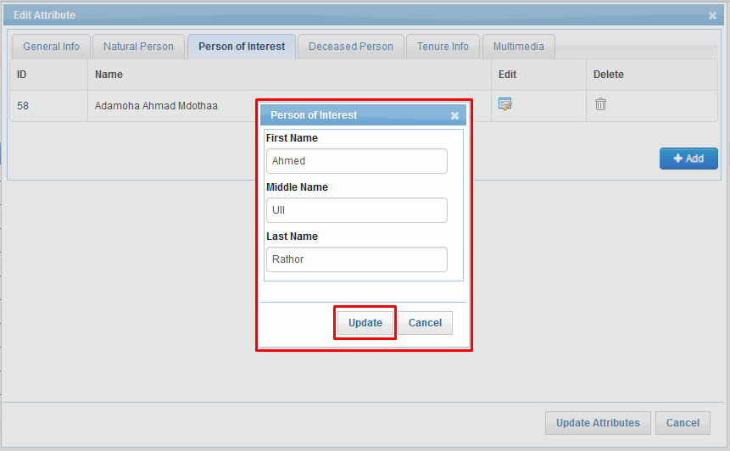

Enter required values and click on ‘Update’ button.

New ‘Person of Interest’ will be added and will become available in grid.

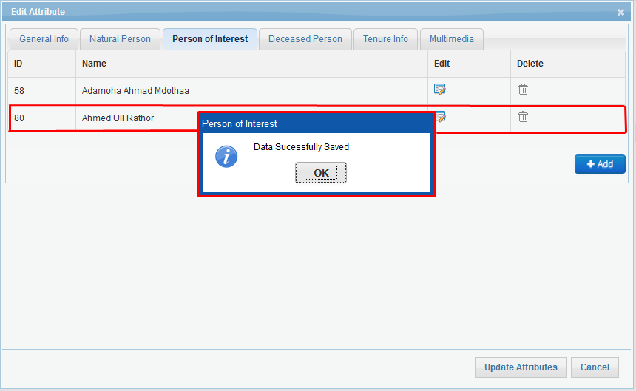

#### Update Deceased Person

‘Update Deceased Person’ tab facilitates user to add/update details of deceased person.

**Steps:**

1. 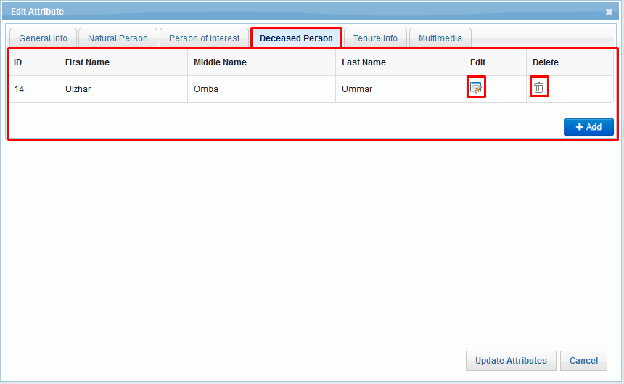Click on ‘Deceased Per’ tab, Details of available persons will be displayed in grid along with ‘Edit’ and ‘Delete’ options. There will be an option to add new deceased person.
2. Click on ‘Edit’ option, ‘Deceased Person’ dialogue will be displayed. Details of Corresponding person will be available in edit mode.

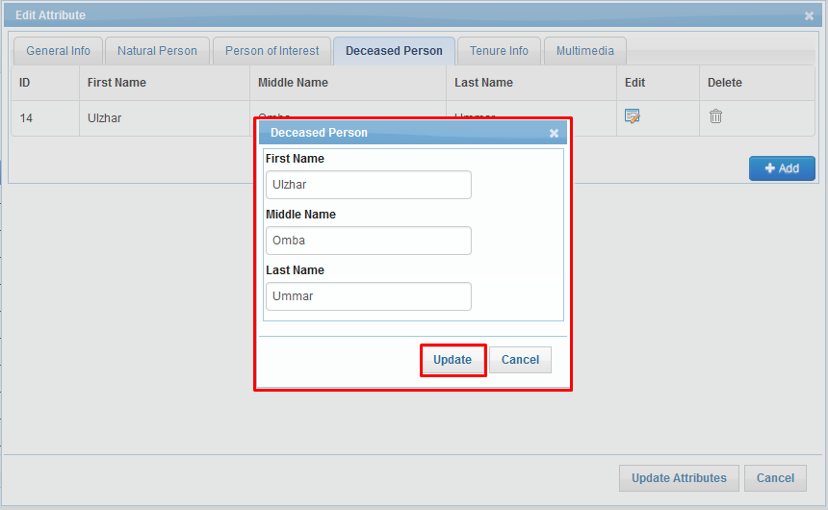

1. Edit the required details and click on ‘Update’ button. Application will save the edited details and will display an acknowledge message.

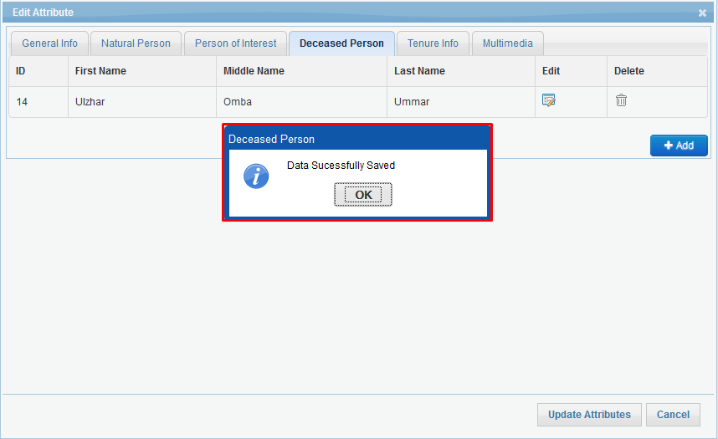

1. To delete the record, click on ‘Delete’ option, Application will display a confirmation message.
2. Click on ‘OK’ button, Application will delete specified person details and will display an acknowledgement message.

**Add New Deceased Person:**

‘+Add’ functionality facilitates user to add new deceased person if deceased person doesn’t exists.

**Steps:**

1. Click on ‘+Add’ button.
2. 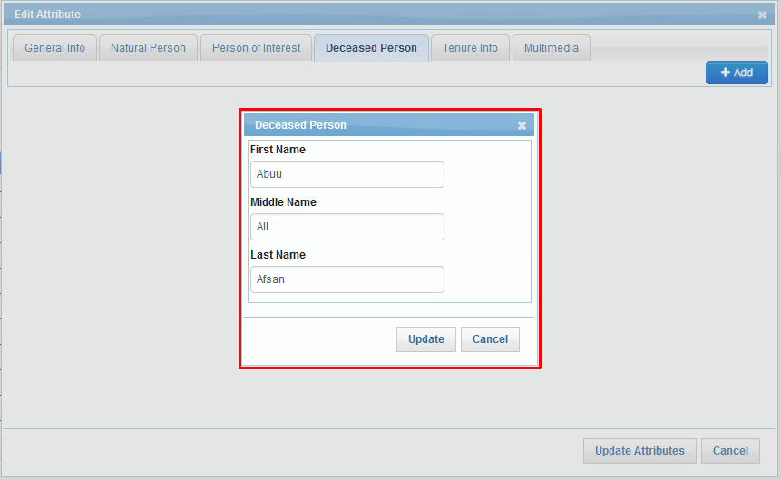Application will display ‘Deceased Person’ dialogue.
3. Enter required values and click on ‘Update’ button.
4. ‘Deceased Person’ will be added and will become available in grid.

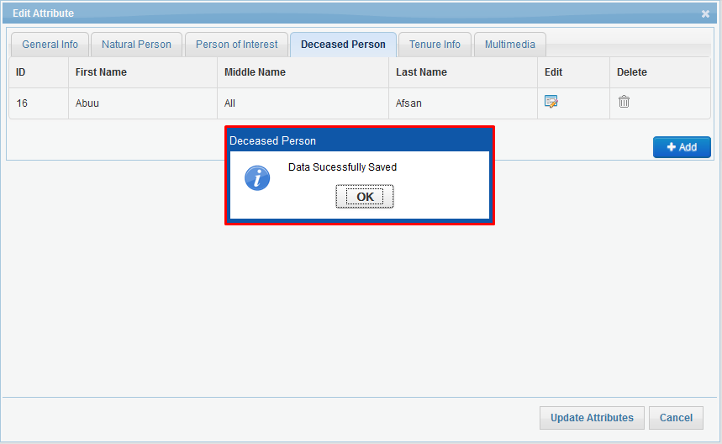

#### Update Tenure Info

This tab facilitates user to update Tenure Info of a specified parcel.

**Steps:**

1. 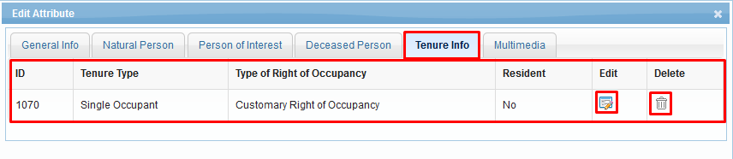Click on ‘Tenure Info’ tab, corresponding attribute details of specified parcel will be displayed in grid along with ‘Edit’ and ‘Delete’ options.
2. 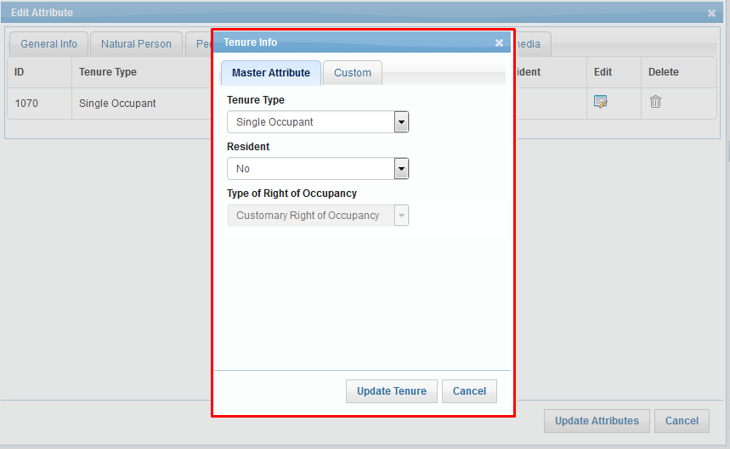Click on ‘Edit’ option, ‘Tenure Info’ dialogue will be displayed with ‘Master Attributes’ and ‘Custom’ tabs and ‘Update Tenure Info’ button. Corresponding details will be available in edit mode.
3. Edit the required details and click on ‘Update Tenure Info’ button. Application will save the edited details and will display an acknowledge message.

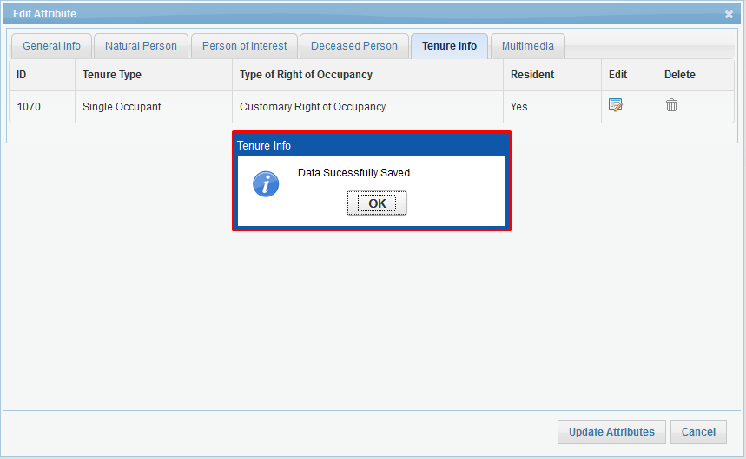

1. 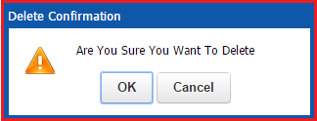To delete the record, click on ‘Delete’ option, Application will display a confirmation message.
2. 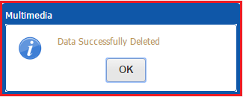Click on ‘OK’ button, Application will delete specified Tenure details and will display an acknowledgement message.

#### Update Multimedia

This tab facilitates user to update multimedia associated with a specified parcel.

**Steps:**

1. 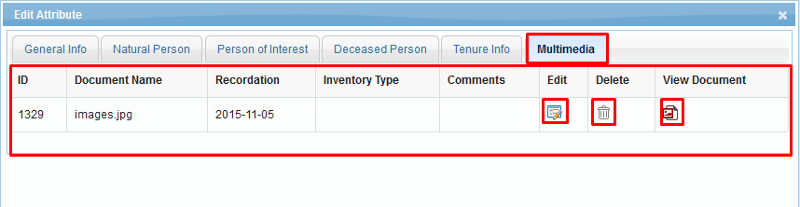Click on ‘Multimedia’ tab, corresponding attribute details of specified parcel will be displayed in grid along with ‘Edit’, 'Delete’ and 'View Document' options.
2. 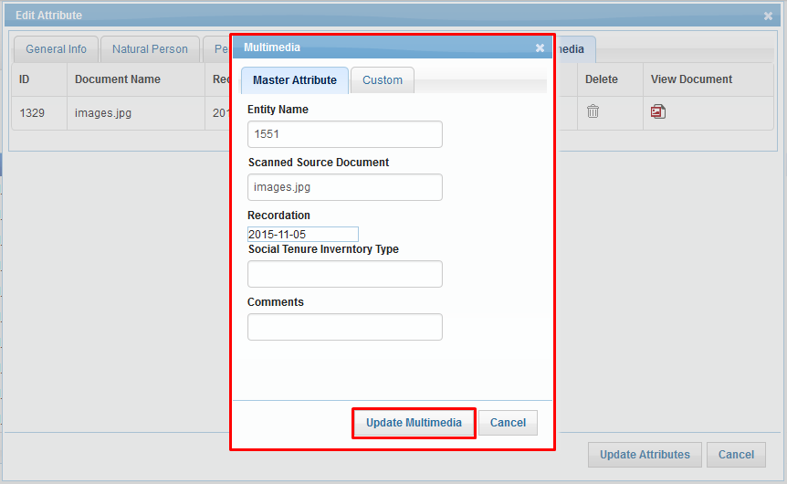Click on ‘Edit’ option, ‘Multimedia’ dialogue will be displayed with ‘Master Attributes’ and ‘Custom’ tabs along with ‘Update Multimedia’ button. Corresponding details will be available in edit mode.
3. 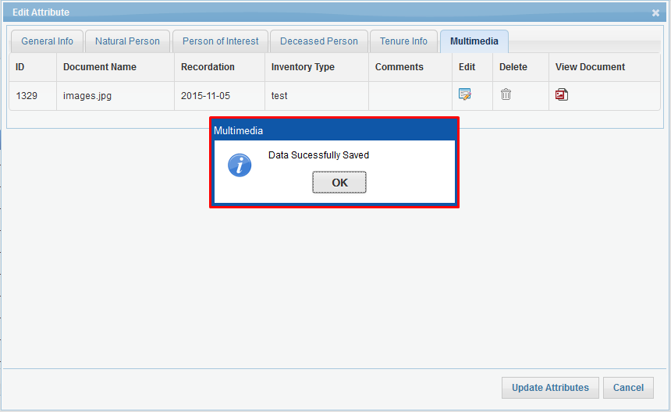 Edit the required details and click on ‘Update Multimedia’ button. Application will save the edited details and will display an acknowledge message.
4. To view associated document, click on ‘View Document’ option, Application will display document in new tab of opened browser.
5. 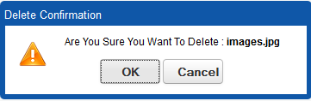To delete the record, click on ‘Delete’ option, Application will display a confirmation message.
6. 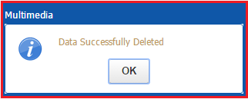Click on ‘OK’ button, Application will delete multimedia details and will display an acknowledgement message.

### Approve Status

‘Approve Status’ facilitate user to approve a spatial unit which is in ‘New’ state.

**Steps:**

1. 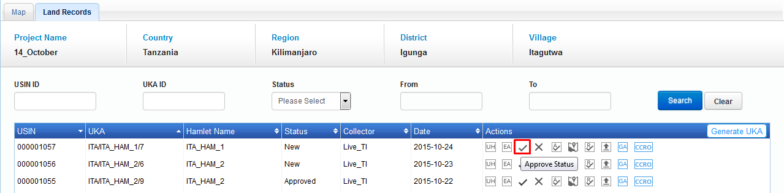User clicks on ‘Approve Status’ option associated with parcel details in grid.
2. 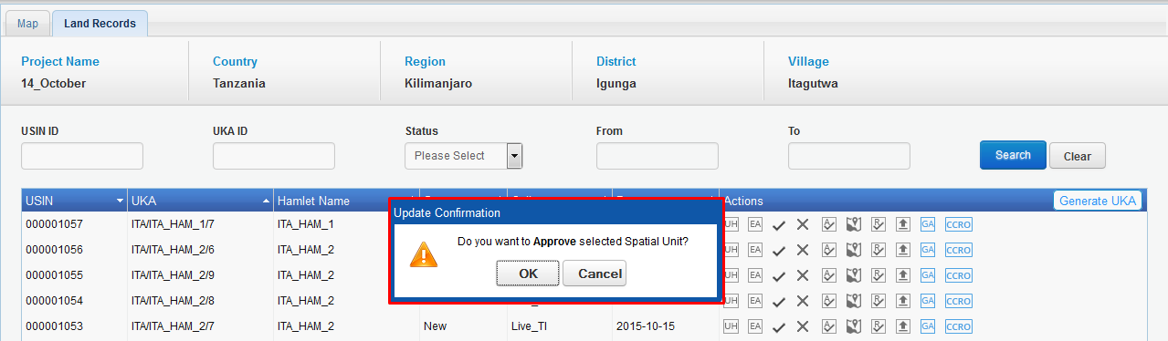Application will display a confirmation message.
3. 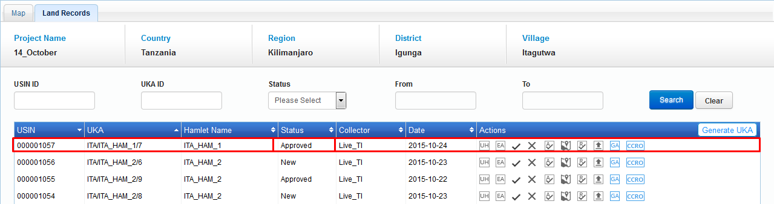Click on ‘OK’ button. Application will update parcels status as ‘Approved’; same will be available in grid.

### Reject Status

‘Reject Status’ facilitate user to reject a spatial unit which is in ‘New’ state.

**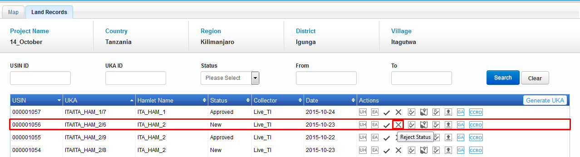Steps:**

1. User clicks on ‘Reject Status’ option associated with parcel details in grid.
2. 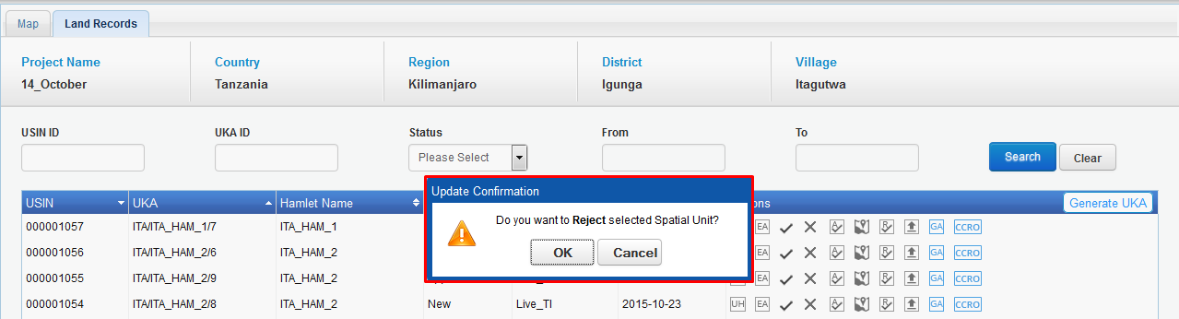Application will display a confirmation message.
3. 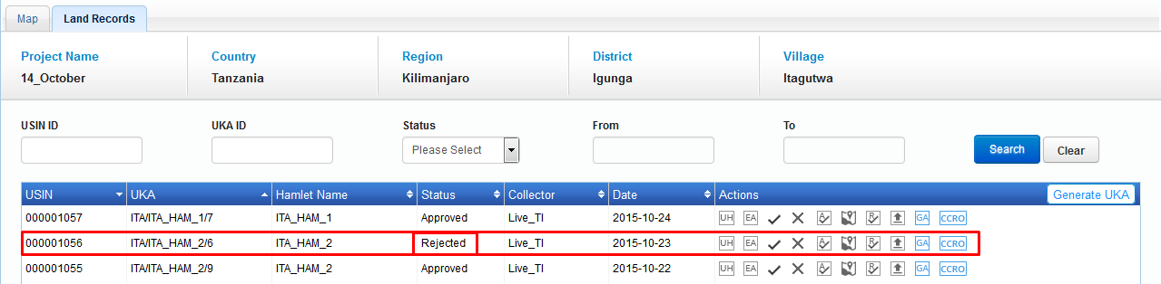Click on ‘OK’ button. Application will update parcels status as ‘Rejected’; same will be available in grid.

### Adjudicate Spatial Attribute

‘Adjudicate Spatial Attribute’ facilitates user to adjudicate a spatial unit which is either in ‘New’ state or in ‘Approved’ state.

**Steps:**

1. 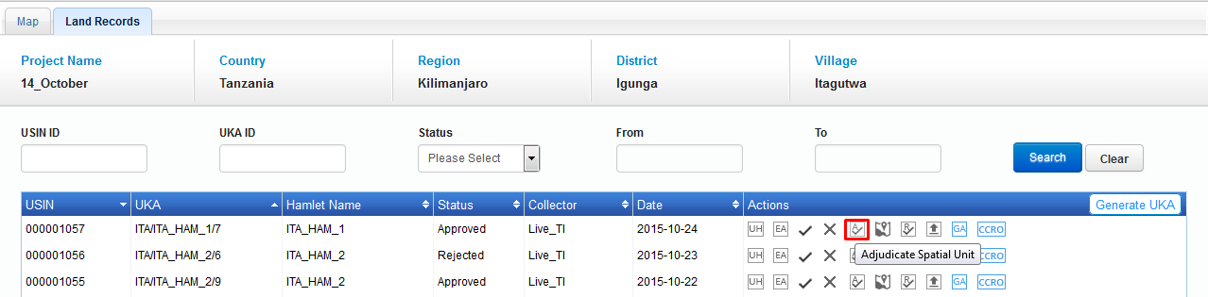User clicks on ‘Adjudicate Spatial Unit’ option associated with parcel details in grid.
2. 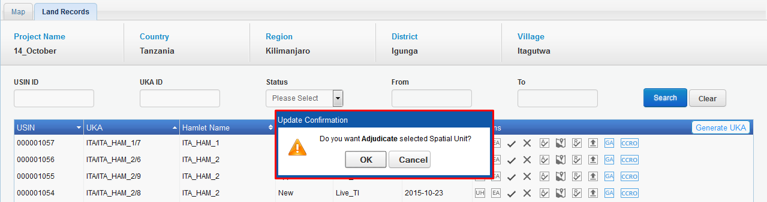Application will display a confirmation message.
3. 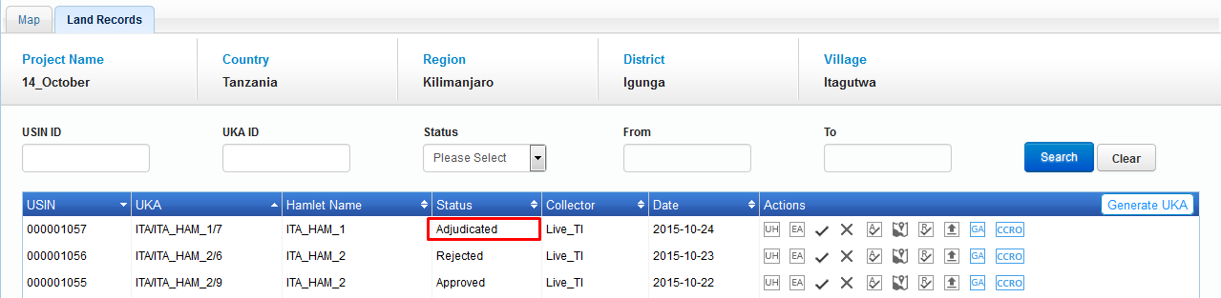 Click on ‘OK’ button. Application will update parcels status as ‘Adjudicated’; same will be available in grid.

### Show on map

‘Show on Map’ facilitates user to navigate to map and zoom to the corresponding spatial unit.

**Steps:**

1. 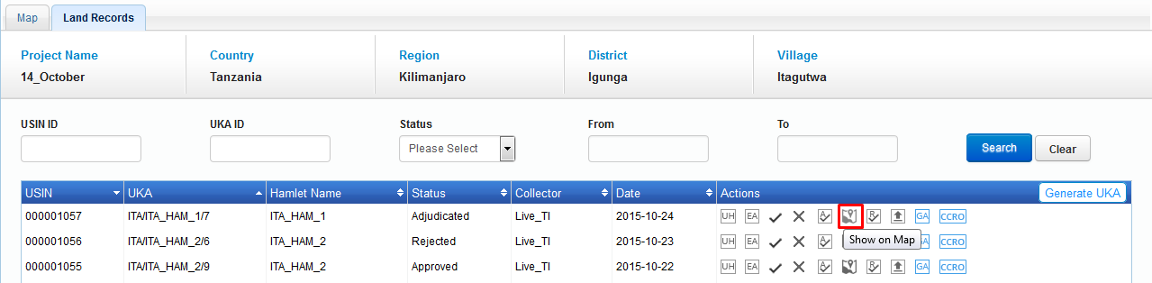User clicks on ‘Show on Map’ option associated with parcel details in grid.
2. Map viewer will be displayed with zoomed in on corresponding parcel.

### Finalize Data

‘Finalize Data’ facilitates user to finalize a spatial unit which is in any state.

**Steps:**

1. 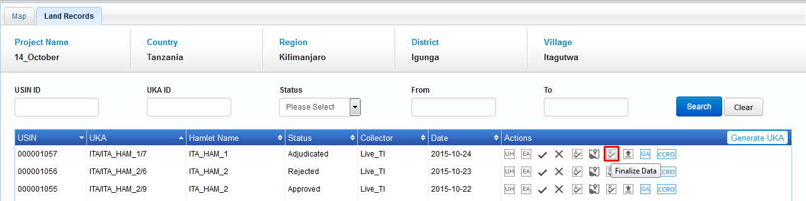User clicks on ‘Finalize Data' option associated with parcel details in grid.

1. 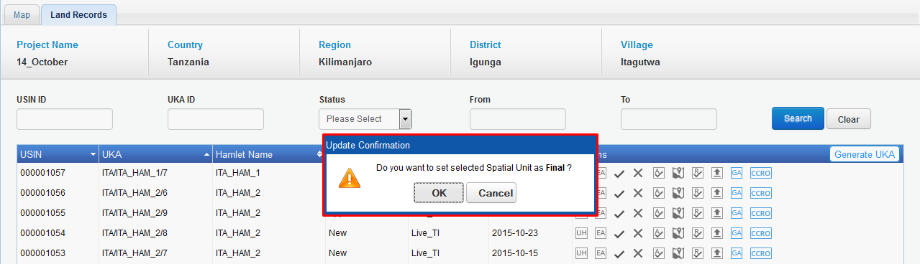Application will display a confirmation message.

1. 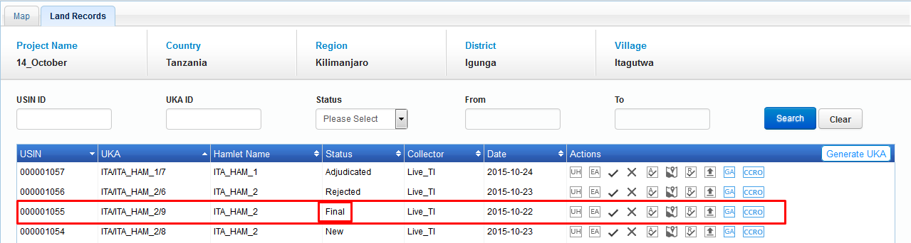Click on ‘OK’ button. Application will update parcels status as ‘Final’; same will be available in grid.

### Upload Document

‘Upload Document’ facilitate user to associate required documents to the spatial unit. This will enable user to attached documents in any of the following extensions – ‘.jpeg’, ’.png’, ’.pdf’, ’.xls’, ’.doc’

**Steps:**

1. User clicks on ‘Upload Document' option associated with parcel details in grid.
2. 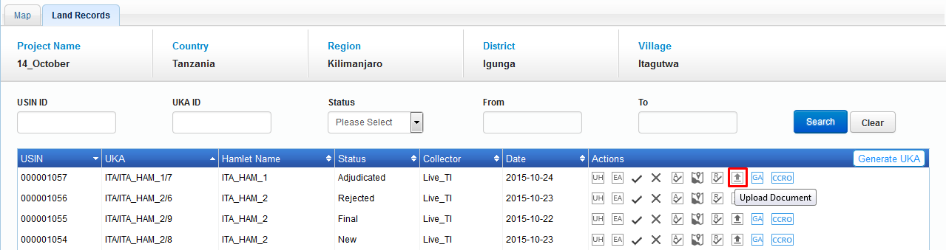'Web Upload' dialogue box will be displayed with 'Document Name', 'Comments' input box, 'Choose File' browser option along with 'Upload' button.
3. 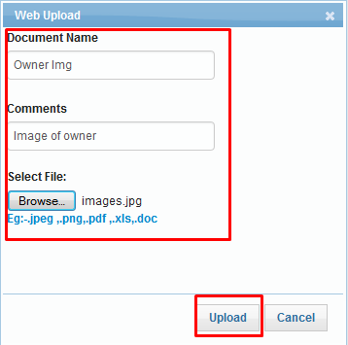Enter 'Document Name', 'Comments', browse required doc and click on ‘Upload’ button.
4. Application will upload specified document and an acknowledgement message will be displayed.

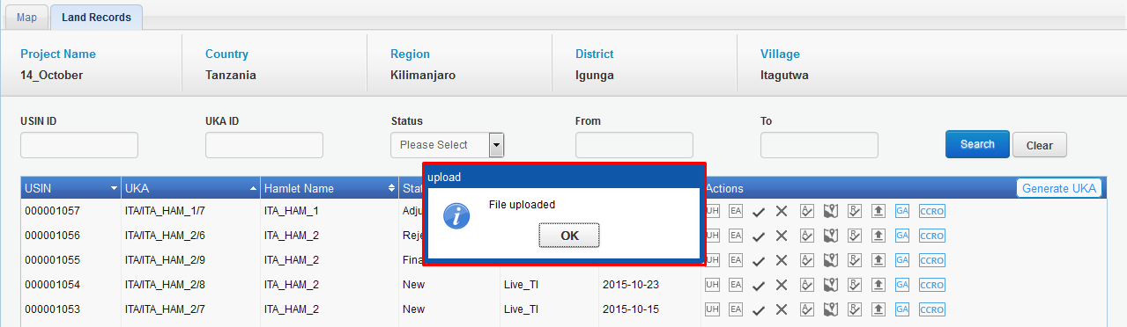

### Generate Adjudication FORM

Generate Adjudication form facilitates user to generate adjudication certificate for a parcel.

**Steps:**

1. Click on ‘Generate Adjudication Form’ option associated with parcel details in grid.

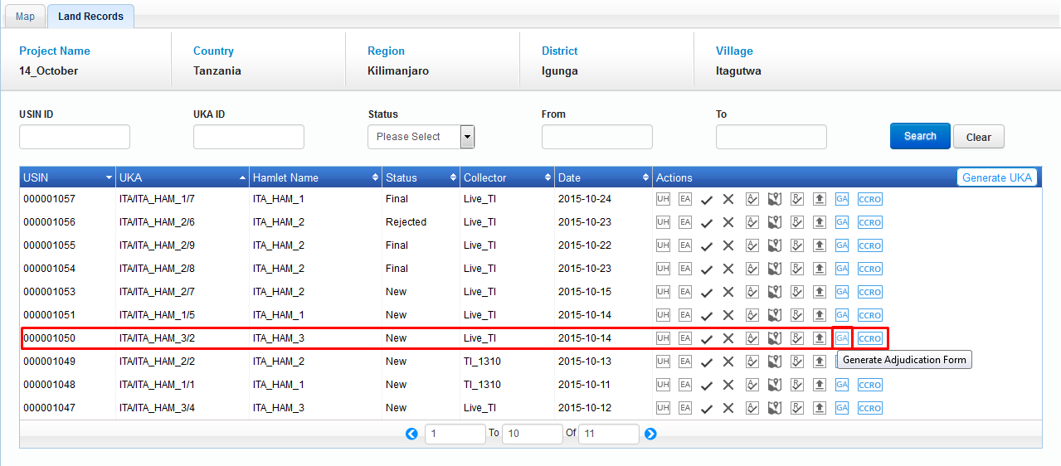

1. Application will display ‘Language Preference’ dialogue to select required language either ‘English’ or ‘Swahili’.

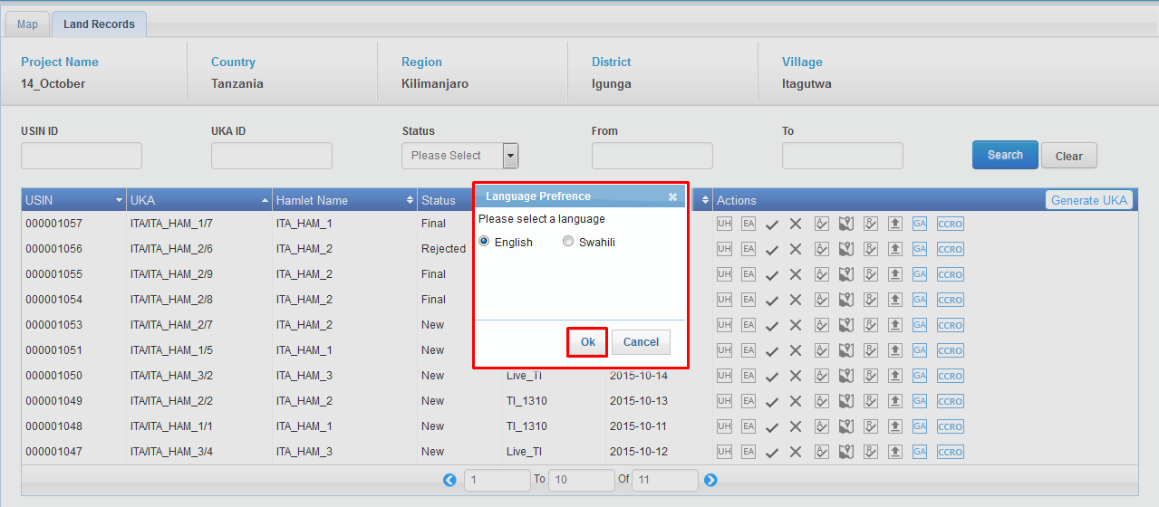

1. Application will generate adjudication certificate for corresponding parcel and same will be displayed in new tab or browser.

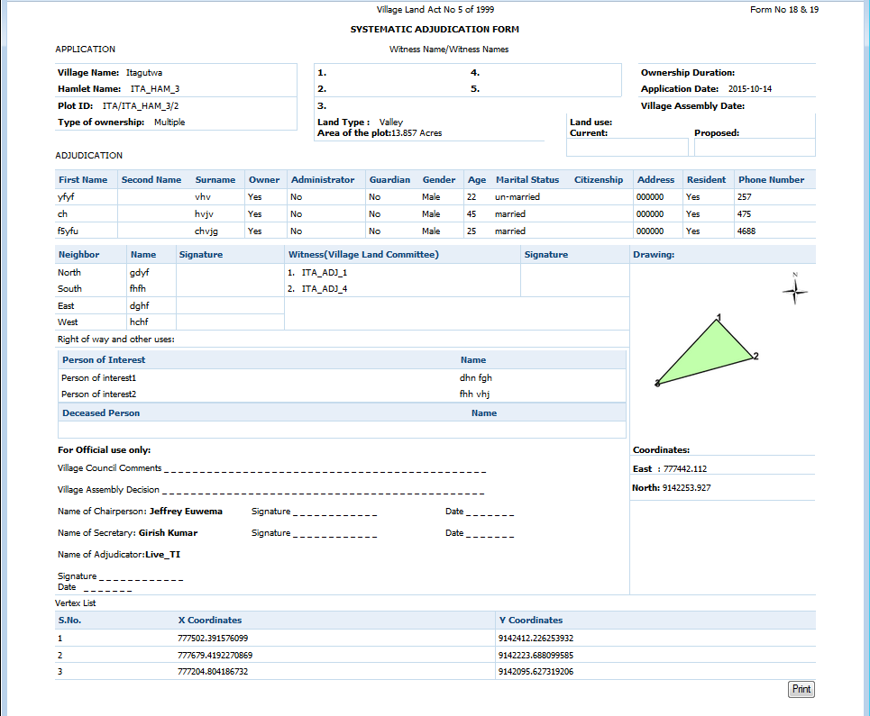

### Generate CCRO Certification

Generate CCRO Certification’ facilitates user to generate CCRO certificate for a parcel.

**Steps:**

1. Click on ‘Generate CCRO Certification’ option associated with parcel details in grid.



1. 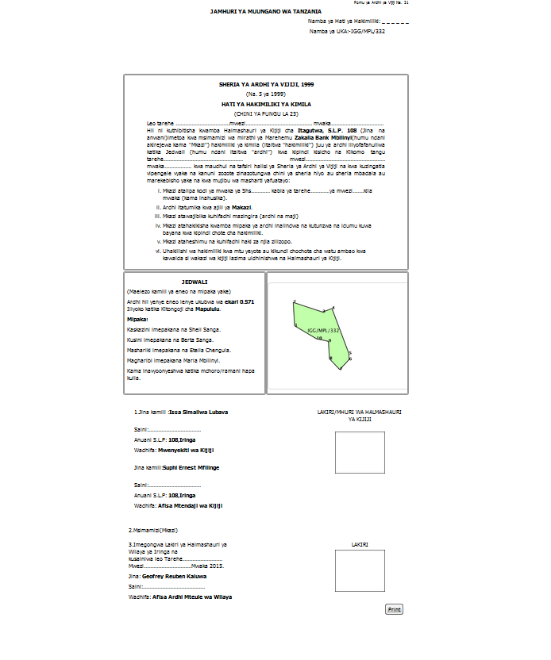Application will generate CCRO certificate for corresponding parcel and same will be displayed in new tab.

Phase –II Implementations

Incorporation of Hamlet Details and Land Adjudication Committee Members

Scope of Work

The MAST user will be allowed to add a list of hamlets for each village while creating a project in the MAST web application. The list of hamlets mapped to the project will then be available to be downloaded into the mobile application along with other configuration data (this is a system process and the user does not see this process). During data capture, the Trusted Intermediary will enter details of a parcel and he/she will select a hamlet from a dropdown list. Similarly, this functionality will be added for adjudication committee members to streamline the data capture process. User will also be allowed to add the committee members (formally known as project

# Phase –II Implementations

# Incorporation of Hamlet Details and Land Adjudication Committee Members

Hamlet details are required in generation of UKA no. & details of committee members are required in mobile application to select the witnesses from a drop down list. Adding functionality to capture hamlet data while filling information of the parcels will ensure that parcels are mapped to hamlets correctly. It takes out the need for additional mapping of hamlet boundaries by the DLO and ensures that there is no conflict in data during signing of adjudication forms. Adding of committee members while creating the project will ensure the correct witness detail are saved while capturing the land data, and available in the adjudication form.

## System Function

### **Incorporation of Hamlet details**

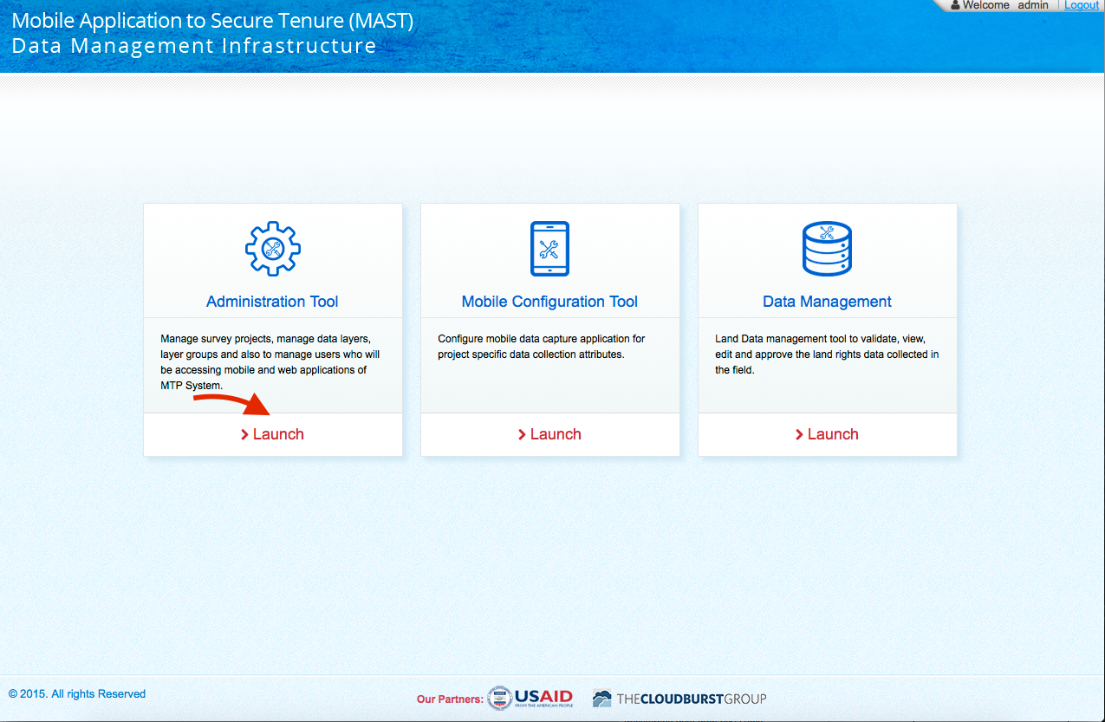User logins the web application & clicks on “Administration Tool” as shown below:

User then selects “Survey Projects” from left side menu, following screen will be shown:

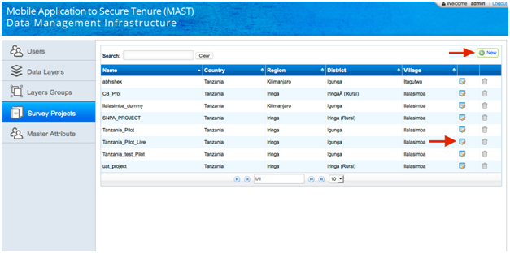

User can add new project by clicking on “New button” or can edit the existing project by clicking on edit icon as shown above. When user clicks on edit icon following screen will be shown:

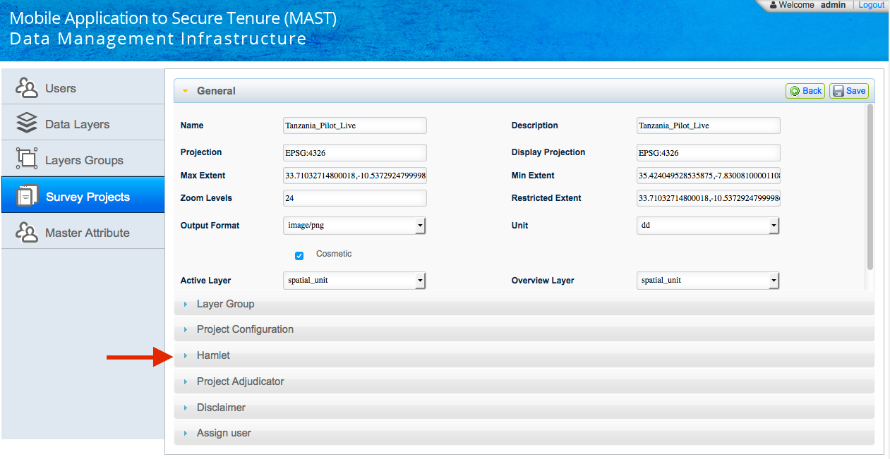User then clicks on Hamlet accordion to see the hamlet details (if exists) or can add the new hamlet detail. Following screen will be shown on clicking **Hamlet accordion**:

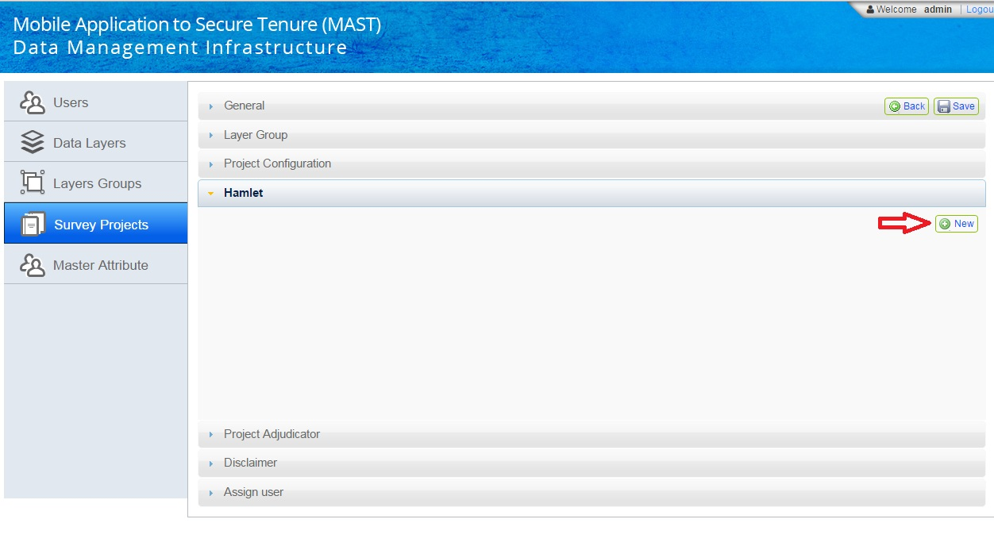

Now user can click on “New” button to add hamlet details as shown above. A form will be shown on clicking “New” button as shown below:

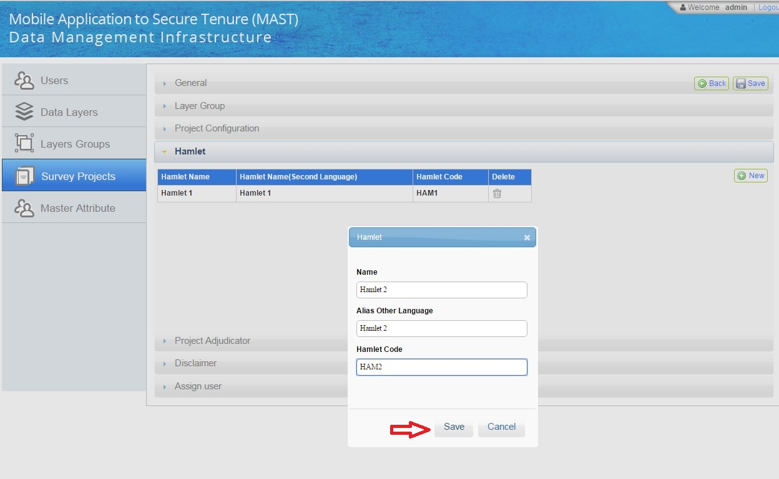

User then will fill the details of hamlet & clicks on “Save” button as shown above, hamlet data will be shown & updated as shown below:

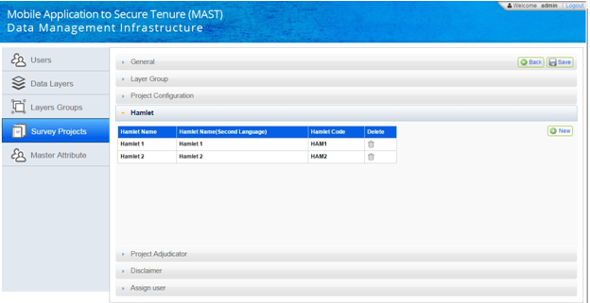

### **Adding of Committee Members (Project Adjudicators)**

Committee members can be added using web application through “Administration Tools”. User 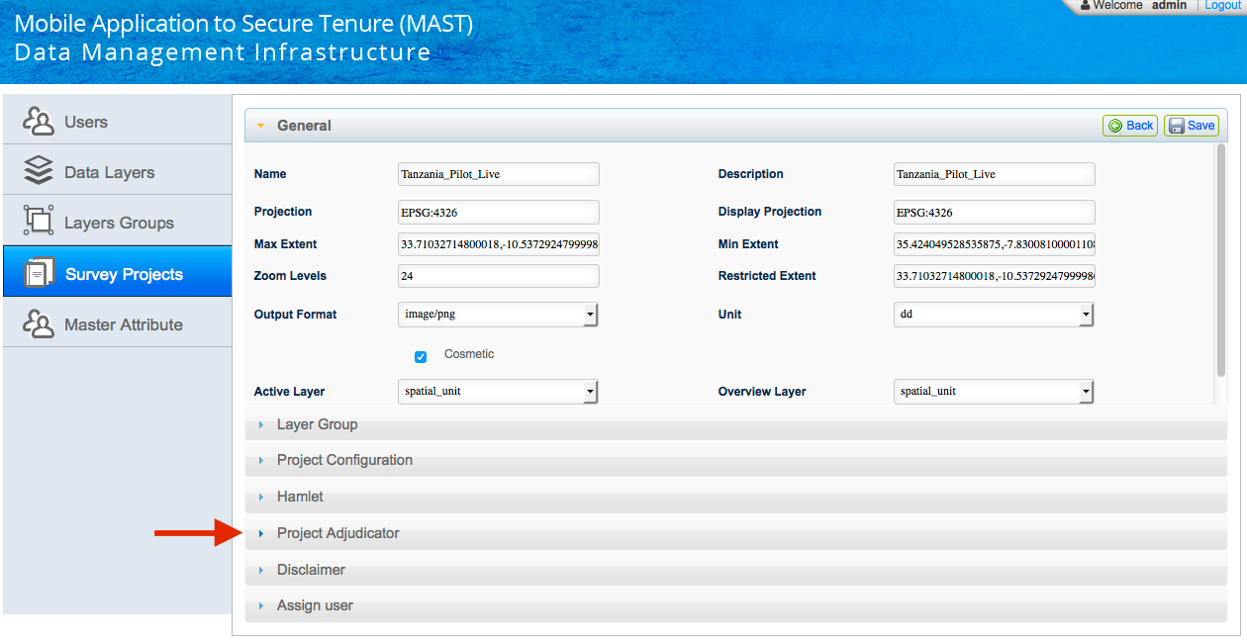will select the “Survey Projects” from menu & then selects “Project Adjudicator” accordion as shown below:

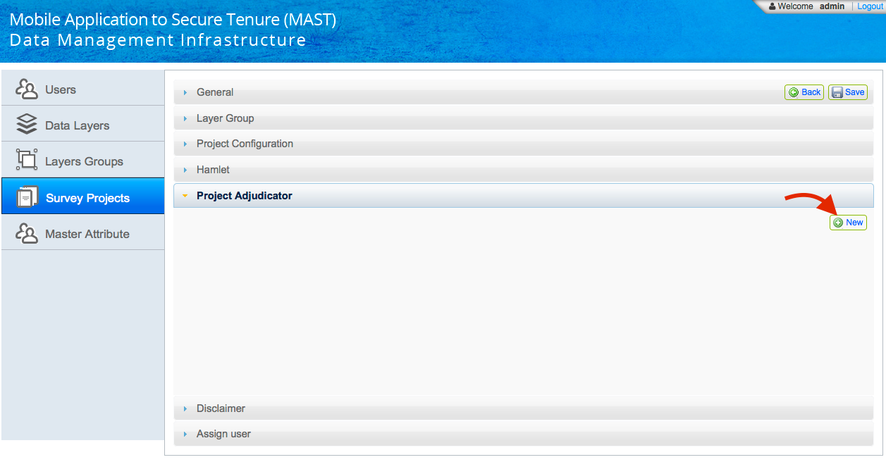Following screen will be shown to user:

User then clicks on “New” button to fill the details of committee member as shown above. A new form will open to fill details as shown below:

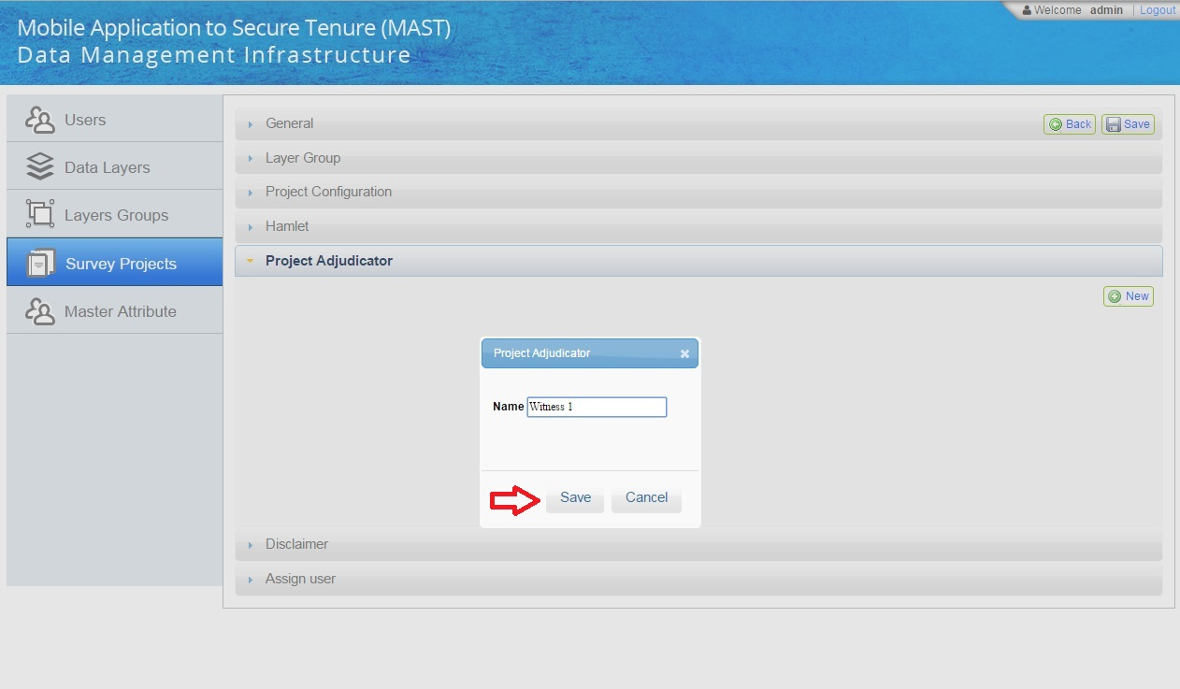User then clicks on “New” button to fill the details of committee member as shown above. A new form will open to fill details as shown below:

Now user will fill the details & the clicks on “Save” button as shown above. Committee members detail will be saved & updated as shown below:

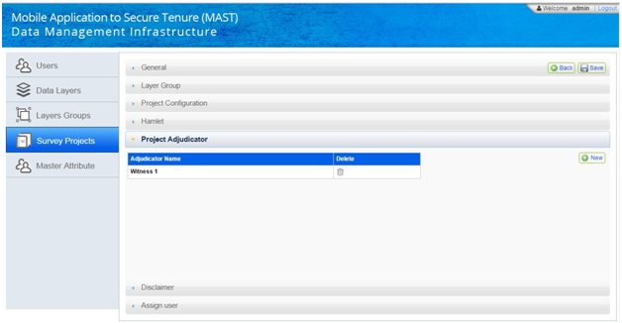

Finally, user saves the project & all the details are saved with project.

#### **Data Model changes**

The hamlets details added using the above method will be added into a new table with the name project\_hamlets and the adjudicator data fill be saved in a new table spatialunit\_personadministrator.

# MAST and Generate UKA Number

## Generation of UKA on Web Application

User clicks on Data Management option as shown in below picture:

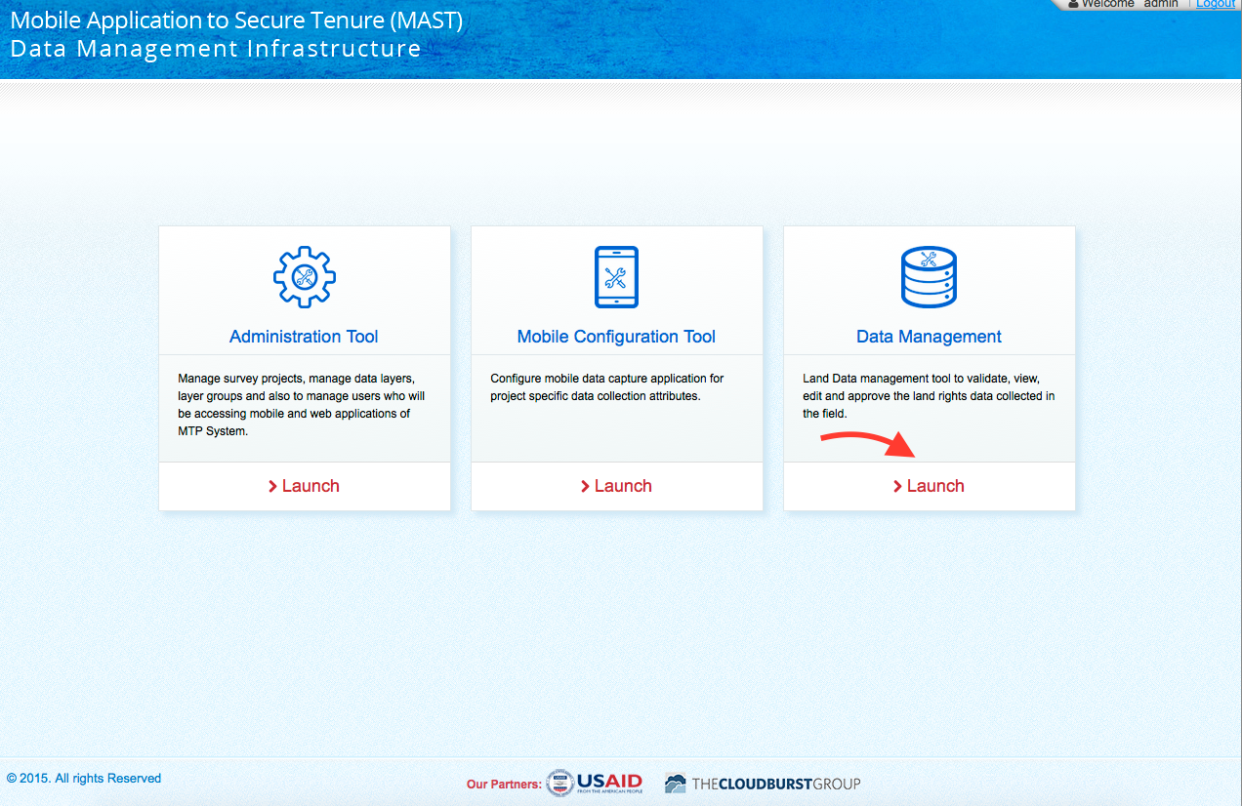

User then clicks on Land Records tab as shown below:

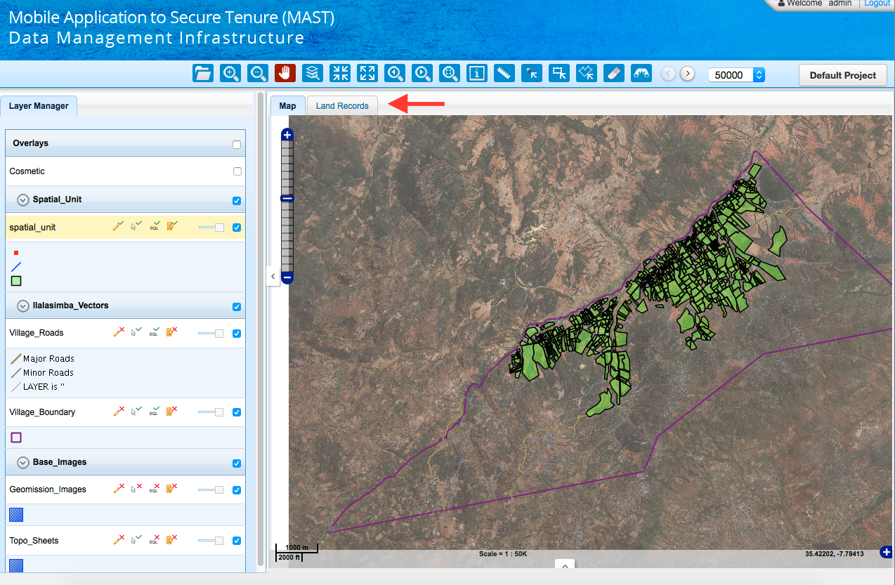

System provides following options to generate UKA number:

UKA number generation for a specific parcel: Generation of UKA number for individual parcels is managed in web application, UKA number needs to be regenerated only in case Hamlet is updated for a Parcel. Application will automatically generate UKA number for the parcel by adding the maximum + 1 unique sequence number to the newly added Parcel in the hamlet.

UKA number generation for all the parcels:

User then clicks on Generate UKA button as shown below:

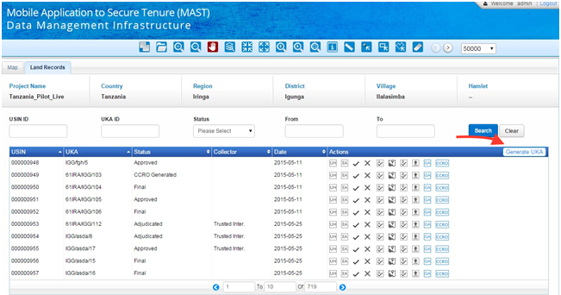

On clicking the Generate UKA button, the system will find all the parcels with empty UKA number and generate the UKA for them. System will keep track of the maximum sequence against all the Hamlets. In case UKA numbers are generated for the first time, system will group all the parcels against Hamlet and start the sequence from 1, in case UKA numbers are generated where UKA numbers are missing or newly created parcels then sequence would be generated from the last sequence count assigned to a parcel.

For the parcels for which UKA number already exists, system will not make any changes.

Format to generate UKA number:

UKA number will be generated by the system utilizing following three parameters:

* Village code
* Hamlet Code
* Sequence number

UKA number will be generated based on ‘Village code/Hamlet code/<sequence number>’.

# MAST Attributes and Reports Update

## Final Listing of MAST Attributes (high Level)

|  |  |  |
| --- | --- | --- |
|  | ***General*** | ***Comments*** |
| 1 | *Project name* |  |
| 2 | *Spatial Unit ID* |  |
| 3 | *Person type* |  |
| 4 | *Village* |  |
| 5 | *Hamlet* |  |
| 6 | *Witness 1 (adjudication Committee member)* |  |
| 7 | *Witness 2 (adjudication Committee member)* |  |
| 8 | *Trusted Intermediary* |  |
|  | ***Property Information*** |  |
| 9 | *Existing Use* |  |
| 10 | *Right Of Way/Other Use* |  |
| 11 | *Land Type* |  |
| 12 | *Neighbor North* |  |
| 13 | *Neighbor South* |  |
| 14 | *Neighbor East* |  |
| 15 | *Neighbor West* |  |
|  | ***Tenure Type*** |  |
| 16 | *Tenure Type* |  |
| 17 | *Type of Right of occupancy* |  |
|  | ***Natural Person (includes Administrator and Guardian)*** | *Can be multiple* |
| 18 | *First Name* |  |
| *19* | *Middle Name* |  |
| *20* | *Last Name* |  |
| *21* | *Gender* |  |
| *22* | *Mobile No.* |  |
| *23* | *Occupation* |  |
| *24* | *Education Level* |  |
| *25* | *Age* |  |
| *26* | *Marital Status* |  |
| *27* | *Citizenship* |  |
| *28* | *Resident* |  |
|  | ***Non- Natural Person*** |  |
| 29 | *Institution name* |  |
| *30* | *Address* |  |
| *31* | *Phone Number* |  |
|  | ***Multi-media*** |  |
| 32 | *Name* |  |
| *33* | *Comments* |  |
| *35* | *Village Chairperson* |  |
| *36* | *Village Secretary* |  |

## Adjudication Forms

The current adjudication form in English is shown below with attributes number from the final listing ([section 3](#_Final_Listing_of)) marked in red in the image below:

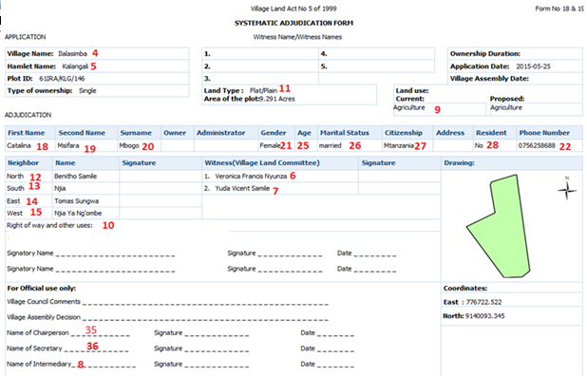

Different adjudication forms based on type of types of natural person and Tenure types are shown below:

* Type of tenure (single occupancy, multiple occupancy,
* Tenancy in common,
* Tenancy in common (with an administrator)
* And tenancy in common (with a Guardian)

### Adjudication Data and Report for Single Occupant

#### Data for Tenure Type: Single Occupant Data

|  |  |  |  |  |  |  |
| --- | --- | --- | --- | --- | --- | --- |
|  | ***General*** | ***Data*** | ***Data*** | ***Comments*** | | |
| 1 | *Project name* |  |  | | *Entered in system* |
| 2 | *Spatial Unit ID* |  |  | | *Captured by system* |
| 3 | *Person type* |  |  | | *Identified by TI* |
| 4 | *Village* | *Ilalasimba* |  | |  |
| 5 | *Hamlet* |  |  | | *entered during field data capture* |
| 6 | *Witness 1 (adjudication Committee member)* | *John Stevens* |  | | *Selected from drop down list in Mobile Application* |
| 7 | *Witness 2 (adjudication Committee member)* | *Henry Stevens* |  | | *Selected from drop down list in Mobile Application* |
| 8 | *Trusted Intermediary* | *Modesty Kachubo* |  | | *Selected from phone ID, assigned to TI* |
|  | ***Property Information*** |  |  | |  |
| 9 | *Existing Use* |  |  | |  |
| 10 | *Right Of Way/Other Use* |  |  | |  |
| 11 | *Land Type* |  |  | |  |
| 12 | *Neighbor North* | *John sassy Ronald* |  | |  |
| 13 | *Neighbor South* | *Jorge Simopnet Malave* |  | |  |
| 14 | *Neighbor East* | *Tito Luis Rentas* |  | |  |
| 15 | *Neighbor West* | *David sin Backahnd* |  | |  |
|  | ***Tenure Type*** |  |  | |  |
| 16 | *Tenure Type* |  |  | |  |
| 17 | *Type of Right of occupancy* |  |  | |  |
|  | ***Natural Person (includes Administrator and Guardian)*** |  |  | | *Can be multiple* |
| 18 | *First Name* | *Jeff* |  | |  |
| *19* | *Middle Name* | *Alan* |  | |  |
| *20* | *Last Name* | *James* |  | |  |
| *21* | *Gender* | *Male* |  | |  | |
| *22* | *Mobile No.* | *000000000* |  | |  |
| *23* | *Owner* | *Yes* |  | |  |
| *24* | *Administrator* | *No* |  | |  |
| *25* | *Guardian* | *No* |  | |  |
| *26* | *Age* | *46* |  | |  |
| *27* | *Marital Status* | *Married* |  | |  |
| *28* | *Citizenship* | *Tanzanian* |  | |  |
| *29* | *Resident* | *Yes* |  | |  |
|  | ***Non- Natural Person*** |  |  | |  |
| 30 | *Institution name* |  |  | |  |
| *31* | *Address* |  |  | |  |
| *32* | *Phone Number* |  |  | |  |
|  | ***Multi-media*** |  |  | |  |
| 33 | *Name* |  |  | |  |
| *34* | *Comments* |  |  | |  |
|  | ***Person of Interest (Next of Kin)*** |  |  | |  |
| *35* | *Name (first, middle, last)* | *Mary Shelly James* | *Alana Susan James* | | *Can be multiple* |
| *36* | *Village Chairperson* |  |  | | *Captured in MAST web during set-up* |
| *36* | *Village Secretary* |  |  | | *Captured in MAST web during set-up* |

#### Report for Tenure Type: Single Occupant

Type of Ownership: Type of Ownership is Single and Multiple. These values are auto filled on the basis on number of Persons associated with spatial unit.

|  |  |  |  |  |  |
| --- | --- | --- | --- | --- | --- |
| **Application** | | | **Witness Names** |  | |
| **Village Name** | Ilalasimba |  | 1. | 4. |  |
| **Hamlet Name** | Ilalasimba |  | 2. | 5. |  |
| **Plot ID** | 61IRA/ILL/136 |  | 3. |  |  |
| **Type of Ownership** | Single |  | **Land Type:** Flat Plain | **Land Use:** |  |
|  |  |  | **Area of Plot:** 2.3 acres | Current: Agriculture | Proposed: Agriculture |
| **Adjudication** | | | | | |

|  |  |  |  |  |  |  |  |  |  |  |  |  |
| --- | --- | --- | --- | --- | --- | --- | --- | --- | --- | --- | --- | --- |
| **First Name** | **Middle Name** | **Last Name** | **Owner** | **Administrator** | **Guardian** | **Gender** | **Age** | **Marital Status** | **Citizenship** | **Address** | **Resident** | **Mobile Number** |
| Jeff | Alan | James | Yes | No | No | M | 46 | Married | Tanzanian | Postal Code for Village | Yes | 00000000 |

|  |  |  |  |  |  |
| --- | --- | --- | --- | --- | --- |
| **Neighbor** | **Name** | **Signature** | **Witness (LAC)** | **Signature** | **Drawing** |
| North | *John sassy Ronald* |  | John Stevens |  |  |
| South | *Jorge Simon Malave* |  | Henry Stevens |  |
| East | *Tito Luis Rentas* |  |  |  |
| West | *David sin Backahnd* |  |  |  |
| Right of Way and other uses: | | | | |
| **Person with Interest** | | | | |
| Signatory Name | *Mary Shelly James* | Signature | \_\_\_\_\_\_\_\_\_\_\_\_\_\_\_\_ | Date | **Coordinates** |
| Signatory Name | *Alana Susan James* | Signature | \_\_\_\_\_\_\_\_\_\_\_\_\_\_\_\_ | Date | East: |
|  |  |  |  |  | North: |
| **Official Use Only** |  |  |  |  |  |
| Village Council Comments | <<<Notes – hand written>> | | | | |
| Village Assembly Decision | <<approval date for adjudication>> | | | | |
| Name of Chairperson | xxxxxxxxx | Signature | \_\_\_\_\_\_\_\_\_\_\_\_\_\_\_\_ | Date |  |
| Name of Secretary | xxxxxxxxx | Signature | \_\_\_\_\_\_\_\_\_\_\_\_\_\_\_\_ | Date |  |
| Name of Adjudicator (TI) | Modesty Kachubo | Signature | \_\_\_\_\_\_\_\_\_\_\_\_\_\_\_\_ | Date |  |

### Adjudication Data and Report for Multiple Occupancy (Joint Tenancy) & Multiple Occupancy (Tenancy in Common)

#### Data for Tenure Type: Multiple Occupancy (Joint Tenancy) & Multiple Occupancy (Tenancy in Common)

|  |  |  |  |  |
| --- | --- | --- | --- | --- |
|  | ***General*** | ***Data*** | ***Data*** | ***Comments*** |
| 1 | *Project name* |  |  | *Entered in system* |
| 2 | *Spatial Unit ID* |  |  | *Captured by system* |
| 3 | *Person type* |  |  | *Identified by TI* |
| 4 | *Village* | *Ilalasimba* |  |  |
| 5 | *Hamlet* |  |  | *entered during field data capture* |
| 6 | *Witness 1 (adjudication Committee member)* | *John Stevens* |  | *Selected from drop down list in Mobile Application* |
| 7 | *Witness 2 (adjudication Committee member)* | *Henry Stevens* |  | *Selected from drop down list in Mobile Application* |
| 8 | *Trusted Intermediary* | *Modesty Kachubo* |  | *Selected from phone ID, assigned to TI* |
|  | ***Property Information*** |  |  |  |
| 9 | *Existing Use* |  |  |  |
| 10 | *Right Of Way/Other Use* |  |  |  |
| 11 | *Land Type* |  |  |  |
| 12 | *Neighbor North* | *John sassy Ronald* |  |  |
| 13 | *Neighbor South* | *Jorge Simopnet Malave* |  |  |
| 14 | *Neighbor East* | *Tito Luis Rentas* |  |  |
| 15 | *Neighbor West* | *David sin Backahnd* |  |  |
|  | ***Tenure Type*** |  |  |  |
| 16 | *Tenure Type* |  |  |  |
| 17 | *Type of Right of occupancy* |  |  |  |
|  | ***Natural Person (includes Administrator and Guardian)*** |  |  | *Can be multiple* |
| 18 | *First Name* | *Jeff* | *Mariya* |  |
| *19* | *Middle Name* | *Alan* |  |  |
| *20* | *Last Name* | *James* | *Farnandis* |  |
| *21* | *Gender* | *Male* | *Female* |  |
| *22* | *Mobile No.* | *000000000* |  |  |
| *23* | *Owner* | *Yes* | *Yes* |  |
| *24* | *Administrator* | *No* | *No* |  |
| *25* | *Guardian* | *No* | *No* |  |
| *26* | *Age* | *46* | *35* |  |
| *27* | *Marital Status* | *Married* | *Married* |  |
| *28* | *Citizenship* | *Tanzanian* | *Tanzanian* |  |
| *29* | *Resident* | *Yes* | *Yes* |  |
|  | ***Non- Natural Person*** |  |  |  |
| 30 | *Institution name* |  |  |  |
| *31* | *Address* |  |  |  |
| *32* | *Phone Number* |  |  |  |
|  | ***Multi-media*** |  |  |  |
| 33 | *Name* |  |  |  |
| *34* | *Comments* |  |  |  |
|  | ***Person of Interest (Next of Kin)*** | *Next of Kin 1* | *Next of Kin 2* |  |
| *35* | *Name (first, middle, last)* | *Mary Shelly James* | *Alana Susan James* | *Can be multiple* |
| *36* | *Village Chairperson* |  |  | *Captured in MAST web during set-up* |
| *36* | *Village Secretary* |  |  | *Captured in MAST web during set-up* |

#### Report for Tenure Type: Multiple Occupancy (Joint Tenancy) & Multiple Occupancy (Tenancy in Common)

|  |  |  |  |  |  |  |  |
| --- | --- | --- | --- | --- | --- | --- | --- |
| **Application** | | | **Witness Names** | | |  | |
| **Village Name** | Ilalasimba |  | 1. | 4. | | |  |
| **Hamlet Name** | Ilalasimba |  | 2. | 5. | | |  |
| **Plot ID** | 61IRA/ILL/136 |  | 3. |  | | |  |
| **Type of Ownership** | Multiple |  | **Land Type:** Flat Plain | | **Land Use:** | |  |
|  |  |  | **Area of Plot:** 2.3 acres | | Current: Agriculture | | Proposed: Agriculture |
| **Adjudication** | | | | | | | |

|  |  |  |  |  |  |  |  |  |  |  |  |  |
| --- | --- | --- | --- | --- | --- | --- | --- | --- | --- | --- | --- | --- |
| **First Name** | **Middle Name** | **Last Name** | **Owner** | **Administrator** | **Guardian** | **Gender** | **Age** | **Marital Status** | **Citizenship** | **Address** | **Resident** | **Mobile Number** |
| Jeff | Alan | James | Yes | No | No | M | 46 | Married | Tanzanian | Postal Code for Village | Yes | 00000000 |
| Mariya |  | Farnandis | Yes | No | No | F | 35 | Married | Tanzanian | 000 | Yes | 1111111 |

|  |  |  |  |  |  |
| --- | --- | --- | --- | --- | --- |
| **Neighbor** | **Name** | **Signature** | **Witness (LAC)** | **Signature** | **Drawing** |
| North | *John sassy Ronald* |  | John Stevens |  |  |
| South | *Jorge Simon Malave* |  | Henry Stevens |  |
| East | *Tito Luis Rentas* |  |  |  |
| West | *David sin Backahnd* |  |  |  |
| Right of Way and other uses: | | | | |
| **Person with Interest** | | | | |
| Signatory Name | *Mary Shelly James* | Signature | \_\_\_\_\_\_\_\_\_\_\_\_\_\_\_\_ | Date | **Coordinates** |
| Signatory Name | *Alana Susan James* | Signature | \_\_\_\_\_\_\_\_\_\_\_\_\_\_\_\_ | Date | East: |
|  |  |  |  |  | North: |
| **Official Use Only** |  |  |  |  |  |
| Village Council Comments | <<<Notes – hand written>> | | | | |
| Village Assembly Decision | <<approval date for adjudication>> | | | | |
| Name of Chairperson | xxxxxxxxx | Signature | \_\_\_\_\_\_\_\_\_\_\_\_\_\_\_\_ | Date |  |
| Name of Secretary | xxxxxxxxx | Signature | \_\_\_\_\_\_\_\_\_\_\_\_\_\_\_\_ | Date |  |
| Name of Adjudicator (TI) | Modesty Kachubo | Signature | \_\_\_\_\_\_\_\_\_\_\_\_\_\_\_\_ | Date |  |

### Adjudication Data and Report for Tenancy in Probate (administrator)

#### Data for Tenancy in probate (Administrator)

|  |  |  |  |  |
| --- | --- | --- | --- | --- |
|  | ***General*** | ***Data*** | ***Data*** | ***Comments*** |
| 1 | *Project name* |  |  | *Entered in system* |
| 2 | *Spatial Unit ID* |  |  | *Captured by system* |
| 3 | *Person type* |  |  | *Identified by TI* |
| 4 | *Village* | *Ilalasimba* |  |  |
| 5 | *Hamlet* |  |  | *entered during field data capture* |
| 6 | *Witness 1 (adjudication Committee member)* | *John Stevens* |  | *Selected from drop down list in Mobile Application* |
| 7 | *Witness 2 (adjudication Committee member)* | *Henry Stevens* |  | *Selected from drop down list in Mobile Application* |
| 8 | *Trusted Intermediary* | *Modesty Kachubo* |  | *Selected from phone ID, assigned to TI* |
|  | ***Property Information*** |  |  |  |
| 9 | *Existing Use* |  |  |  |
| 10 | *Right Of Way/Other Use* |  |  |  |
| 11 | *Land Type* |  |  |  |
| 12 | *Neighbor North* | *John sassy Ronald* |  |  |
| 13 | *Neighbor South* | *Jorge Simopnet Malave* |  |  |
| 14 | *Neighbor East* | *Tito Luis Rentas* |  |  |
| 15 | *Neighbor West* | *David sin Backahnd* |  |  |
|  | ***Tenure Type*** |  |  |  |
| 16 | *Tenure Type* |  |  |  |
| 17 | *Type of Right of occupancy* |  |  |  |
|  | ***Natural Person (includes Administrator and Guardian)*** |  |  | *Can be multiple* |
| 18 | *First Name* | *Jeff* | *Mariya* |  |
| *19* | *Middle Name* | *Alan* |  |  |
| *20* | *Last Name* | *James* | *Farnandis* |  |
| *21* | *Gender* | *Male* | *Female* |  |
| *22* | *Mobile No.* | *000000000* |  |  |
| *23* | *Owner* | *No* | *Yes* |  |
| *24* | *Administrator* | *Yes* | *No* |  |
| *25* | *Guardian* | *No* | *No* |  |
| *26* | *Age* | *46* | *35* |  |
| *27* | *Marital Status* | *Married* | *Married* |  |
| *28* | *Citizenship* | *Tanzanian* | *Tanzanian* |  |
| *29* | *Resident* | *Yes* | *Yes* |  |
|  | ***Non- Natural Person*** |  |  |  |
| 30 | *Institution name* |  |  |  |
| *31* | *Address* |  |  |  |
| *32* | *Phone Number* |  |  |  |
|  | ***Multi-media*** |  |  |  |
| 33 | *Name* |  |  |  |
| *34* | *Comments* |  |  |  |
|  | ***Person of Interest (Next of Kin)*** | *Next of Kin 1* | *Next of Kin 2* |  |
| *35* | *Name (first, middle, last)* | *Mary Shelly James* | *Alana Susan James* | *Can be multiple* |
| *36* | *Village Chairperson* |  |  | *Captured in MAST web during set-up* |
| *36* | *Village Secretary* |  |  | *Captured in MAST web during set-up* |

#### Report for Tenancy in probate (Administrator)

|  |  |  |  |  |  |
| --- | --- | --- | --- | --- | --- |
| **Application** | | | **Witness Names** |  | |
| **Village Name** | Ilalasimba |  | 1. | 4. |  |
| **Hamlet Name** | Ilalasimba |  | 2. | 5. |  |
| **Plot ID** | 61IRA/ILL/136 |  | 3. |  |  |
| **Type of Ownership** | Multiple Occupancy |  | **Land Type:** Flat Plain | **Land Use:** |  |
|  |  |  | **Area of Plot:** 2.3 acres | Current: Agriculture | Proposed: Agriculture |
| **Adjudication** | | | | | |

|  |  |  |  |  |  |  |  |  |  |  |  |  |
| --- | --- | --- | --- | --- | --- | --- | --- | --- | --- | --- | --- | --- |
| **First Name** | **Middle Name** | **Last Name** | **Owner** | **Administrator** | **Guardian** | **Gender** | **Age** | **Marital Status** | **Citizenship** | **Address** | **Resident** | **Mobile Number** |
| Jeff | Alan | James | Yes | Yes | No | M | 46 | Married | Tanzanian | Postal Code for Village | Yes | 00000000 |
| Mariya |  | Farnandis | Yes | No | No | F | 35 | Married | Tanzanian | 000 | Yes | 1111111 |

|  |  |  |  |  |  |
| --- | --- | --- | --- | --- | --- |
| **Neighbor** | **Name** | **Signature** | **Witness (LAC)** | **Signature** | **Drawing** |
| North | *John sassy Ronald* |  | John Stevens |  |  |
| South | *Jorge Simon Malave* |  | Henry Stevens |  |
| East | *Tito Luis Rentas* |  |  |  |
| West | *David sin Backahnd* |  |  |  |
| Right of Way and other uses: | | | | |
| **Person with Interest** | | | | |
| Signatory Name | *Mary Shelly James* | Signature | \_\_\_\_\_\_\_\_\_\_\_\_\_\_\_\_ | Date | **Coordinates** |
| Signatory Name | *Alana Susan James* | Signature | \_\_\_\_\_\_\_\_\_\_\_\_\_\_\_\_ | Date | East: |
|  |  |  |  |  | North: |
| **Official Use Only** |  |  |  |  |  |
| Village Council Comments | <<<Notes – hand written>> | | | | |
| Village Assembly Decision | <<approval date for adjudication>> | | | | |
| Name of Chairperson | xxxxxxxxx | Signature | \_\_\_\_\_\_\_\_\_\_\_\_\_\_\_\_ | Date |  |
| Name of Secretary | xxxxxxxxx | Signature | \_\_\_\_\_\_\_\_\_\_\_\_\_\_\_\_ | Date |  |
| Name of Adjudicator (TI) | Modesty Kachubo | Signature | \_\_\_\_\_\_\_\_\_\_\_\_\_\_\_\_ | Date |  |

### Adjudication Data and Report for Tenancy in Common (Guardian)/Data for Tenancy in Common (Guardian) – minor

|  |  |  |  |  |
| --- | --- | --- | --- | --- |
|  | ***General*** | ***Data*** | ***Data*** | ***Comments*** |
| 1 | *Project name* |  |  | *Entered in system* |
| 2 | *Spatial Unit ID* |  |  | *Captured by system* |
| 3 | *Person type* |  |  | *Identified by TI* |
| 4 | *Village* | *Ilalasimba* |  |  |
| 5 | *Hamlet* |  |  | *entered during field data capture* |
| 6 | *Witness 1 (adjudication Committee member)* | *John Stevens* |  | *Selected from drop down list in Mobile Application* |
| 7 | *Witness 2 (adjudication Committee member)* | *Henry Stevens* |  | *Selected from drop down list in Mobile Application* |
| 8 | *Trusted Intermediary* | *Modesty Kachubo* |  | *Selected from phone ID, assigned to TI* |
|  | ***Property Information*** |  |  |  |
| 9 | *Existing Use* |  |  |  |
| 10 | *Right Of Way/Other Use* |  |  |  |
| 11 | *Land Type* |  |  |  |
| 12 | *Neighbor North* | *John sassy Ronald* |  |  |
| 13 | *Neighbor South* | *Jorge Simopnet Malave* |  |  |
| 14 | *Neighbor East* | *Tito Luis Rentas* |  |  |
| 15 | *Neighbor West* | *David sin Backahnd* |  |  |
|  | ***Tenure Type*** |  |  |  |
| 16 | *Tenure Type* |  |  |  |
| 17 | *Type of Right of occupancy* |  |  |  |
|  | ***Natural Person (includes Administrator and Guardian)*** |  |  | *Can be multiple* |
| 18 | *First Name* | *Jeff* | *Mariya* |  |
| *19* | *Middle Name* | *Alan* |  |  |
| *20* | *Last Name* | *James* | *Farnandis* |  |
| *21* | *Gender* | *Male* | *Female* |  |
| *22* | *Mobile No.* | *000000000* |  |  |
| *23* | *Owner* | *Yes* | *No* |  |
| *24* | *Administrator* | *No* | *No* |  |
| *25* | *Guardian* | *No* | *yes* |  |
| *26* | *Age* | *15* | *35* |  |
| *27* | *Marital Status* | *Unmarried* | *Married* |  |
| *28* | *Citizenship* | *Tanzanian* | *Tanzanian* |  |
| *29* | *Resident* | *Yes* | *Yes* |  |
|  | ***Non- Natural Person*** |  |  |  |
| 30 | *Institution name* |  |  |  |
| *31* | *Address* |  |  |  |
| *32* | *Phone Number* |  |  |  |
|  | ***Multi-media*** |  |  |  |
| 33 | *Name* |  |  |  |
| *34* | *Comments* |  |  |  |
|  | ***Person of Interest*** | *Next of Kin 1* | *Next of Kin 2* |  |
| *35* | *Name (first, middle, last)* | *Mary Shelly James* | *Alana Susan James* | *Can be multiple* |
| *36* | *Village Chairperson* |  |  | *Captured in MAST web during set-up* |
| *36* | *Village Secretary* |  |  | *Captured in MAST web during set-up* |

### Report for Tenancy in Common (Guardian) – minor

|  |  |  |  |  |  |  |  |
| --- | --- | --- | --- | --- | --- | --- | --- |
| Application | | | Witness Names | | |  | |
| **Village Name** | Ilalasimba |  | 1. | 4. | | |  |
| **Hamlet Name** | Ilalasimba |  | 2. | 5. | | |  |
| **Plot ID** | 61IRA/ILL/136 |  | 3. |  | | |  |
| **Type of Ownership** | Multiple Occupancy |  | **Land Type:** Flat Plain | | **Land Use:** | |  |
|  |  |  | **Area of Plot:** 2.3 acres | | Current: Agriculture | | Proposed: Agriculture |
| **Adjudication** | | | | | | | |

|  |  |  |  |  |  |  |  |  |  |  |  |  |
| --- | --- | --- | --- | --- | --- | --- | --- | --- | --- | --- | --- | --- |
| **First Name** | **Middle Name** | **Last Name** | **Owner** | **Administrator** | **Guardian** | **Gender** | **Age** | **Marital Status** | **Citizenship** | **Address** | **Resident** | **Mobile**  **Number** |
| Jeff | Alan | James | Yes | No | No | M | 15 | Married | Tanzanian | Postal Code for Village | Yes | 00000000 |
| Mariya |  | Farnandis | No | No | Yes | F | 35 | Married | Tanzanian | 000 | Yes | 1111111 |

|  |  |  |  |  |  |
| --- | --- | --- | --- | --- | --- |
| **Neighbor** | **Name** | **Signature** | **Witness (LAC)** | **Signature** | **Drawing** |
| North | *John sassy Ronald* |  | John Stevens |  |  |
| South | *Jorge Simon Malave* |  | Henry Stevens |  |
| East | *Tito Luis Rentas* |  |  |  |
| West | *David sin Backahnd* |  |  |  |
| Right of Way and other uses: | | | | |
| **Person with Interest** | | | | |
| Signatory Name | *Mary Shelly James* | Signature | \_\_\_\_\_\_\_\_\_\_\_\_\_\_\_\_ | Date | **Coordinates** |
| Signatory Name | *Alana Susan James* | Signature | \_\_\_\_\_\_\_\_\_\_\_\_\_\_\_\_ | Date | East: |
|  |  |  |  |  | North: |
| **Official Use Only** |  |  |  |  |  |
| Village Council Comments | <<<Notes – hand written>> | | | | |
| Village Assembly Decision | <<approval date for adjudication>> | | | | |
| Name of Chairperson | xxxxxxxxx | Signature | \_\_\_\_\_\_\_\_\_\_\_\_\_\_\_\_ | Date |  |
| Name of Secretary | xxxxxxxxx | Signature | \_\_\_\_\_\_\_\_\_\_\_\_\_\_\_\_ | Date |  |
| Name of Adjudicator (TI) | Modesty Maallaa | Signature | \_\_\_\_\_\_\_\_\_\_\_\_\_\_\_\_ | Date |  |

Form for Non-Natural Person:

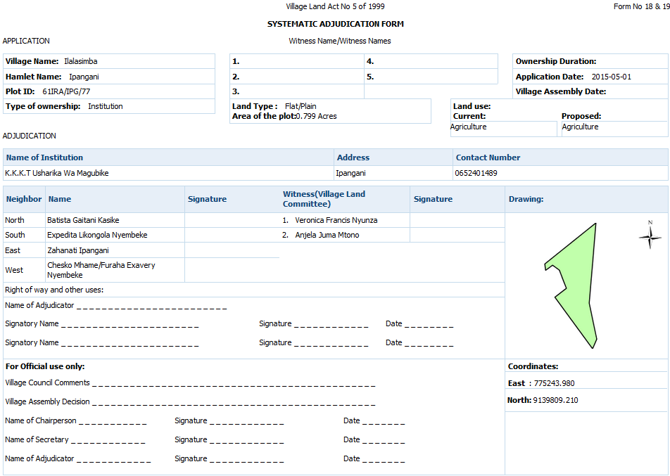

## CCRO

### CCRO for Single Owner

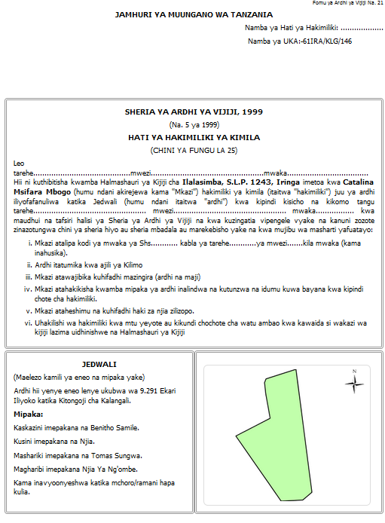CCRO page 1:

CCRO Page 2 :

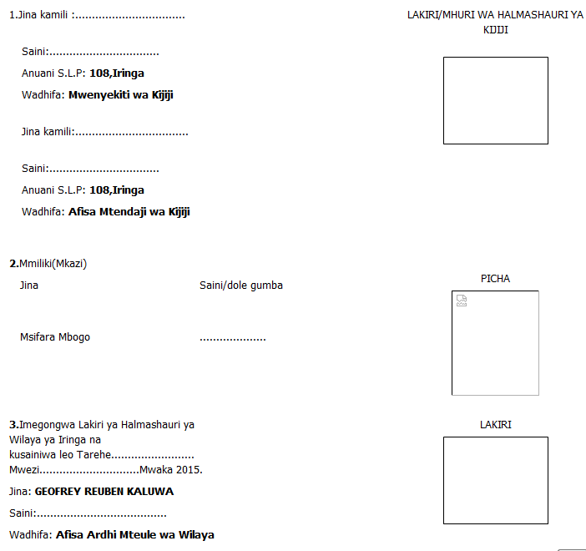

### CCRO for MULTIPLE OWNER

CCRO page 1:

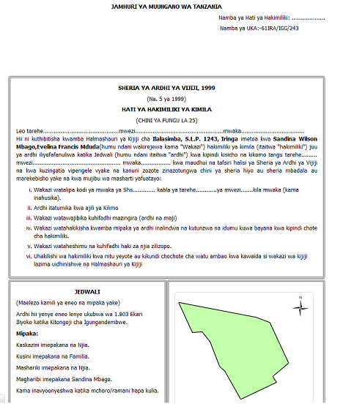

CCRO Page 2 :

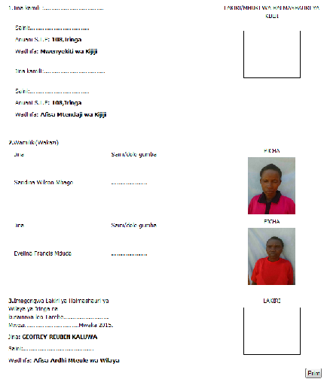

# Adding/Editing Persons of interest (Next of kin) & Natural Persons

## Web Application Flow

User clicks on Data Management option as shown below:

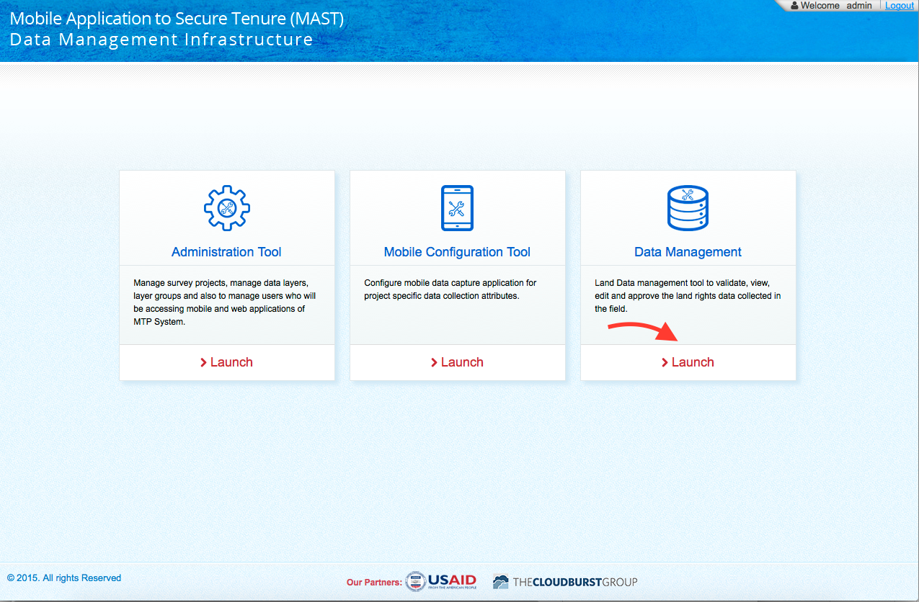

*User clicks on “Edit Attribute” (EA) button as shown below:*



*User can click on “+ New Person” to add new person as shown below:*

* 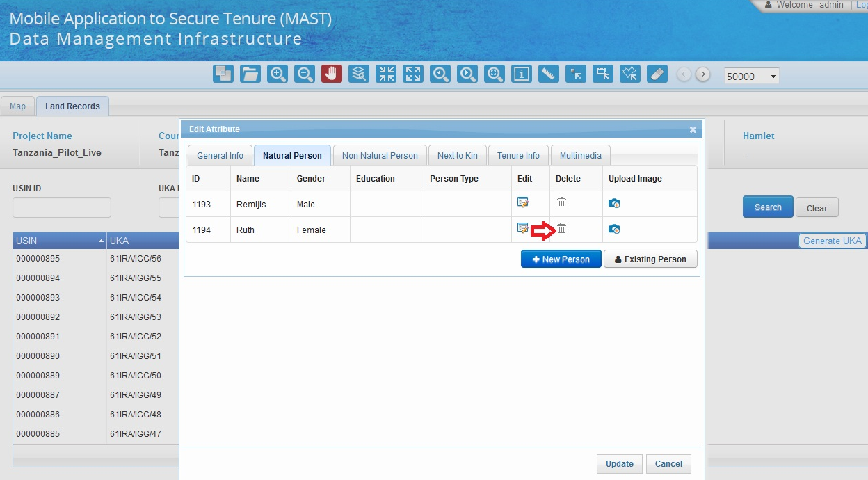User can delete a person by clicking on the trash icon in Natural person tab on edit attribute form.
* 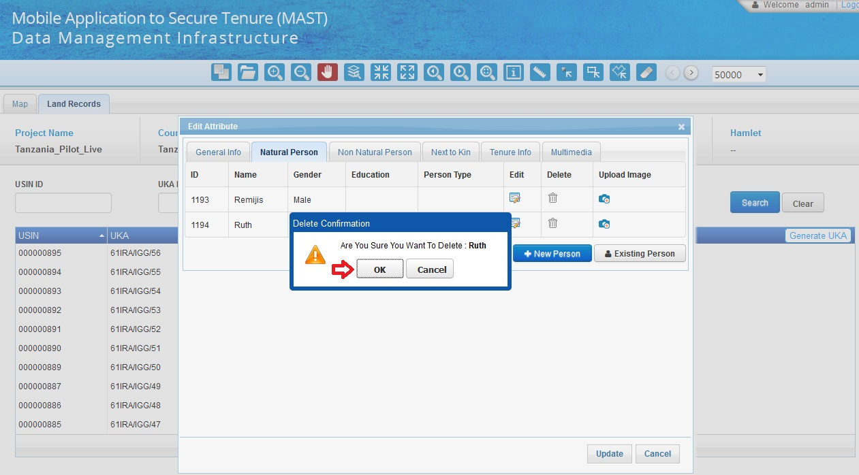On clicking the trash icon, system will ask for delete confirmation from user as shown in below screenshot.
* *User can also add new person/persons of interest by clicking on “Person of Interest” tab & then by clicking on “+ add” button as shown below:*

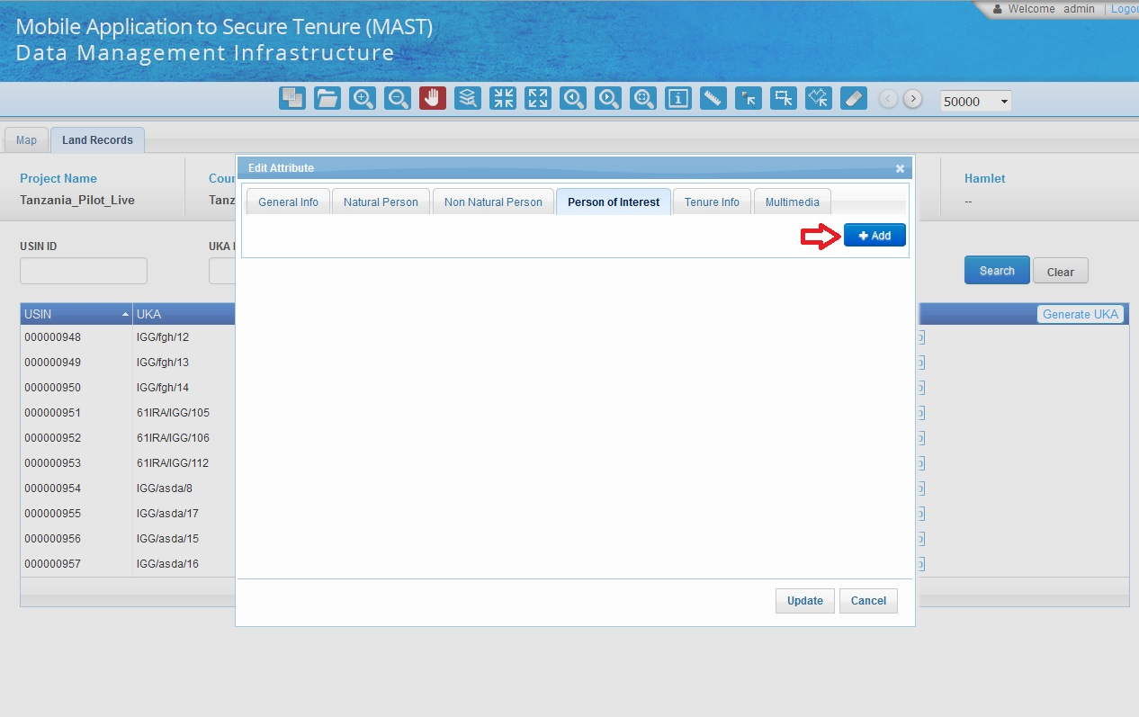

## A form will open where user can add the details related to Person of Interest and click on “Save” button to update the records as shown below:

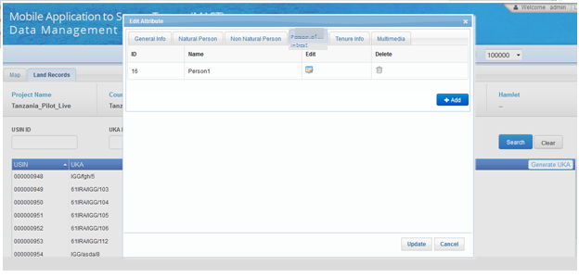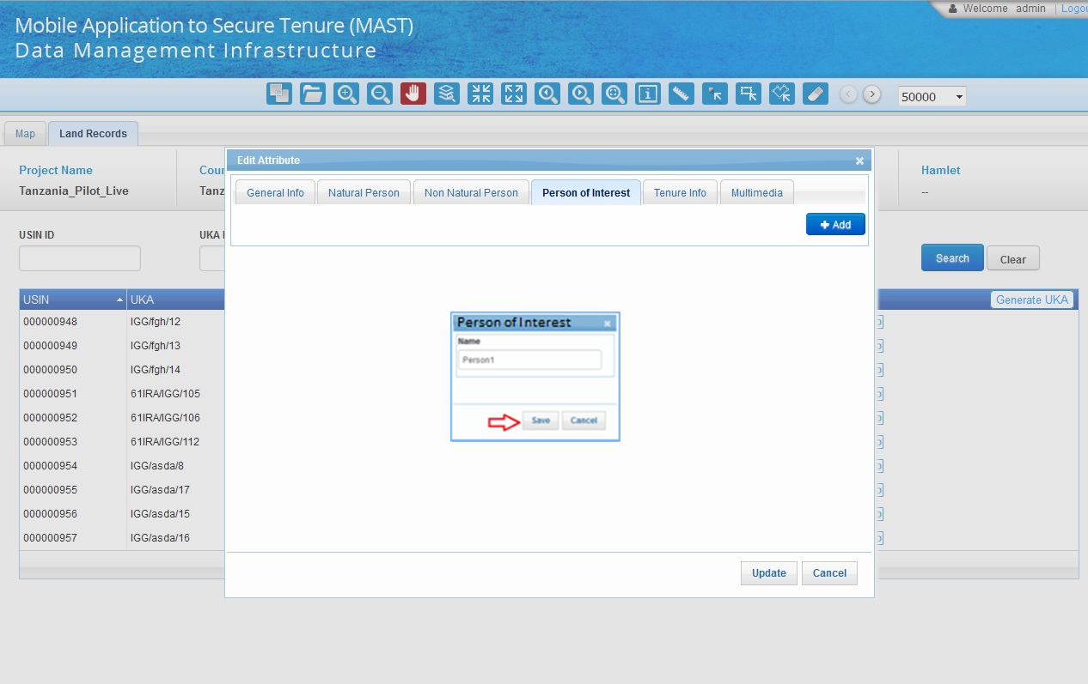  
  
  
  
  
  
  
  
  
  
  
  
  
  
  
  
  
  
  
  
The updated records will be displayed in a tabular format as shown below:

* *User can also click on Upload image icon to upload new image or to replace the existing image if any as shown below:*



* *After clicking on upload image icon, user will be shown the following image & user can upload or replace the image by browsing the picture as shown below:*

# Mobile Data Capture Application Map Layout

Map layout is required to help with the process of verifying and correcting data, especially correcting parcel boundary information.

## System Function

After the data has been captured by the trusted intermediaries and synced to the MAST web application, it is anticipated that there will be scenarios like overlapping parcels, in some cases, there may be instances of where incorrect data has been captured. The map layout will therefore be used for a quick verification of data. A print functionality will be developed to facilitate this process which will enable users to easily get all the information of the parcels in a single layout.

This functionality will be provided in the tools section of the map viewer in the Data Management module of the MAST web application.



User need to adjust the map on the parcels for which field verification needs to be done. On clicking the map layout tool (Print tool as shown below) from the toolbar, the web app will capture screen from the map viewer and list the attributes of all the parcels in the map view.

**Steps**

* User selects the **Data Management** option as shown below:

User will be shown the following screen & then user can select the  **Print** button icon as shown below:

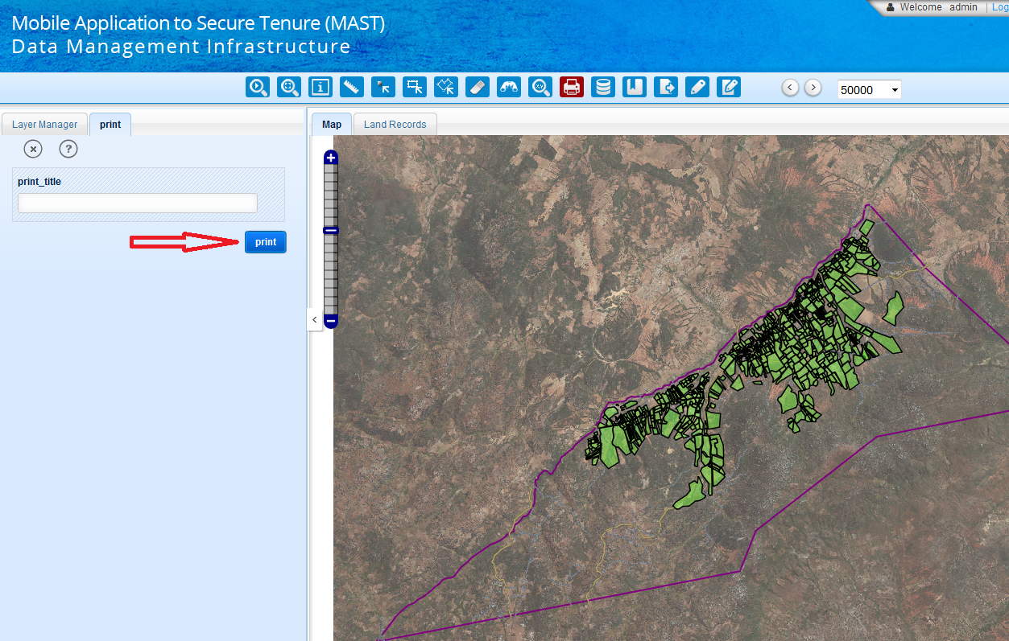

After clicking on **Print** button icon, user will be shown following screen, user can click on **Print** button present in left menu as shown below:

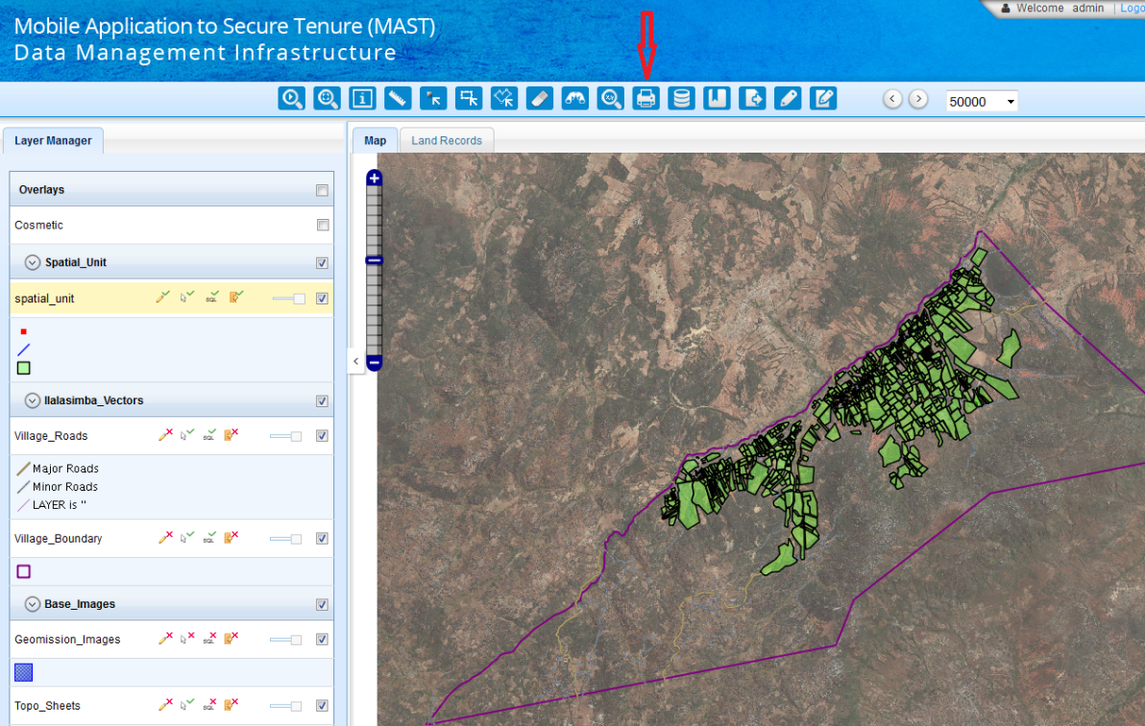

After clicking on **Print** button, a pop up will be shown with map area as well as with parcel attributes as shown below:

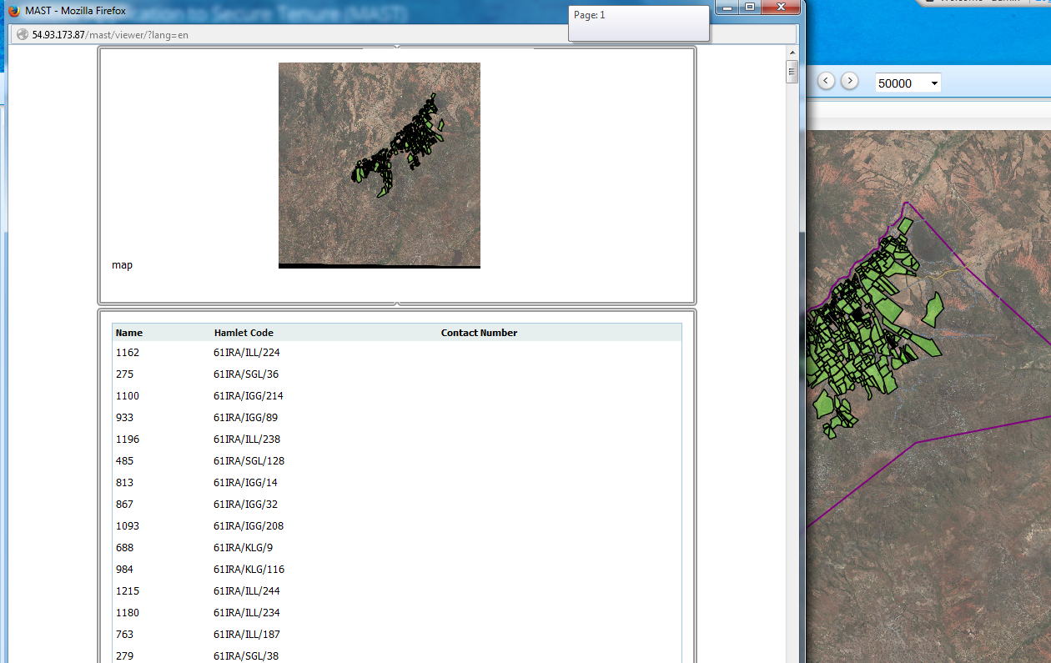

User can take the print out of the same.

The sample of the Map Layout is shown in the section below.

### Sample Map Layout

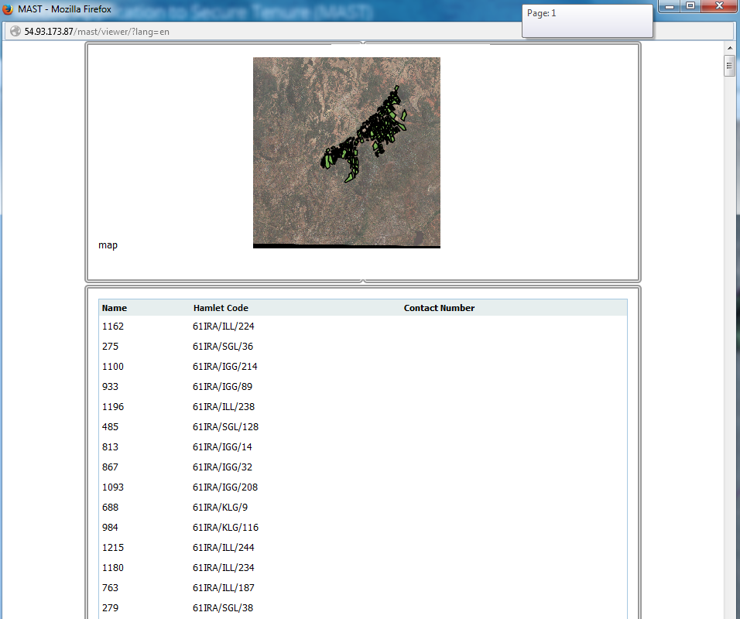

### Map Layout sample

**Mobile Application to Secure Tenure**

**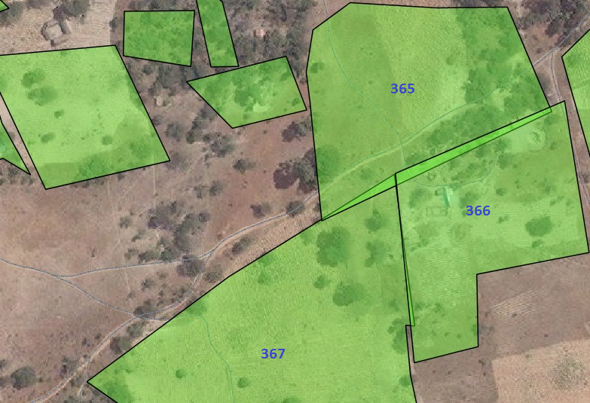**

**Parcel Details**

|  |  |  |  |  |  |
| --- | --- | --- | --- | --- | --- |
| **USIN** | **Hamlet Name** | **Person Type** | **Owner Name** | **Person With Interest** | **Contact No.** |
| 365 | Hamlet A | Owner | John Stevens | Susan Stevens, Henry Stevens | 7845664512 |
| 366 | Hamlet A | Guardian | James | Jeffrey Euwema, Kilman Henry | 7842145542 |
| 367 | Hamlet A | Administrator | Thomas | Alton Vidal, Jennifer Vidal | 9857269213 |

# MAST Spatial Data Validation

Spatial data validation is required to find any discrepancies in data and to remove/resolve the discrepancies in features. Any intersection/overlapping of the features or invalid geometry will be identified and the will be able to resolve the errors using existing editing tools provided in the MAST data management module.

## System Function

User clicks on Data Management tool as shown below:



* Users will select a spatial validation tool in map viewer as shown below:

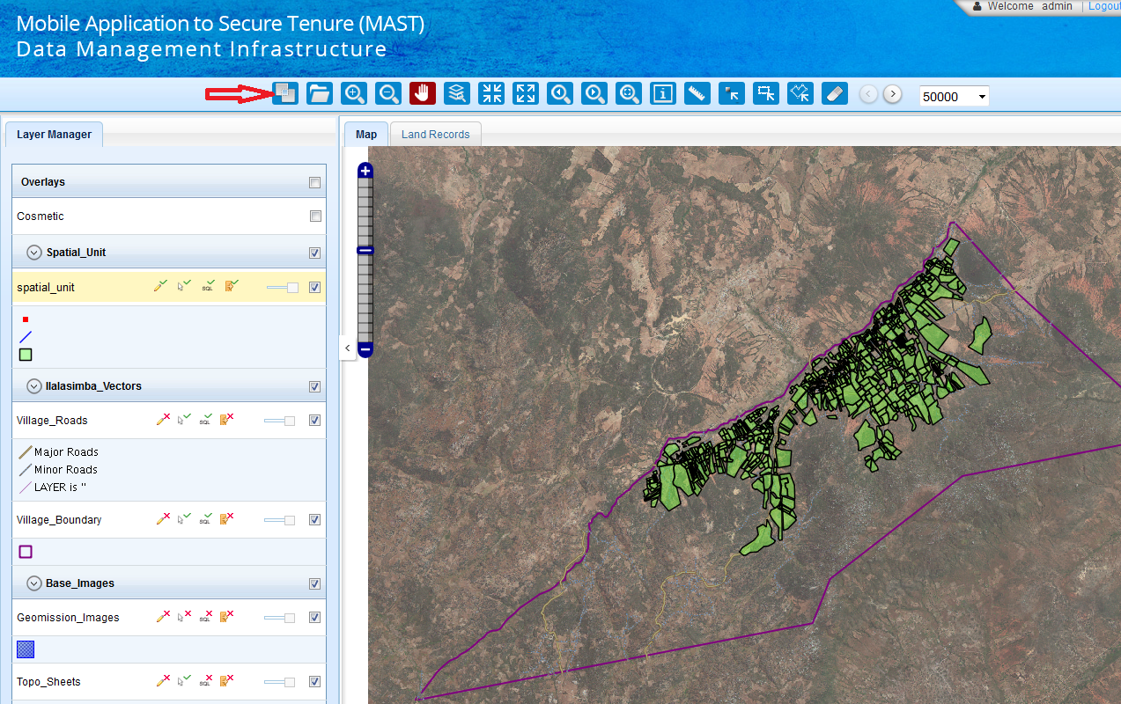

* On selecting the spatial validation tool, a popup will appear providing the user with the following options to check topology. Users will be allowed to check topology by geographic area, either for an entire hamlet, or will be able to utilize the select tool for a specific rectangle. The user will also be provided the option to select all spatial units in a project.

1. Select by Hamlet
2. Select by Rectangle
3. Select All parcels

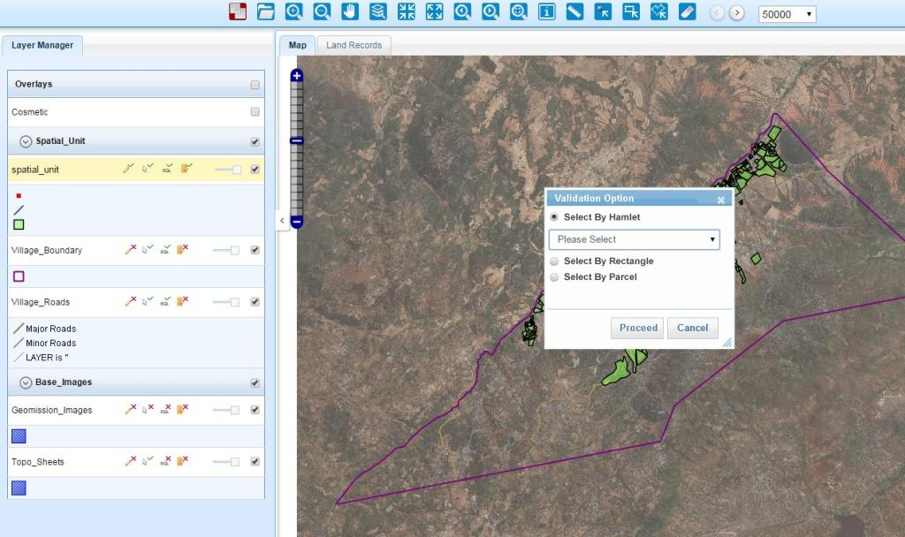

1. Select by hamlet: On selecting this option a dropdown with all the hamlets mapped to the project will appear. User can select the desired hamlet for spatial validation and click on Proceed button.
2. Select by Rectangle: On selecting this option, user can select the spatial unit geometries within the map view using the rectangle selection. Spatial validation tool will run on all the features selected using the rectangle selection.
3. Select all parcels: On selection of this option spatial validation tool will run for all the parcels captured in the project.

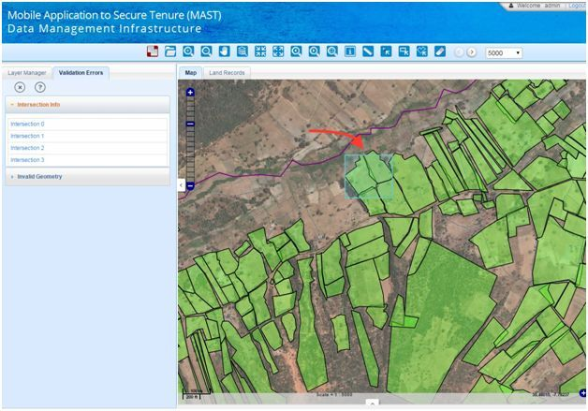

### Spatial Validation Methodology

MAST web application utilizes JSTS processes/methods for geometry validation pertaining to a single Layer. Java Script Topological Suite or JSTS is a JavaScript library of spatial predicates and functions for processing geometry conforming to the Simple Features Specification for SQL published by the Open Geospatial Consortium. JSTS Topology has a built in parser for Open Layers geometries which eases the spatial validations parsing. Following are the geometric validations that will be executed by the system along with the corresponding operation/feature of JSTS that will be utilized for the validation:

|  |  |
| --- | --- |
| Function | JSTS geometric operation |
| Geometry validation  Ref:  Must Not Self-Overlap.  Must Not Self-Intersect.  Must Be Single Part | Validation  isValid() |
| Intersect operations  Ref:  Computes a Geometry representing the points shared by this Geometry and other. | Spatial Predicates  intersects()  intersection(other) |

### Spatial Validation Results

Now system will generate **validation error** result in three sections viz. Summary, Intersection errors & Invalid geometry errors as a popup as shown in image below:

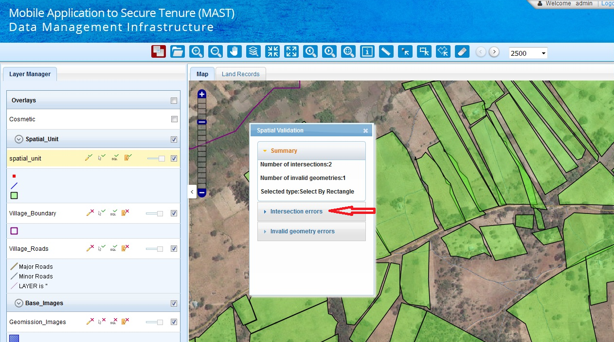

Summary section will show the type of selection & counts of Intersection errors & Invalid geometry errors.

**Error Listing: -** when user selects one of the sections from validation errors option i.e. either **Intersection errors** or **Invalid geometry errors,** system will show listing of all the topological errors in geometries found by the validation tool under the relevant selected section.

Then user selects one of the geometry error listed in a section by clicking on the list item, the clicked geometry error will get highlighted on map.

The result of the spatial validation tool is categorized under two headings:

**Intersection/Overlapping Geometry Errors**

When user selects the **Intersection geometry** errors option following screen will be shown as shown in the image below:

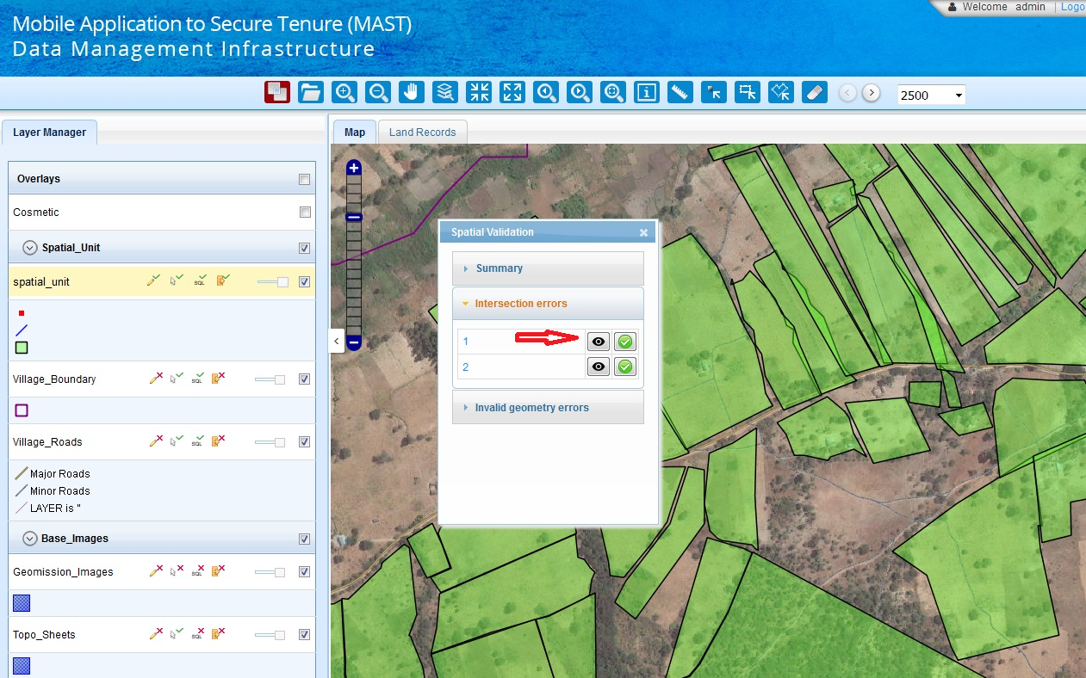

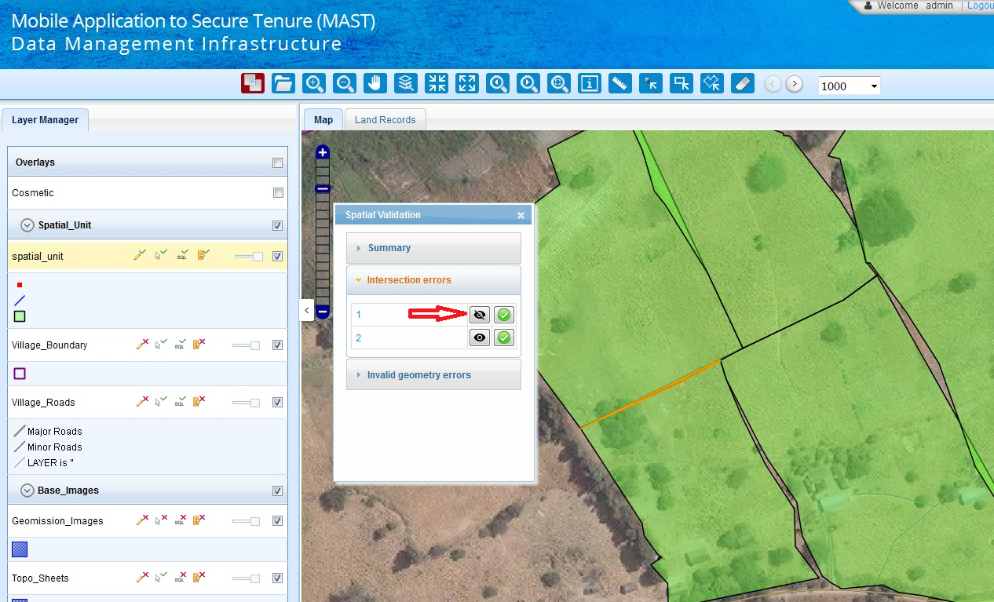Now, user clicks on view icon as shown in image above, the selected intersection error will get highlighted on map as shown in image below:

If user again clicks on view icon as shown in image above, then highlighted geometry will get in normal state as shown in image below

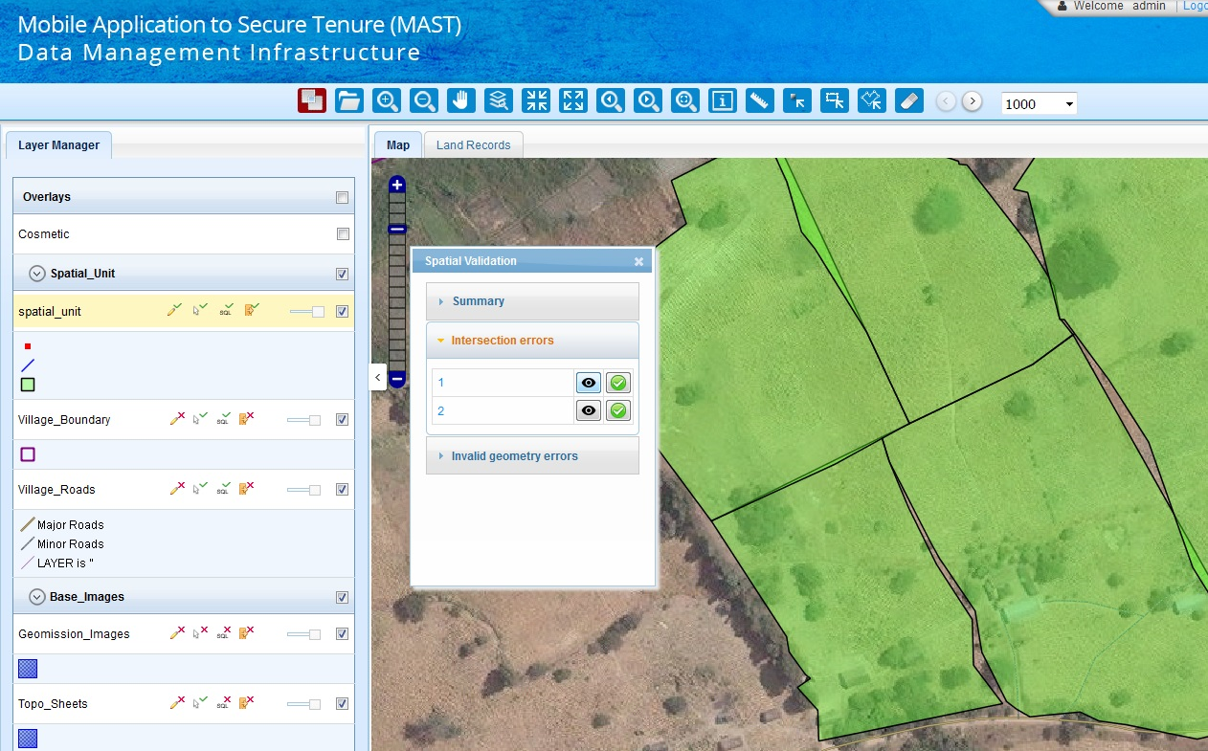

This functionality is provided to toggle display of error markup. This would facilitate in editing when user wants to observe and fix the actual error in the geometry.

**Invalid geometry Errors**

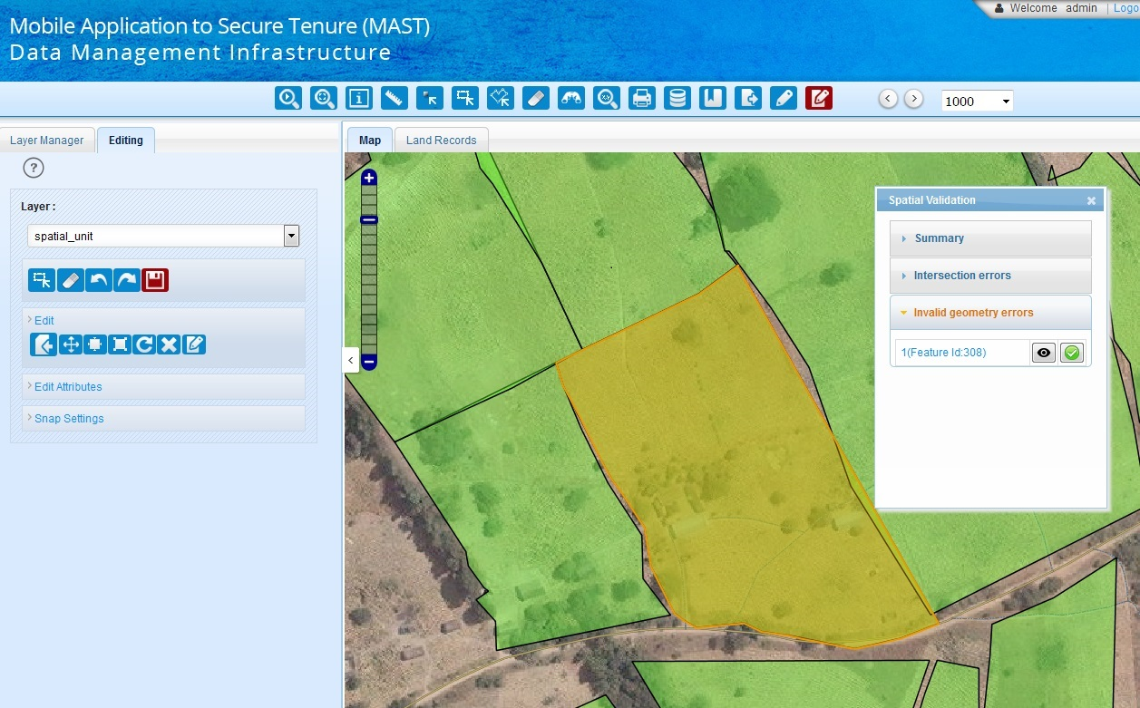If user selects any invalid geometry errors, following screen will be shown as shown below:

Geometry error markup toggle in invalid geometry works similar to intersection error.

### Spatial Validation Error Correction

User can fix the geometry errors by selecting Editing tool as shown below:

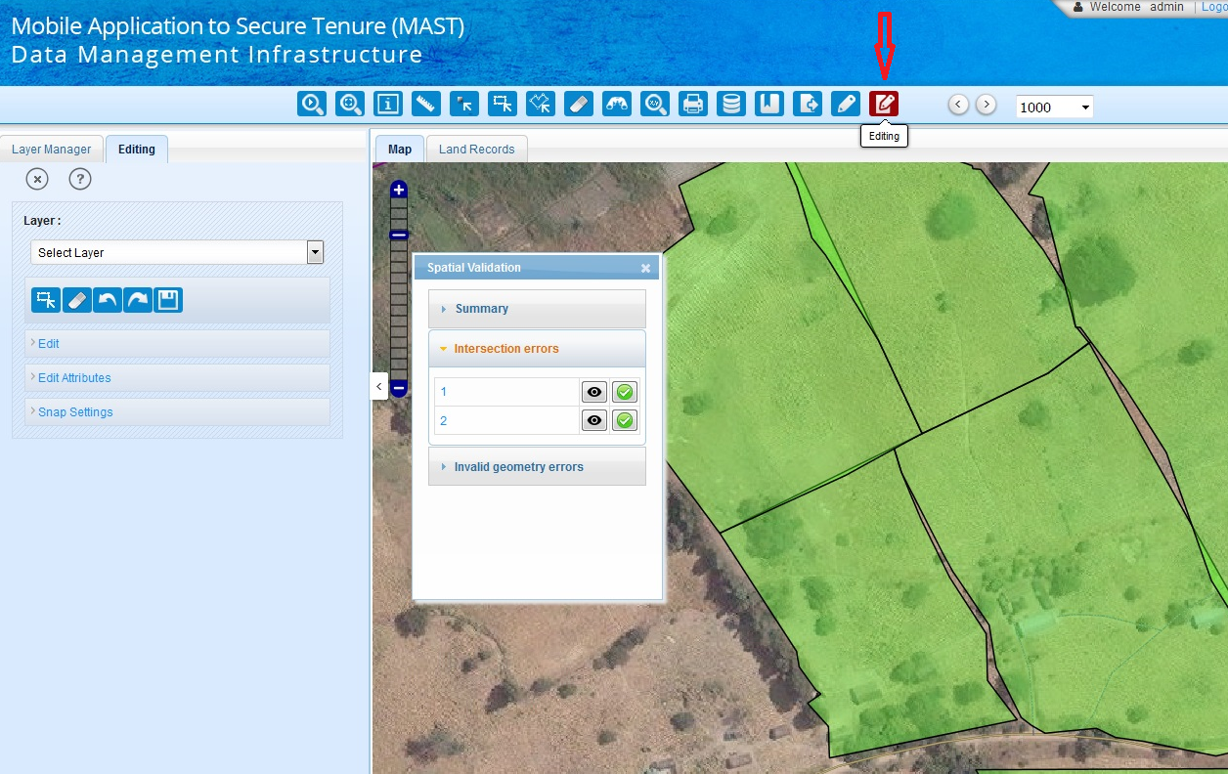

Before the user starts the editing work, he/she needs to set a snap tolerance, which would be 10 pixels by default.

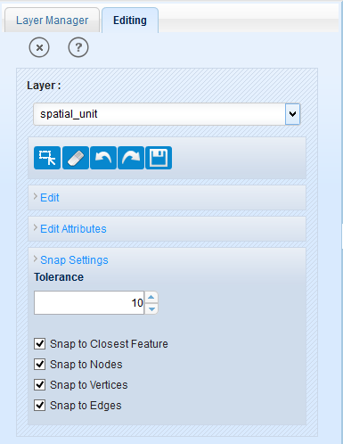

Snap setting are available in the last accordion of the editing tab. User can select the snap parameters according to requirement. Available options are:

After selecting the **Editing** tool user will be shown the editing menu on left side, user will select the **Layer (spatial\_unit)** & then clicks on **edit** tab, user will be shown more options to edit the geometry as shown below:

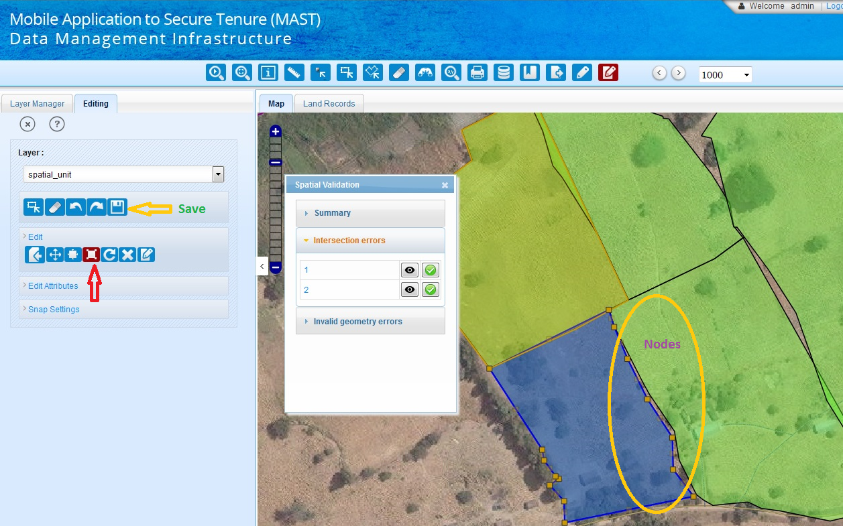

Now user can reshape the geometry by dragging Nodes and vertex as shown above. User can save the edited geometry by clicking on save button icon.

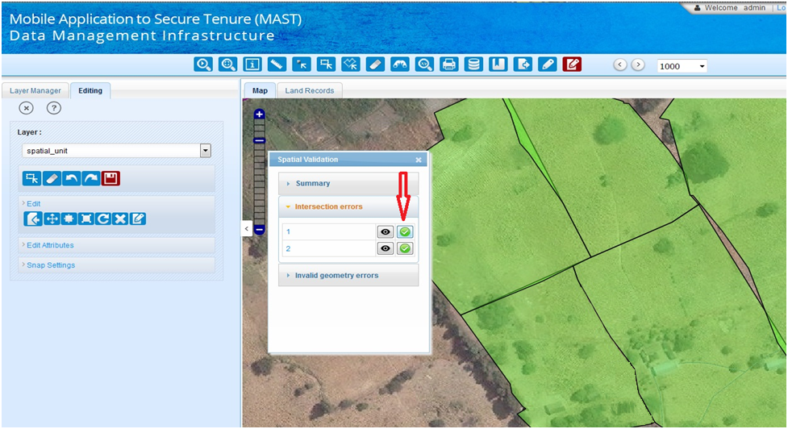

User can mark the error as fixed by clicking on fixed icon as shown in image above. When user clicks on fixed icon, error item that have been fixed will be removed from the list as shown in image.

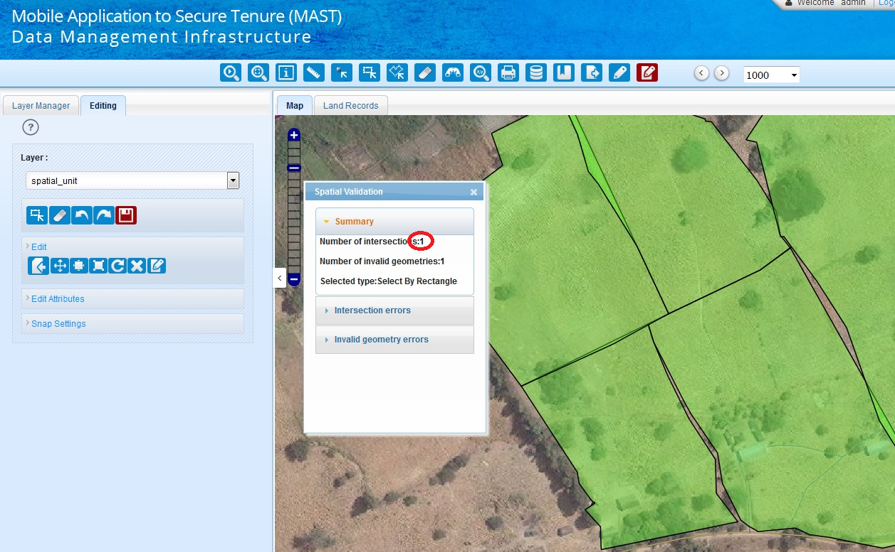

Once the user clicks on fixed icon, error list get refreshed & error count would be decreased by one as shown in above image.

Once all the errors are fixed, user can run the validation tool again to check if any other error is introduced in data while editing. Validation tools should be rerun till all the topological errors are removed from the data.

U.S. Agency for International Development

1300 Pennsylvania Avenue, NW

Washington, DC 20523

Tel: (202) 712-0000

Fax: (202) 216-3524

www.usaid.gov